SUBCOURSE EDITION
IS1132 5

US ARMY SIGNAL SCHOOL
ANTENNA SYSTEMS

MQS II SHARED TASKS

ANTENNA SYSTEMS

SUBCOURSE IS1132

US Army Signal School
Fort Gordon, GA

Two Credit Hours

GENERAL

This subcourse is designed by the US Army Field Artillery School to train the skills necessary for performing tasks related to antenna systems. This subcourse is presented in two lessons, each lesson corresponding to a terminal objective supporting the following lieutenant's MQS II task:

LESSON 1: Antenna Fundamentals

TASK NO: 01-5703.03-0003

TASK: Inspect and install RC-292 antenna.

CONDITIONS: This task is performed as an evaluation of antenna RC-292; as a final check before operation; or as directed by your supervisor. This task may be performed in a tactical or nontactical situation and may be performed in an NBC environment. You will be provided with the following: antenna RC-292, installed, frequency, and TM 11-5820-348-15.

STANDARDS: 1. Inspect the antenna to ensure that it has been erected in an area clear of any obstruction that degrade radio transmission or reception. Possible obstructions are hills, buildings, cliffs, densely wooded areas, power lines, depressions, and trees.

2. Inspect the antenna to ensure stability:

a. Ground guy stakes are at a 120-degree angle.

b. Ground guy stakes are 15 feet from the mast.

c. Each of the guy ropes have equal tension to prevent bowing of the antenna mast.

W 3471

i

3. Inspect the transmission line to ensure it has been taped to the mast at 5-foot intervals from top to bottom. A loop should be left in the transmission line at the top of the mast to remove stress from the cable connectors.

4. Inspect the number of antenna elements installed with the frequency being utilized. See table, page 26.

5. Inspect the antenna kit to ensure running spares are available and that the TM is available for additional information.

6. Inspect the DA Form 2404 to ensure operator PMCS has been performed.

TASK NO: 01-5703.03-0002

TASK: Inspect an installed antenna group OE-254/GRC.

CONDITIONS: This task is performed as an evaluation of antenna group OE-254/GRC; as a final check before operation; or as directed by your supervisor. This task may be performed in a tactical or nontactical situation and may be performed in an NBC environment. You will be provided with the following: antenna OE-254/GRC installed, frequency, and TM 11-5985-357-13.

STANDARDS: 1. Inspect the antenna to ensure that it has been erected in an area free of any obstruction that might degrade radio transmission or reception. Possible obstructions are hills, buildings, cliffs, densely wooded areas, power lines, depressions, and trees.

2. Inspect the antenna to ensure stability:

a. Ground guy stakes are at a 90-degree angle.

b. Ground guy stakes are 25 feet from the mast.

c. Each of the guy ropes have equal tension to prevent bowing of the antenna mast.

3. Inspect the transmission line to ensure it has been taped to the mast at 5-foot intervals from top to bottom.

4. The strain relief clamp should be connected through the upper guy plate and attached to the transmission cable. A loop should be utilized to prevent stress on the cable connectors.
ii
5. Ensure that all antenna elements are used correctly. Each element should have the same number of sections.

6. Inspect the antenna kit to ensure running spares are available and that the TM is available for additional information.

7. Inspect the DA Form 2404 to ensure operator PMCS has been performed.

LESSON 2: Field-Expedient Antennas

TASK NO: 01-5703.03-0001

TASK: Construct field-expedient antenna.

CONDITIONS: This task is performed as an evaluation of expedient antennas; as a final check before operation; or as directed by your supervisor. This task may be performed in a tactical or nontactical situation and may be performed in an NBC environment. You will be provided with the following: radio set AN/PRC-77, broken or damaged antenna, poles or branches, field wire WD-1/TT), electrical tape, tool kit TE-33, and FM 24-1.

STANDARDS: 1. Determine required material to repair a broken antenna or construct a field-expedient antenna.

a. Obtain any type wire that is available; however, copper or aluminum are recommended.

b. Obtain any type wire that is available; however, antenna is the same as the length of the antenna it replaces.

c. Check to ensure that emergency antennas supported by trees or poles can withstand adverse weather conditions.

2. Compute required wavelength of field-expedient antenna.

a. Divide 234 (constant) by your operating frequency in MHz to figure a quarter wavelength in feet.

b. Divide 468 (constant) by your operating frequency in MHz to figure a half wavelength in feet.

c. Divide 936 (constant) by your operating frequency in MHz to figure full wavelength in feet.

iii
d. Multiply computed wavelength in feet by .3048 (constant) to convert to meters.

3. Repair antenna, if required; material is available.

a. Connect the broken sections of a whip antenna with the use of a pole or branch and lashing when the antenna is broken in two sections.

b. Substitute a bamboo pole or other nonconductive light sturdy type pole for missing whip antenna sections. Attach field wire to the antenna binding post of the radio set and add a piece of wire that is nearly the same length as the missing part of the antenna.

c. Fasten antenna to the vehicle body if mast base is missing.

d. Lower broken wire antenna to ground, clean the surfaces, and twist wires together.

e. Substitute a piece of wire for a wire antenna that is damaged beyond repair and ensure the length of the wire is approximately the same as that of the original antenna.

4. Replace a broken antenna insulator with a piece of dry wood or glass.

5. Repair broken antenna guys by inserting a nonconducting material such as rope, a piece of dry wood, or a dry cloth.

6. Construct field-expedient directional antennas to increase the rated operating range of the receiver/transmitter.

a. Fabricate a half-rhombic antenna.

(1) Extend approximately 30 meters of WD-1/TT in the direction of transmission.

(2) Elevate the field wire at midpoint to a height of 10 meters using a Lance pole or tree.

(3) Secure one end of the field wire to the radio set and the other end to a ground stake.

iv

(4) Separate the ground stake and radio set equal distances from the support.

b. Fabricate a wave antenna.

(1) Secure WD-1/TT to two poles or trees separated a distance of 28 to 33 meters.

(2) Elevate the wire 3.5 to 4.5 meters above the ground.

(3) Secure the distant end of the wire to the radio set and the other end to a ground stake.

(4) Separate radio set and ground stake from the supports at equal distances.

6. Construct field-expedient vertical antenna.

a. Elevate WD-1/TT to a height approximately that equal to the antenna normally supplied with the radio set.

b. Support the vertical antenna by another piece of field wire supported by a pole or trees or a field wire suspended between two poles or trees.

c. Insert an insulator to separate the antenna wire and the support wire.

v

TABLE OF CONTENTS

Section Page

TITLE PAGE i

TABLE OF CONTENTS vii

Lesson 1: Antenna Fundamentals

Introduction 1

General 2

Terms 2

Functions of Antennas 3

Radiation 6

Radiation Patterns 7

Radio Wave Propagation 11

Polarization 12

Receiving Antennas 15

Antenna Siting 16

Antenna AT-984A/G 17

Antenna System RC-292 21

Assemble Antenna Equipment RC-292 23

Erect the Antenna Mast 28

Connect Antenna to Radio 29

Lower and Disassemble Antenna 29

Operator Checks and Services 30

Antenna Group OE-254/GRC 33

Assemble Antenna Equipment 34

Erect the Antenna 41

vii

Connect to Radio Set 41

Summary 44

Lesson 2: Field-Expedient Antennas

Introduction 45

Field Expedients 45

Improvising Antennas 46

Computing Wavelength 47

Improvising Whip Antennas 50

Improvising Vertical Antennas 51

Insulators 53

Improvising Ground-plane Antennas 55

Improvising Horizontal (Doublet) Antennas 56

Expedient Long-Wire Antennas 57

Elevated Antennas 60

Summary 63

viii

***IMPORTANT NOTICE***
THE PASSING SCORE FOR ALL ACCP MATERIAL IS NOW 70%.
PLEASE DISREGARD ALL REFERENCES TO THE 75% REQUIREMENT.

ix

Lesson 1
ANTENNA FUNDAMENTALS

OBJECTIVE

Upon completion of this lesson, you will be able to--

• Describe the function of military antennas and wave propagation.

• Check, install, operate, and maintain antenna RC-292.

• Check, install, operate, and maintain antenna AT-984A/G.

• Check, install, operate, and maintain antenna OE-254/GRC.

• Select effective operating sites for tactical radios.

REFERENCES

This lesson is based on FM 24-18, TM 11-666, TM 11-5820-348-15, TM 11-5985-357-13, and other materials approved for US Army instruction; however, development and progress render the text continually subject to change. Therefore, base your examination answers on material presented in this text rather than on individual or unit experiences.

1. INTRODUCTION.

a. Military thinkers envision that the battles of the next war will be fought over expanded frontages by widely dispersed, highly mobile forces concentrating superior combat power at critical places and times to influence the battle. Command, control, and communication (C3) will be essential to fight and win on this lethal battlefield. All forces will rely heavily on radios to communicate over long distances under less than ideal conditions.

b. The US Army has several configurations of radios available to help complete its fire support mission. Maximum performance from radio communication is necessary. The antenna is the heart of the radio system. The antenna is the means used to send and receive electromagnetic energy. Proper use of the antenna may increase radio communicating range to several times its rated value.

c. This subcourse deals with radio antennas--their function, installation, and capability. Lesson 2 deals with improvising antennas from material readily available on the battlefield.

d. As a lieutenant, you must be able to install, operate, and maintain all radio components. How you use or abuse your radios determines how effectively you communicate and perform the fire support mission.

1

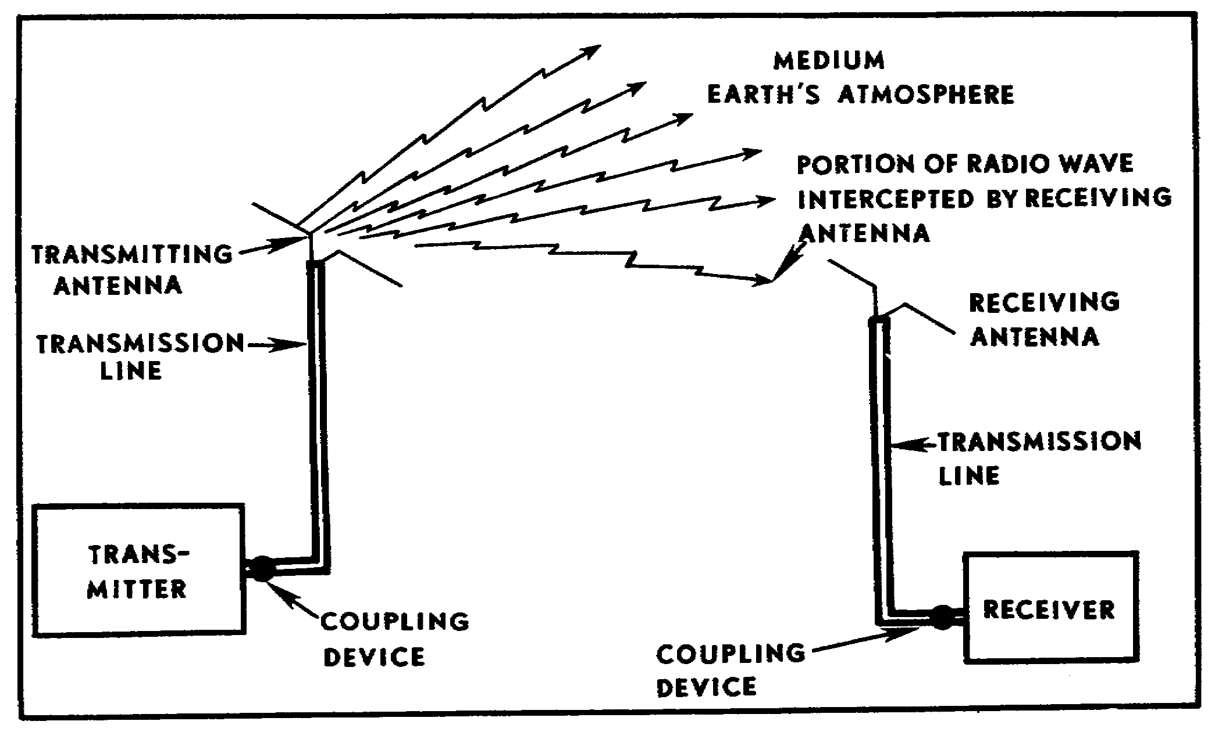
Figure 1. Radio communication network.

2. GENERAL. The study of antennas and wave propagation is essential to completely understand radio communication. In a radio communication system (Figure 1), energy in the form of electromagnetic (radio) waves is generated by electrical equipment (a radio transmitter) and fed to an antenna by special transmission lines. The antenna radiates this energy into space at the speed of light (300,000,000 meters per second). Receiving antennas, placed in the path of this traveling wave of energy, absorb part of the energy and send it to the receiving equipment through a transmission line. The ability to communicate by radio waves depends chiefly on the power output of the transmitter, the distance between the transmitter and the receiver, and the sensitivity of the receiver. Without the proper antenna system and its correct use, you cannot communicate by radio.

3. TERMS. Some basic electronic terms are used throughout this subcourse. These terms are defined here for better understanding as you proceed through the course.

• Alternating current. An electric current that continually changes in amplitude and periodically reverses direction.

• Antenna. An electrical conductor used to radiate radio waves into space or to intercept waves from space.

2

• Continuous wave. A continuous-wave transmitter sends out a continuous flow of radio frequency energy except when disrupted by a switch or a key.

• Counterpoise. A conductor used as a substitute for ground in an antenna system. It is commonly referred to as an artificial ground.

• Coupling. The association of two electrical circuits in such a way that energy can be transferred from one circuit to the other.

• Frequency. The repetition rate of a periodically recurring waveform. It is commonly measured in hertz, kilohertz, or megahertz.

• Hertz. A unit of frequency equal to 1 cycle per second.

• Polarization. The condition of light or radiant energy in which the transverse vibrations of the wave are confined to one plane or direction. The process of being positive or negative with respect to some reference point.

• Radiation. The process of sending energy into space, as in the case of electromagnetic waves radiated from an antenna.

• Resonance. An electrical condition in which the natural frequency of the circuit is the same as the frequency of the incoming signal.

• Transmission line. A conductor or system of conductors used to carry electrical energy from its source to its load.

• Wave. A single cycle of a periodic disturbance, such as a radio wave.

• Wavelength. The distance in meters traveled by a wave during the time interval of one complete cycle (1 hertz).

Wavelength (in meters) = velocity (in meters)
frequency (in hertz)

4. FUNCTIONS OF ANTENNAS. In principle, an antenna is a rod or wire which radiates or receives radio frequency signals (radio waves). Good radio communication depends on resonant transmitting and receiving antennas--antennas which radiate and receive on the same frequency. For best results, especially when transmitting, an antenna must be (electrically) about one-half as long as the frequency wavelength on which it is operating. This electrical relationship is maintained in tactical radios by automatically adjusting (tuning) the electrical length of the antenna instead of changing (shortening or lengthening) the physical length of the antenna every time the operator changes frequency. Antenna AS-1729/VRC, issued with the AN/VRC-46, -47, and -49 radio sets, is an example of an electrically tuned antenna.

a. Half-wave antenna. A half-wavelength antenna (commonly referred to as a half-wave antenna) is a single wire that is electrically equal to one-half the wavelength of the signal it transmits. The wire can be installed either

3

horizontally or vertically. The half-wave antenna can be used with FM radio equipment for high frequency operation. The half-wave antenna is normally installed horizontally and used with AM radio equipment.

b. Quarter-wave antenna. A quarter-wave antenna is about one-quarter the wavelength of the signal transmitted. When a quarter-wave antenna is erected vertically and is connected electrically to ground, it becomes the equivalent of a half-wave antenna (fig 2). The ground takes the place of the missing quarter wave, and the ground reflections supply the radiated energy which would normally be supplied by the lower half of an ungrounded half-wave antenna. This ground-reflected quarter wave is designated as an image antenna--a reflection of the grounded quarter wave.

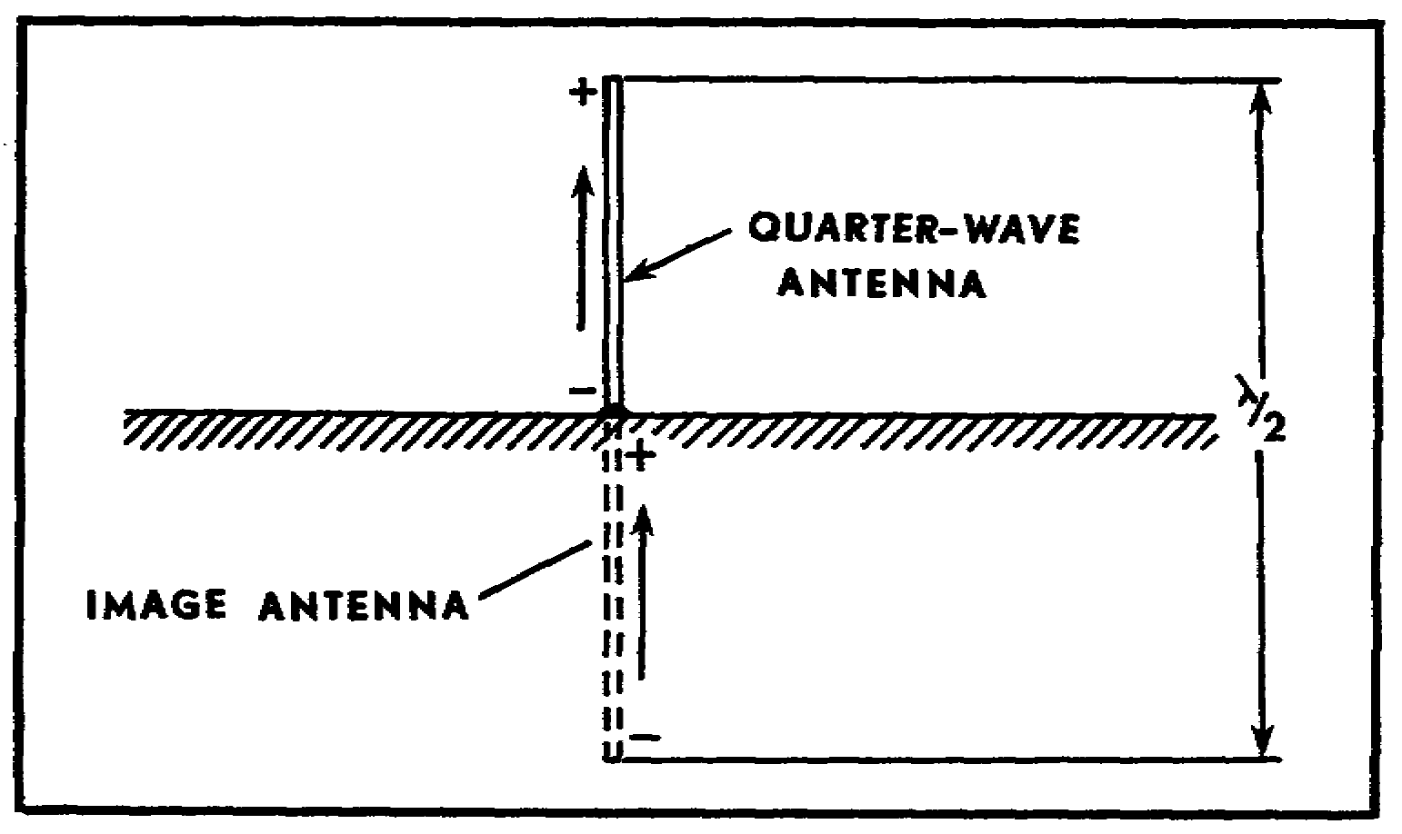
Figure 2. Quarter-wave antenna connected to ground.

c. Ground. When grounding an antenna; it is important that the ground be highly conductive. This reduces the loss of radiated energy and provides a reflecting surface for most of the radiated energy from the antenna. For simple field operations, a single ground rod is usually all that is necessary. Metal buildings or underground pipe systems are commonly used as ground connections .

d. Counterpoise. When an actual ground connection cannot be used because of soil conditions or because a large buried ground system is not practical, a counterpoise may be used to replace ground. The counterpoise (Figure 3) can be constructed of wire and mounted below the antenna a short distance off the ground. The area of the counterpoise should be equal to, and preferably larger than, the antenna.

4
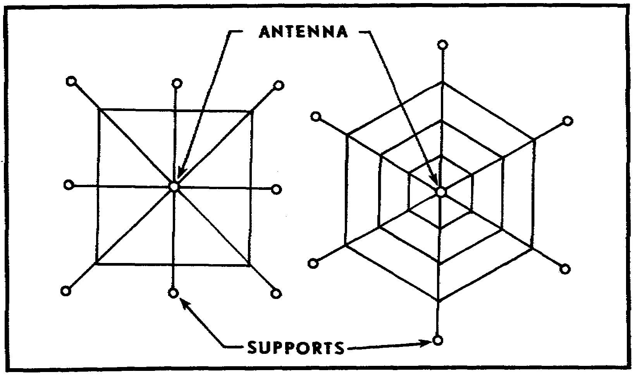
Figure 3. Wire counterpoises.

• The counterpoise is used with ground-mounted, quarter-wave antennas.

• The vehicle itself acts as the counterpoise for quarter-wave whip antennas mounted on tactical vehicles.

• A counterpoise is commonly referred to as an artificial ground.

PRACTICE EXERCISES:

Complete the following exercises by circling T true or F for false, circling the letter preceding the correct answer, or filling in the blanks, as appropriate. Be sure to complete the practice exercises as they appear. They are "building blocks" and will help you complete the rest of the subcourse successfully. The answers follow the last exercise and are separated by rows of slashes (////). If any of your answers are incorrect, restudy the appropriate part of the subcourse before you continue.

1. Antennas have two functions; they transmit energy into space and they ___________ energy from space.

2. A radio transmitter or receiver cannot function properly without an ______________.

5

3. A wavelength is the distance traveled by a wave during the time interval of __________________________________________________________

4. Waves are radiated from an antenna at a speed of ____________ meters per second.

5. To operate properly, an antenna should be electrically about ________ the wavelength of the frequency being transmitted.

////////////////////////////////////////////////////////////////////////////

ANSWERS:

1. receive
2. antenna.
3. one complete hertz.
4. 300,000,000
5. one-half

////////////////////////////////////////////////////////////////////////////

5. RADIATION. When a radio transmitter is activated (code key or voice), power is delivered to the antenna. Two electrical fields are set up by this fluctuating energy. One is the inducting field, which is associated with stored energy; and the other is the radiation field, which moves into space at nearly the speed of light. At the antenna, both these fields are strong (depending on the power delivered to the antenna). The induction field rapidly loses strength, and only the radiation field remains a short distance from the antenna. This radiation field is composed of an electric component and a magnetic component (Fig 4). These components make up the electromagnetic field which is responsible for the transmission of electromagnetic energy through space. This field, as it travels through space, is commonly referred to as a radio wave. Thus, a radio wave may be described as a moving electromagnetic field, having velocity in the direction of travel and with components of electrical intensity and magnetic intensity arranged at right angles to each other (Fig 4).

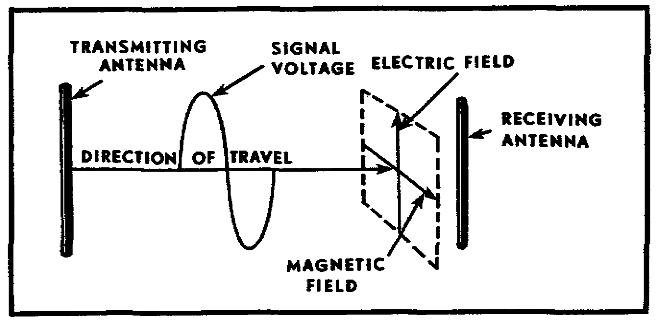
Figure 4. Components of electromagnetic waves (vertical antenna).

6

NOTE: The radio frequency energy radiated by a transmitting antenna is a form of electricity. Severe burns or shock can be received if you make contact with the antenna while it is transmitting. All personnel should be trained to avoid contact with an antenna while a transmission is being made.

6. RADIATION PATTERNS. The energy of radio signals radiated by an antenna forms an electromagnetic field which moves outward from the antenna (Figure 4) much like the waves created when a stone is dropped into a calm pond. Figure 5 graphically portrays this action. As the stone is dropped into the water (Fig 5 (A)) and strikes the surface, the water is pushed outward and upward, imparting an initial velocity to the mass of water at the point of disturbance (Fig 5 (B) and (C)). The leading wave continues to move outward and is followed by a series of waves of decreasing amplitude and velocity. Notice that these waves have amplitude (Fig 5 (A)) and wavelength (Fig 5 (B)).

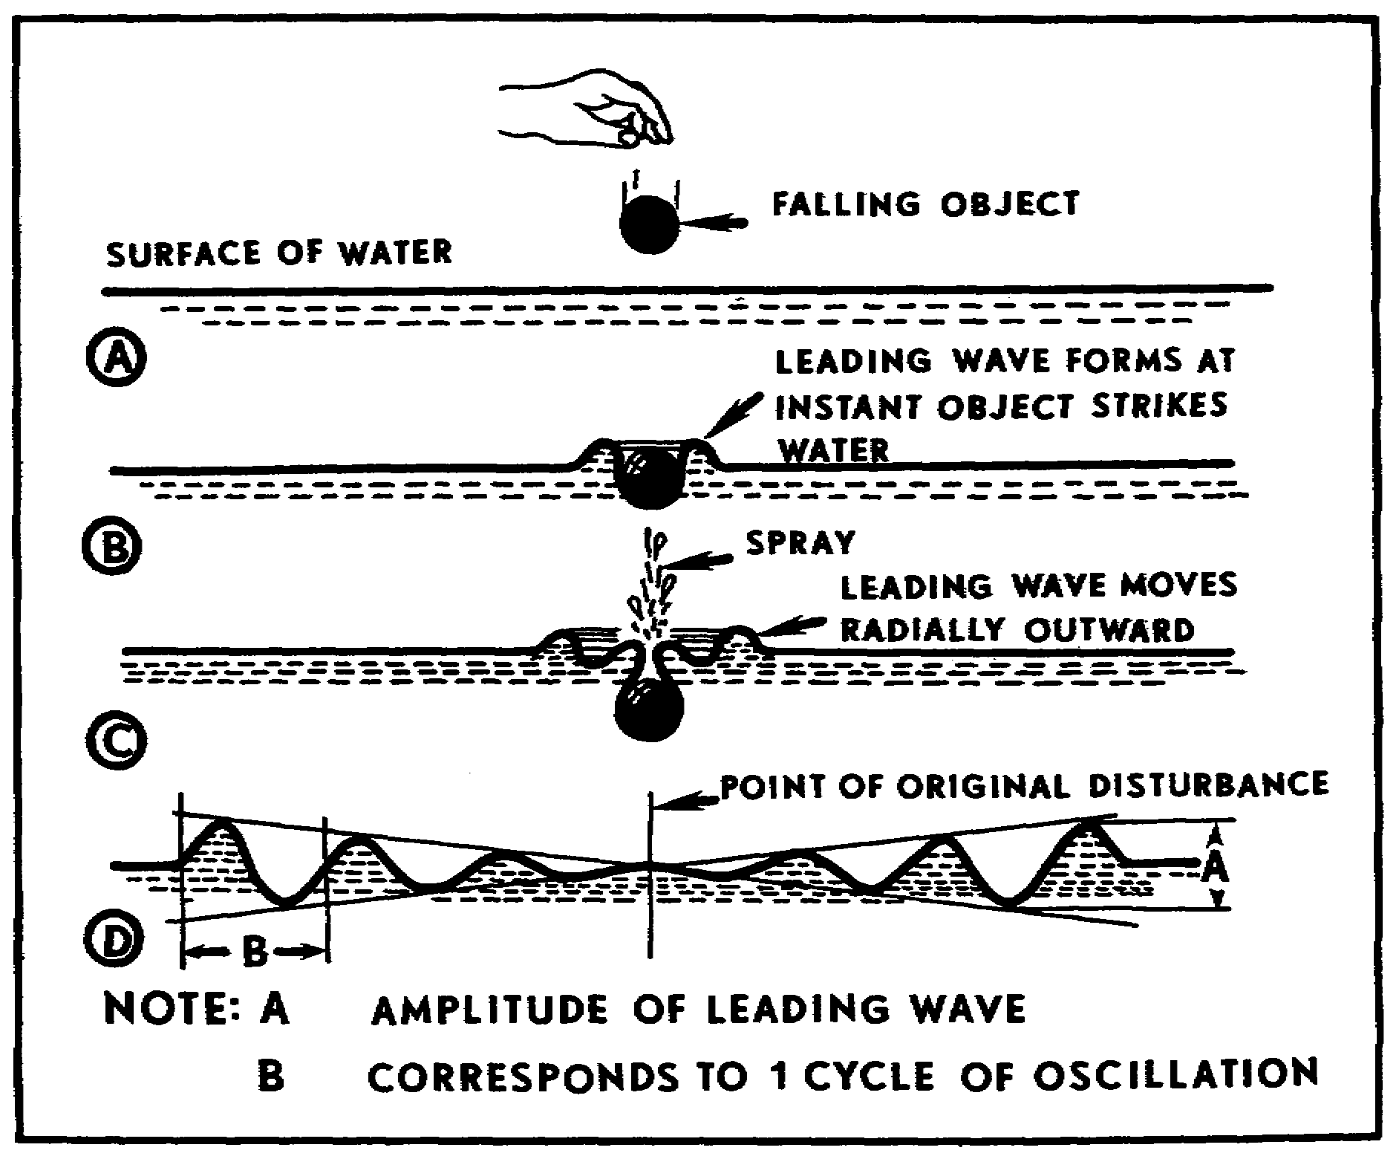
Figure 5. Wave motion on a water surface.

7

a. Radio waves. The traveling electromagnetic field referred to as a radio wave in paragraph 4 behaves in the same general manner as the waves of disturbed water. As it leaves the antenna, it creates a continuous wave disturbance which travels outward from the antenna at a constant velocity (a frequency of 300,000,000 meters per second) and at a constant amplitude in free space. Of course, the term "free space" implies that the radio waves are traveling in the atmosphere or a vacuum. The presence of hills, trees, lakes, and other terrain features (natural and man-made) modifies the effective radiation of an electromagnetic (radio) wave and distorts the radiation pattern.

b. Quarter-wave antenna. The full- or solid-radiation pattern is a three-dimensional figure that looks somewhat like a doughnut with the transmitting antenna in the center (Fig 6). The quarter-wave, vertically mounted antenna is omnidirectional (radiates in all directions). The vertically mounted antenna has minimum radiation off the top.

c. Half-wave antenna. The half-wave antenna, because of its physical length, is normally mounted horizontally. The radiation pattern (Fig 6) is bidirectional (in two directions) and is at right angles (broadside) to the antenna length.

8

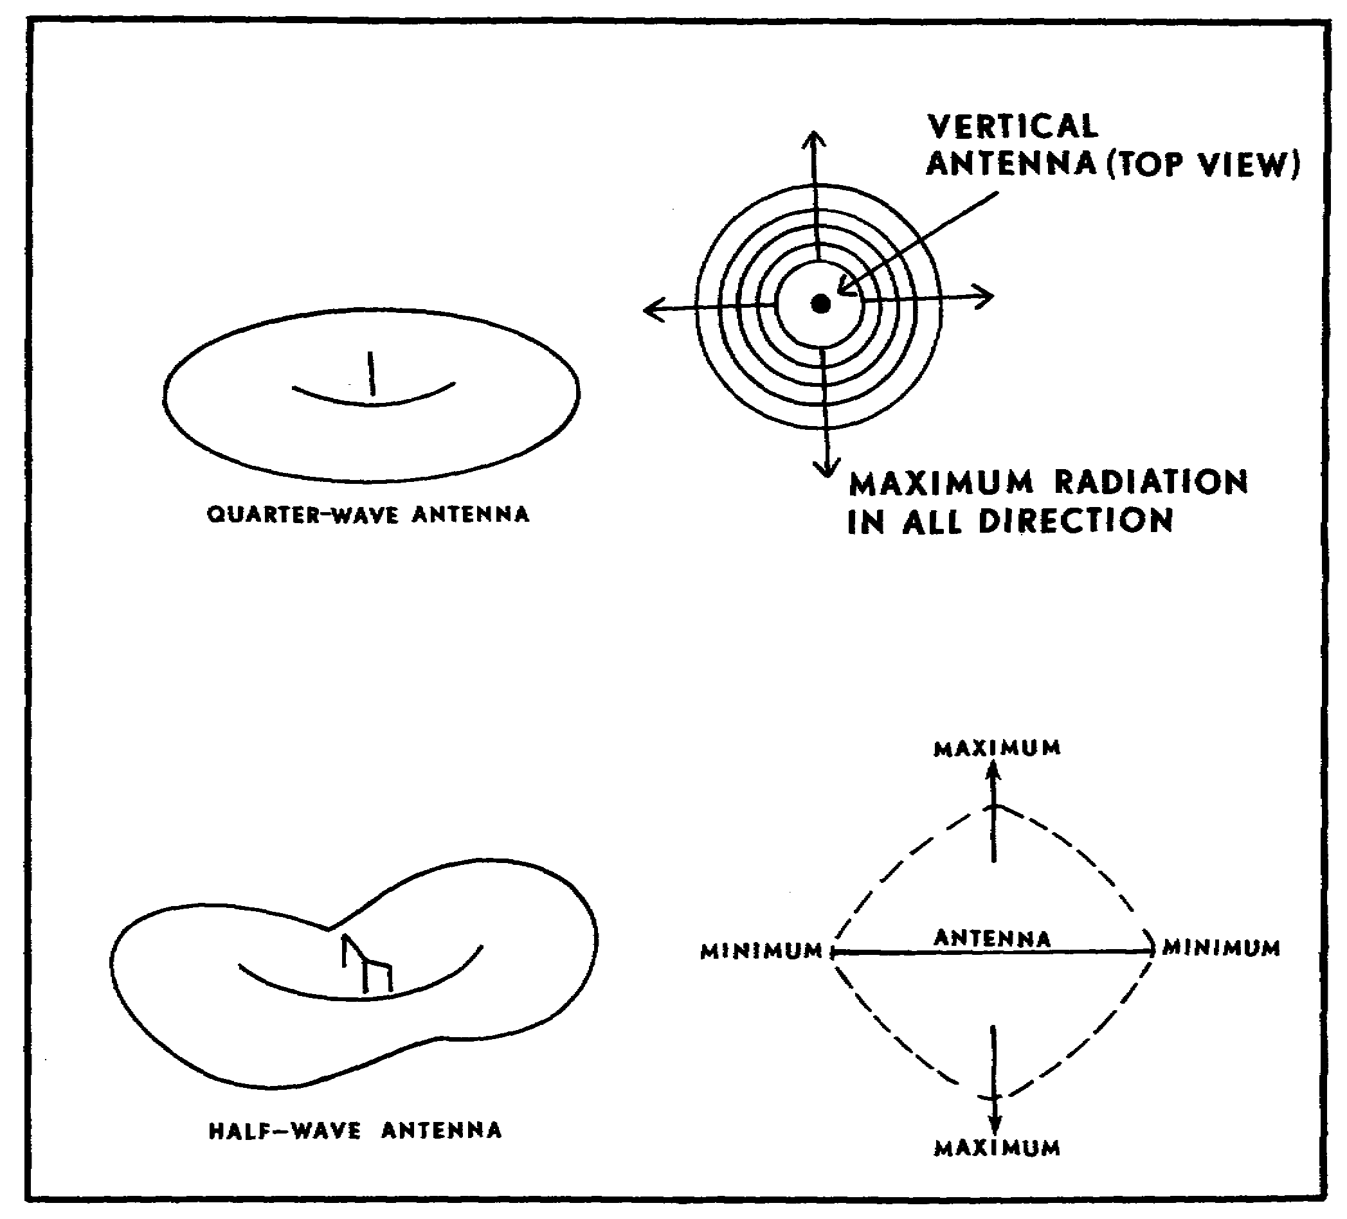
Figure 6. Radiation patterns from antennas.

9

PRACTICE EXERCISES:

6. When power is delivered to an antenna, two electrical fields are set up by this fluctuating energy. These fields are the _______________ field and the _______________ field.

7. Only the ______________ field moves out into space. This field is composed of two components, the _____________ component and the _____________ component.

8. These two components are arranged at ___________ angles to each other.

9. Radio waves radiated from an antenna create a ____________ wave disturbance which travels outward from the antenna at a velocity of _______________ meters per second.

10. A quarter-wave antenna is _________ mounted and radiates in _________.

11. A half-wave antenna is usually ________________ mounted and radiates ______________ to its length.

12. T F A quarter-wave antenna has maximum radiation off the top of the antenna.

13. T F The quarter-wave antenna is an omnidirectional antenna, because it radiates radio waves in all directions.

14. T F The half-wave antenna radiates maximum radiation from the ends of the antenna.

15. T F The term "continuous wave" describes a radio wave traveling through the atmosphere at a constant velocity and amplitude.
////////////////////////////////////////////////////////////////////////////

ANSWERS:

6. induction, radiation
7. radiation, electric, magnetic
8. right
9. continuous, 300,000,000
10. vertically, all directions or omnidirectional.
11. horizontally, at right angles (or broadside) to its length.
12. F
13. T
14. F
15. T

////////////////////////////////////////////////////////////////////////////

NOTE TO STUDENT: Before proceeding, it is best to review radio wave propagation. This paragraph will be brief--you may wish to review TM 11-666.
10
7. RADIO WAVE PROPAGATION. There are two principal paths by which radio waves travel from the transmitter to the receiver. One is by ground waves (Fig 7) which travel directly from the transmitting antenna to the receiving antenna. The other is by sky waves (Fig 7), which travel upward to the ionosphere and are reflected back to the surface of the earth. Long-distance radio transmission is achieved principally by the use of sky waves. The short-distance (8 to 40 kilometers) transmissions of field artillery radios are generally by ground waves. The three components of the ground wave are the direct wave, the surface wave, and the ground-reflected wave.

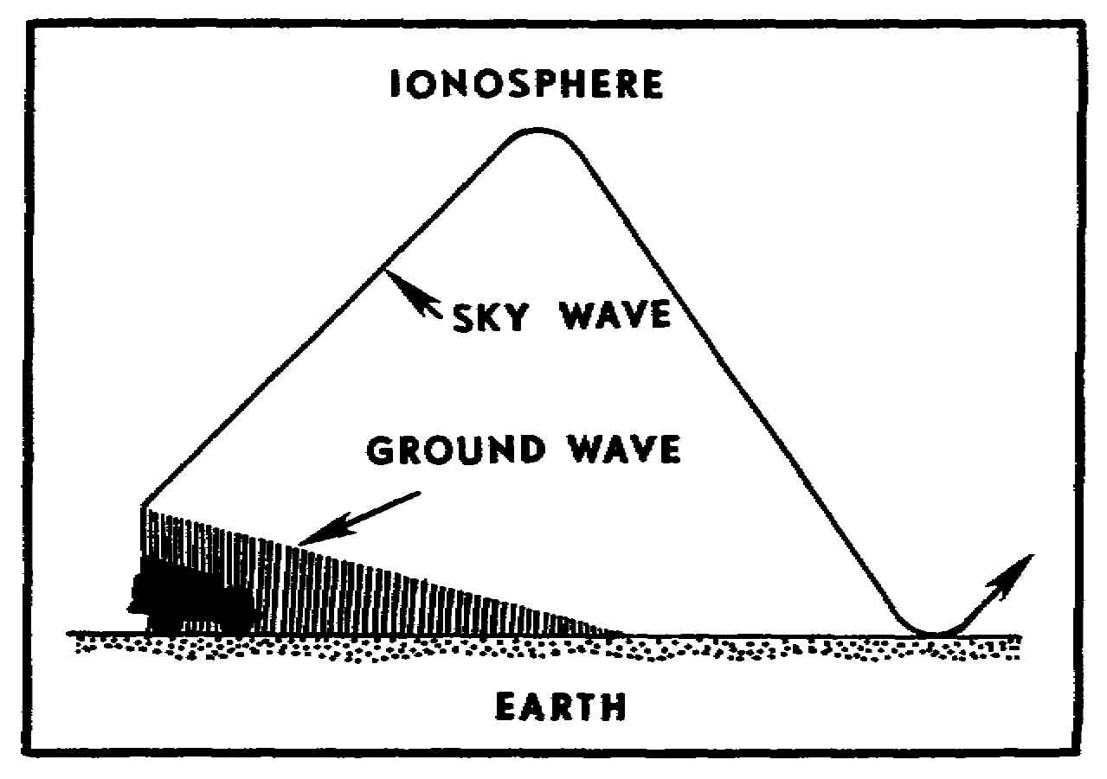
Figure 7. Radio wave propagation.

a. Direct wave. The direct wave (Fig 8) travels directly from the transmitting antenna to the receiving antenna. This component is limited to line-of-sight distance. This distance can be increased by increasing the height of either the transmitting antenna, the receiving antenna, or both.

b. Ground-reflected wave. The ground-reflected wave is that component of the surface wave that reaches the receiving antenna after being reflected from the surface of the earth (Fig 8).

c. Surface wave. The surface wave (Fig 8) follows the curvature of the earth. This component is affected by the electrical characteristics of the earth.

11

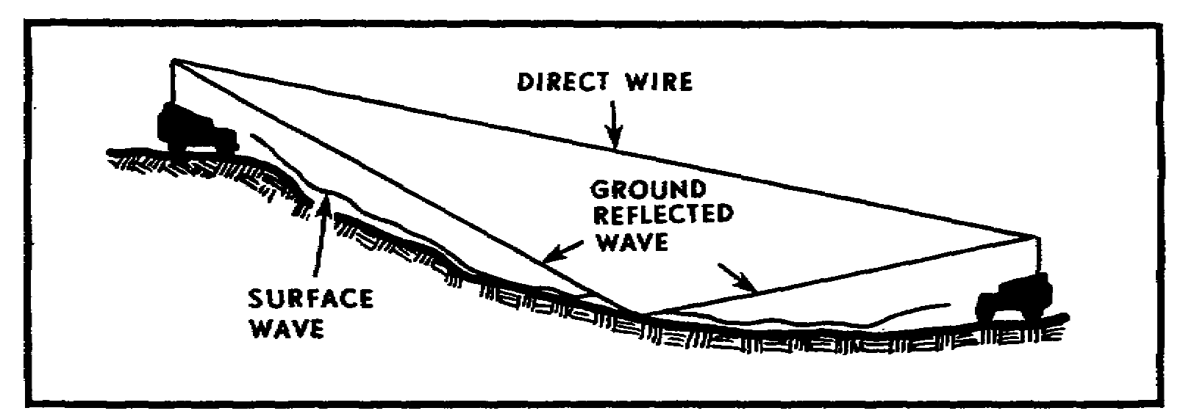
Figure 8. Possible routes for ground waves.

8. POLARIZATION. Polarization of a radiated wave is determined by the direction of the lines of force making up the electrical field. If the lines of force are at right angles to the surface of the earth, as radiated from a vertically mounted antenna, the wave is said to be vertically polarized (Fig 9). If the lines of electrical force are parallel to the surface of the earth, as radiated from a horizontally mounted antenna, the wave is said to be horizontally polarized (Fig 10). The polarization of the wave front is an important factor in the effective transmission and reception of radio signals. Thus, if a single wire antenna is used to extract energy from a passing radio wave, maximum pickup will result when the antenna is physically positioned so that it lies in the same direction as the electrical component of the radiation field. A vertical antenna (mounted perpendicular to the ground) should be used for the effective reception of vertically polarized waves (those transmitted from a vertical antenna). A horizontal antenna should be used for the reception of horizontally polarized waves (those transmitted from a horizontally mounted antenna). In both cases, the direction of travel is considered to be parallel to the surface of the earth (Figs 9 and 10).

12

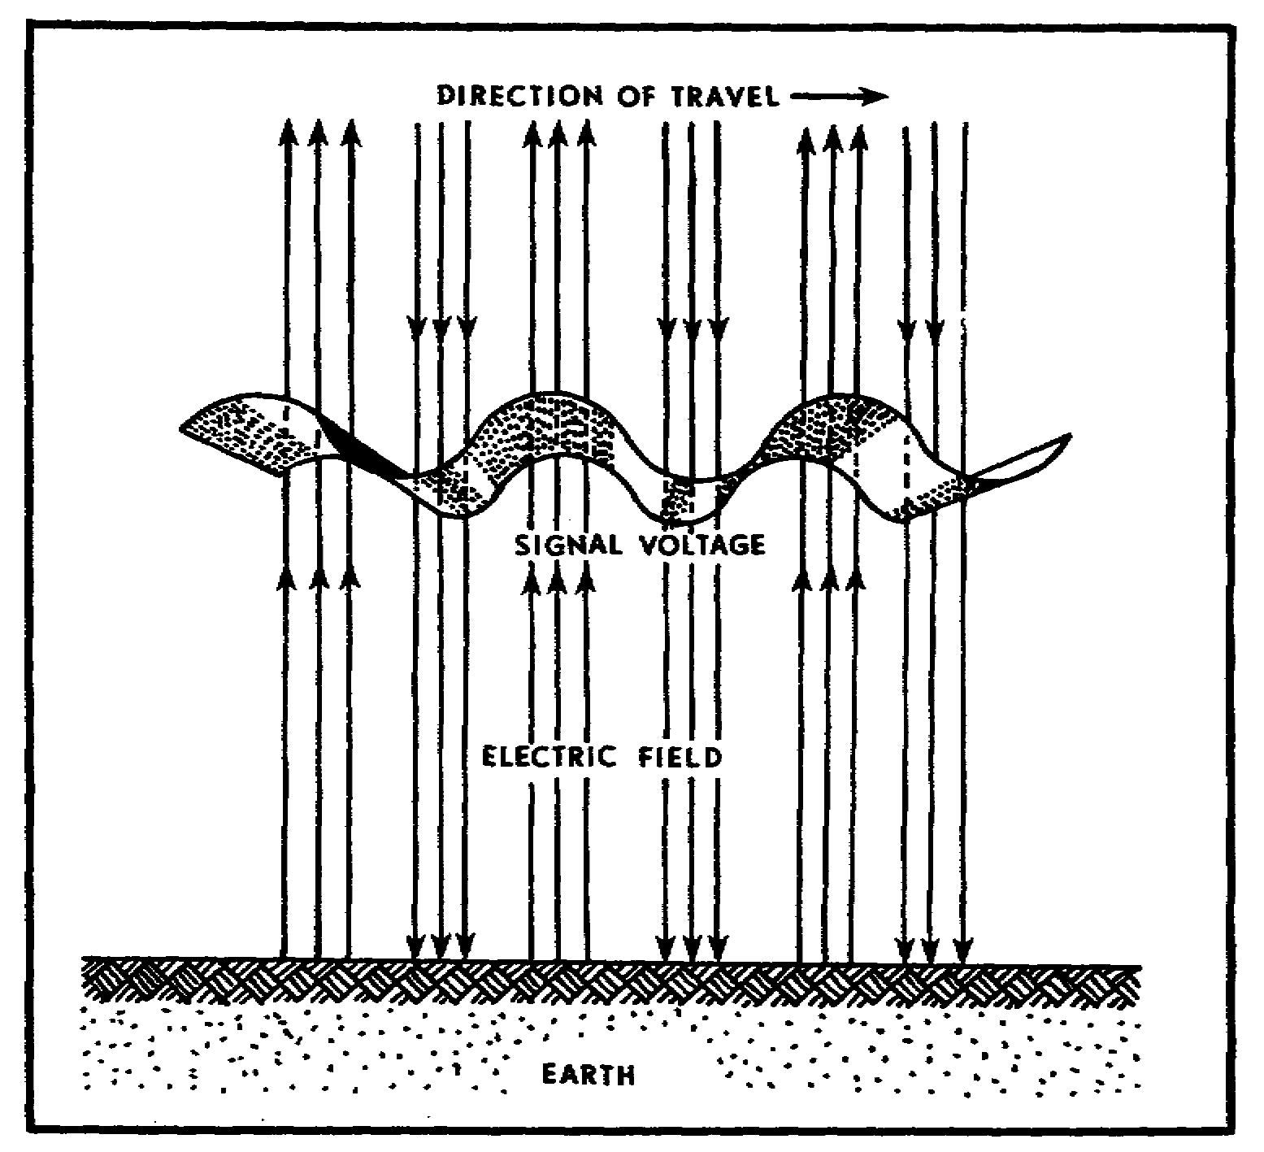
Figure 9. Vertically polarized signal.

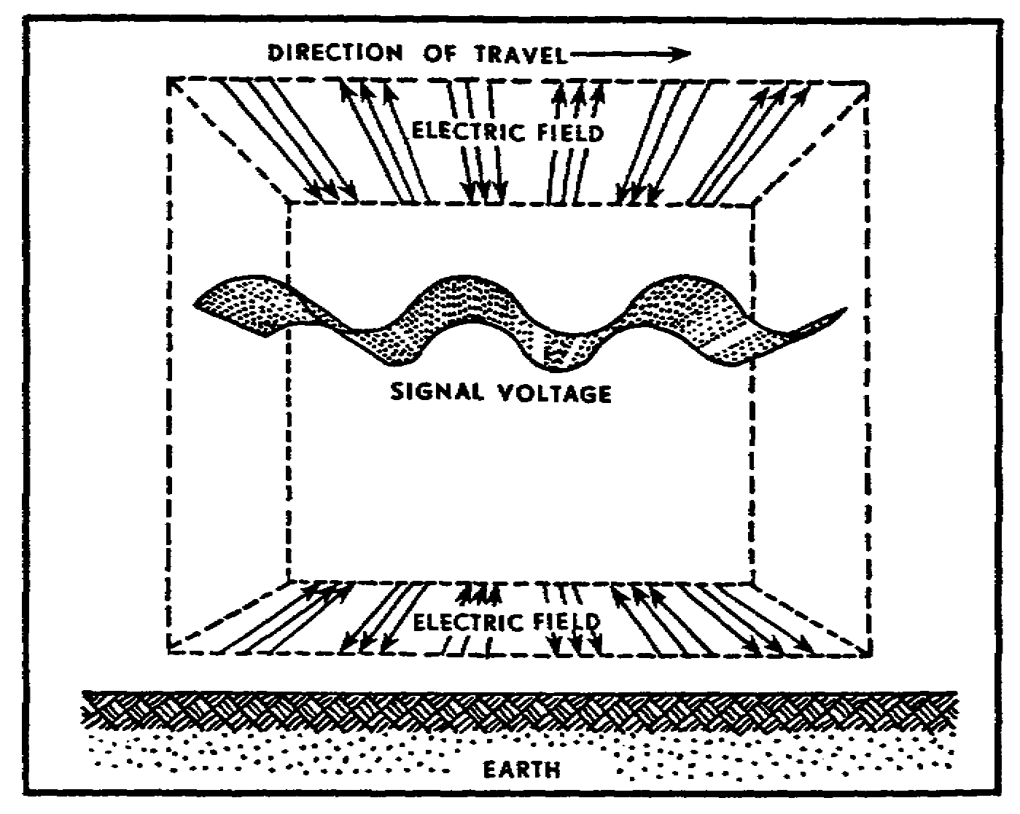
Figure 10. Horizontally polarized signal.

13

a. Advantages of vertical polarization. A simple vertically mounted antenna provides omnidirectional (all directions) communications. The advantages of using vertically polarized antennas are as follows:

• Best for communicating with a radio mounted in a moving vehicle.

• Provide a stronger signal at frequencies up to 50 MHz when antenna lengths are limited (10 feet or less).

• Less affected by reflections from aircraft flying over the transmission path.

• Less interference produced or picked up from strong VHF and UHF broadcasts. (Commercial television and radio stations [VHF and UHF broadcasting stations] use horizontally polarized antennas.)

b. Advantages of horizontal polarization. A simple horizontally mounted half-wave antenna is bidirectional. The advantages of using horizontally polarized antennas are as follows:

• It is bidirectional--accepts signals from all directions except the direction in line with the ends of the antenna.

• It is less likely to pick up man-made interference (other tactical radios which use vertically polarized antennas and electrical motors and generators).

• When located near dense forests, it suffers lower output power losses than vertically polarized antennas (especially above 100 MHz).

• Small changes in antenna location do not cause large variations in field intensity when antennas are located among trees or near buildings.

PRACTICE EXERCISES:

16. T F The transmission requirements of field artillery radios are usually accomplished by means of sky waves.

17. T F Line-of-sight radio transmission is accomplished by the direct wave component of propagated ground waves.

18. T F Regardless of the type of antenna polarization (horizontal or vertical), the direction of travel of radiated radio waves is considered to be parallel to the surface of the earth.

14

19. You are directed to install your tactical radio station near an urban area airport. You decide to use vertically polarized antennas at this site in order to eliminate interference caused by--

a. FM radio stations, electrical machinery, and tall buildings.
b. tall buildings, the television station, and FM radio stations.
c. aircraft, television stations, and FM radio stations.
d. aircraft, tall buildings, and commercial radio broadcasts.

20. When compared with a horizontally polarized antenna, the vertical antenna is better for--

a. propagating sky wave transmissions.
b. rejecting enemy electronic jamming transmissions.
c. rejecting electronic interference from friendly transmissions.
d. receiving transmissions from all directions.

////////////////////////////////////////////////////////////////////////////

ANSWERS:

16. F
17. T
18. T
19. c.
20. d.

////////////////////////////////////////////////////////////////////////////

9. RECEIVING ANTENNAS.

a. Vertical antennas. Vertically mounted receiving antennas accept radio signals equally from all directions. Because of this omnidirectional characteristic, vertical antennas are best for most tactical operations. Radios operating in highly mobile situations must receive signals from many directions. (All vehicle-mounted ratios use the vertically mounted quarter-wave whip antenna.)

b. Horizontal antennas. Horizontally mounted antennas accept radio signals from all directions other than the two directions in direct line with the ends of the antenna. Thus, interference can be reduced (or eliminated) by positioning the receiving antenna so that one end of the antenna points directly at the interfering station.

c. Directivity. Radio communication for field artillery is satisfactory when the receiver is within range of the transmitter--when the signal at the receiver is strong enough to override unwanted signals and noise. Occasionally, an operator may find that the station he is trying to reach is out of range. There are several things that can be done to overcome this problem.

• Increase transmission power.

• Change to continuous-wave signals (AM radios so equipped).

• Reposition transmitting antenna (Fig 11).

15

• Use a high-gain bidirectional antenna, such as antenna AT-984A/G.

• Fabricate and install a directional field-expedient antenna.

• Install an omnidirectional ground-plane antenna, such as the RC-292 or OE-254.

• If receiving a very weak signal, use a headset to cut out local noise.

• Raise the height of your antenna.

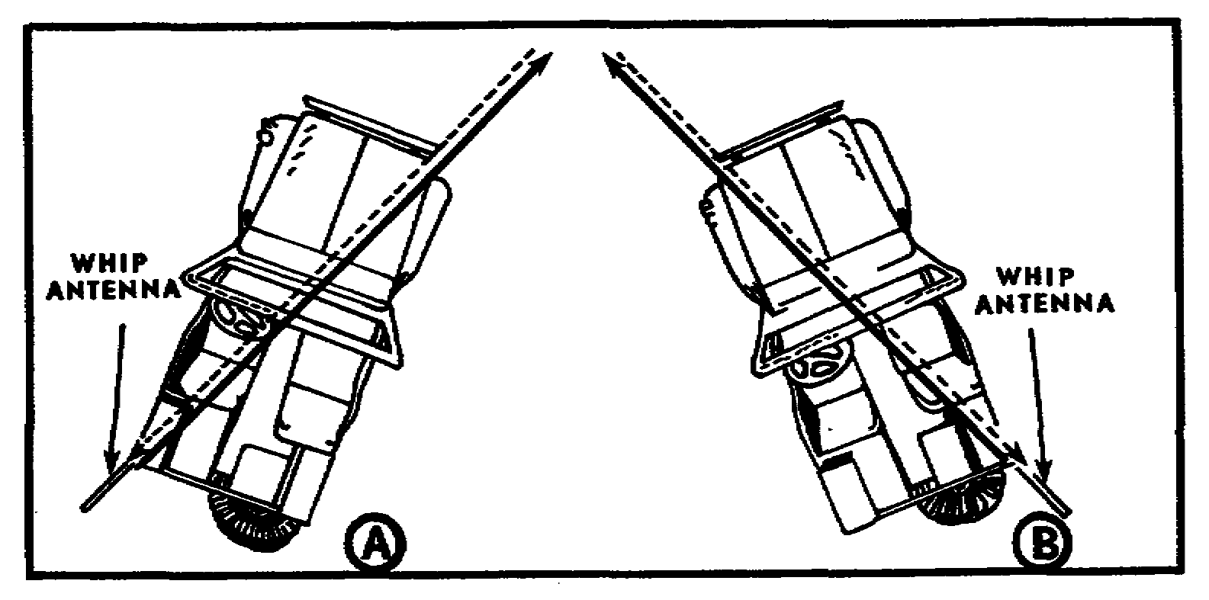
Figure 11. Directivity of vehicle-mounted whip antenna.

NOTE: A vehicle with a quarter-wave whip antenna mounted on its left rear transmits its strongest signal in a line running from the antenna through the right front of the vehicle (Fig 11 (A)). Similarly, an antenna mounted on the right rear radiates its strongest signal in a direction toward the left front (Fig 11 (B)).

10. ANTENNA SITING. The most obvious fundamental of radio communication is that a radio and its antenna must be situated in a position that ensures communications with all the other stations in the net. The transmitter and receiver will have greater range if the antenna is located in a high position that is clear of hills, buildings, cliffs, densely wooded areas, and other obstructions. Dips, depressions, valleys, and low places are poor radio locations, because the surrounding high terrain tends to absorb the radio frequency energy. Weak signals may be expected if the radio is operated near steel bridges, power lines, or other electrical circuits. The siting of a tactical radio station usually is a compromise between the technical requirements for transmission and reception and the tactical considerations of cover and concealment.

16
The use of remote equipment overcomes some of these problems. It allows the antenna to be positioned in an operationally correct site while the radio is operated from a well concealed command post area. Field radio communication will always be better if a few simple rules for siting antennas are consistently applied. They are as follows:

• Locate the antenna high enough to overlook the surrounding terrain. (Always keep line of sight in mind.)

• Keep the antenna clear of brush and tree branches. (Foliage touching antenna elements may ground the antenna.)

• In a clearing, locate the antenna on the edge farthest from the distant station. (Ideally, the clearing should extend 100 meters from the antenna in the direction of the distant station.)

• Keep antenna joints, transmission lines, and coupling connectors free of dirt, water, and snow.

• Orient a directional antenna in a straight path to the receiving station. (If the straight path is masked or obstructed, a slight off-path course may be used.)

• In mountainous terrain, use valleys and gaps as transmission paths.

• Use an adequate counterpoise, especially in desert areas where ground conduction is poor.

• If you have trouble reaching a distant station, move the antenna a short distance and try again. (Even a small movement may cancel what is affecting your transmission.)

• Use a retransmission station.

11. ANTENNA AT-984A/G. The fire support team (FIST) depends primarily on the low-power FM radio AN/PRC-77 as its link with the firing unit(s). Because of the limited range capabilities of this radio, siting of the radio set antenna is critical. To increase communication range, tables of organization and equipment (TOE) changes have added the long-wire, bidirectional antenna AT-984A/G to FIST communication equipment.

a. Description. Antenna AT-984A/G (Fig 12) is a long-wire, end-fed, directional antenna that is used to extend the communication distance of FM tactical radio sets operating in the 30.00 to 76.00 MHz range. It is primarily used with the radio set AN/PRC-77, but can be used with the AN/VRC-12 series of radios when a highly directional antenna is required.

b. Components. The antenna AT-984A/G consists of a wire reel and 150 feet of antenna wire carried in a canvas bag (Fig 12). The antenna wire is terminated on one end with a copper terminal lug. The bag has two locking devices which can be attached to the belt, thus leaving both hands free to install the antenna.

17

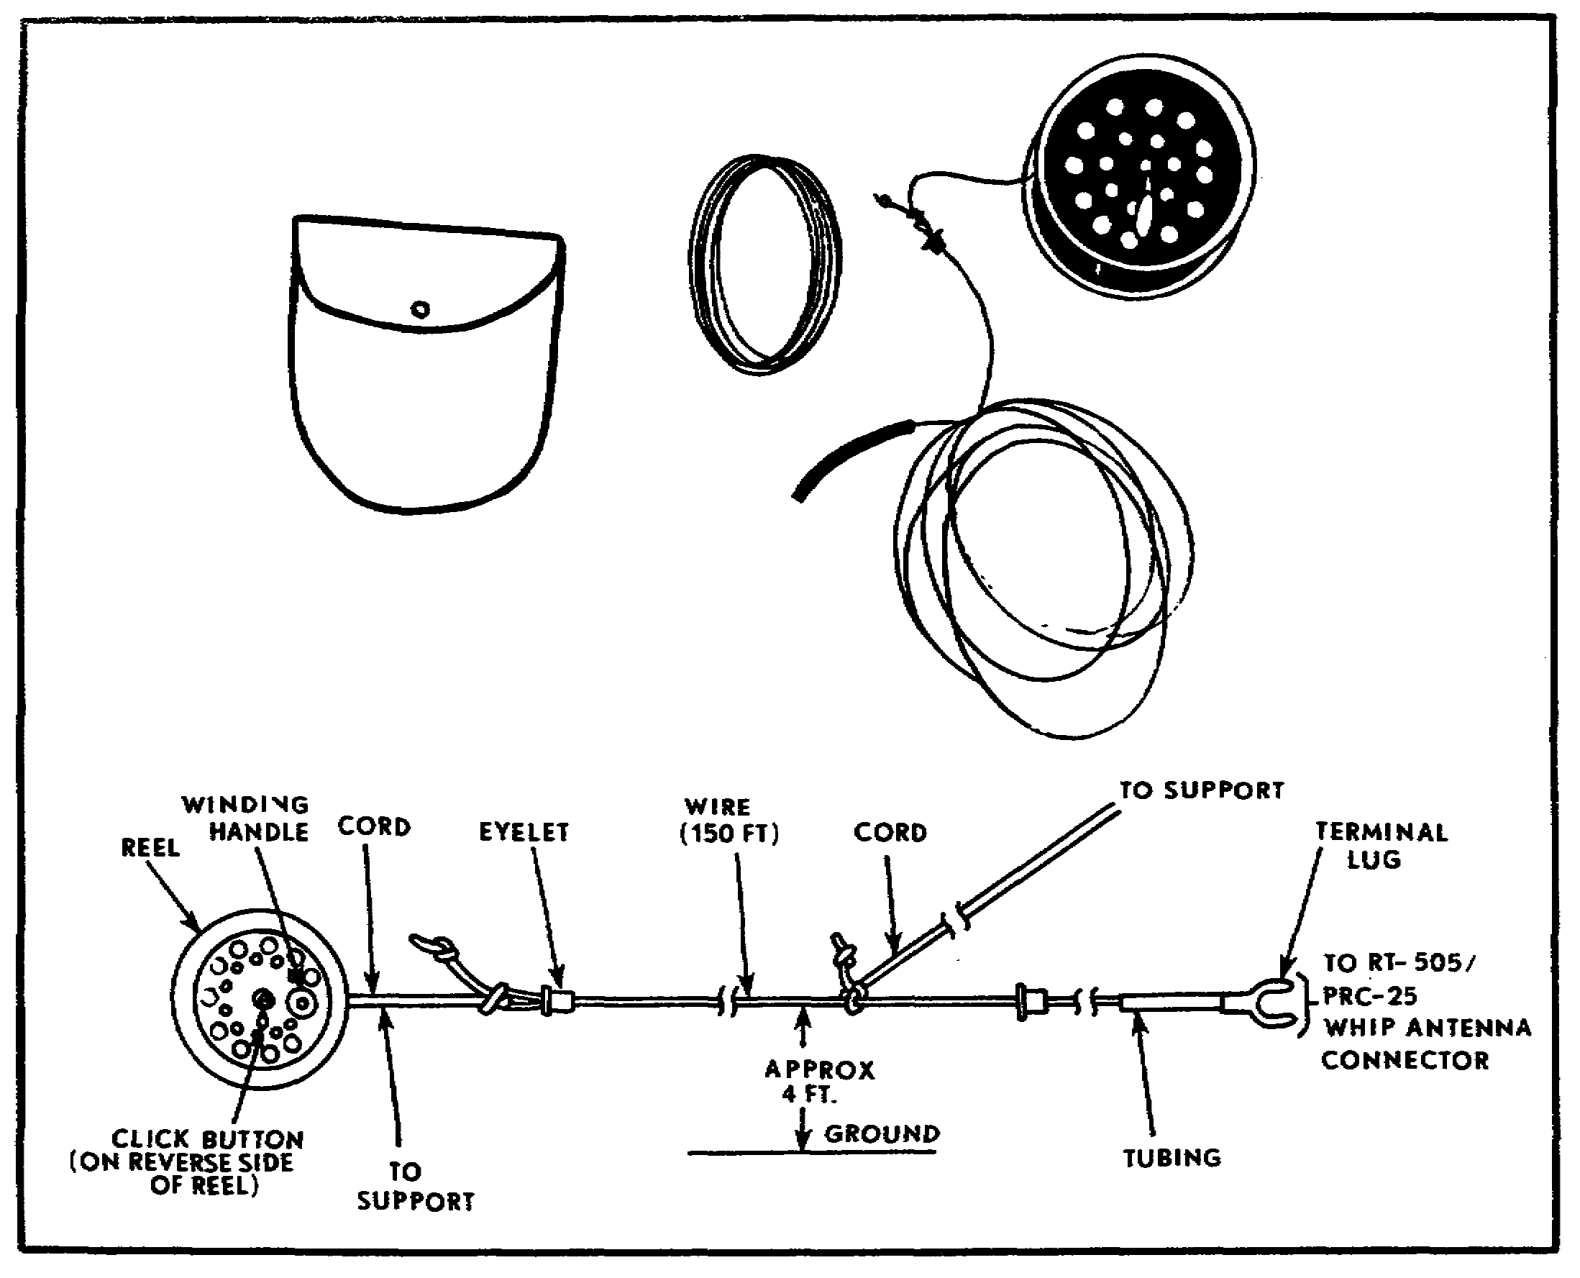
Figure 12. Antenna AT-984A/G.

c. Installation. The speed of the reel action can be varied by changing the position of the button on the side of the reel unit. The button engages (or disengages) a ratchet which controls the speed at which wire can be fed from the reel.

(1) Connect antenna to radio. Connect the terminal lug on the end of the antenna wire to the radio set AN/PRC-77 in three steps:

• Remove whip antenna from antenna support AB-591/PRC-77.

• Unscrew the support a few turns, and insert the terminal lug under the support.

• Tighten the antenna support.

18

(2) Secure antenna. Tie the cord that is attached to the antenna wire (Fig 12) to some convenient support near the radio set.

(3) Install antenna Wire. Unreel the antenna wire in the direction of the distant station. Unreel the entire 150 feet. Stretch the antenna wire approximately 4 feet above the ground.

NOTE: The reel can be placed in the canvas bag, which can then be attached to the belt. In this way, the antenna can be unreeled without handling the reel.

(4) Complete installation. With the radio set at the desired frequency and the power switch on, move the antenna about until communication is established. Secure the antenna wire to a support by using the nylon cord at the reel end of the antenna wire.

d. Operation. When the antenna is pointed toward a receiving station equipped with a long-wire antenna, the area of communications covers about 270 mils azimuth (Fig 13) on either side of the line of the antenna and increases the range to approximately 28 kilometers. When communicating with a receiving station equipped with a whip antenna, the operating range is about 19 kilometers. Long-wire directional antennae reduce the effects of enemy jamming efforts and other (atmospheric) interference.

e. Maintenance. There are no spare parts for the antenna AT-984A/G. Operator maintenance consists primarily of cleaning. No lubrication is required. Trichloroethane may be used to remove excess dirt and grease from the antenna wire.



TRICHLOROETHANE FUMES ARE TOXIC. PROVIDE VENTILATION AND DO NOT USE NEAR AN OPEN FLAME. THOUGH NOT FLAMMABLE, EXPOSURE TO OPEN FLAME CONVERTS THE FUMES TO A HIGHLY TOXIC GAS.

19

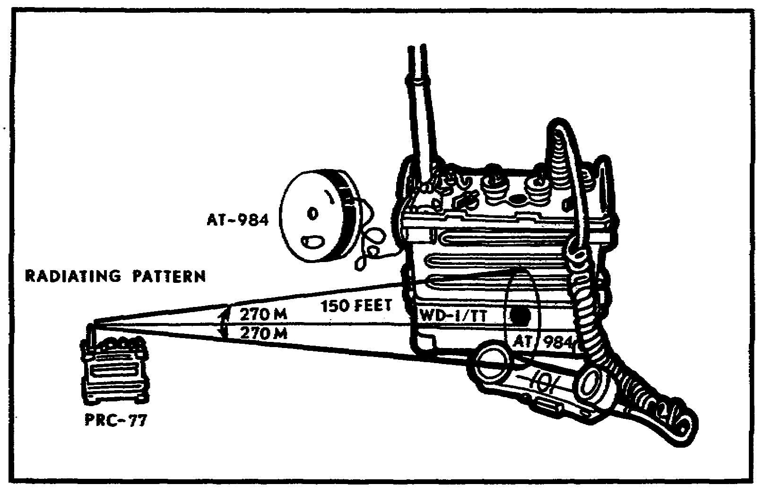
Figure 13. AT-984A/G radiation pattern.

PRACTICE EXERCISES:

21. In highly mobile tactical operations, a vertically mounted receiving antenna is better than a horizontally mounted antenna, because--

a. it is horizontally polarized.
b. it can receive signals from all directions.
c. it is less susceptible to jamming.
d. it is directional.

22. You have just chosen a wide clearing in the woods for a radio transmitter site. You should locate your radio antenna--

a. on the edge nearest the most distant station.
b. on the edge farthest from the distant station.
c. inside the tree line to conceal the antenna system.
d. on the edge nearest the receiving radio set to reduce the length of the transmission line.

23. Antenna AT-984A/G is a long-wire, directional antenna used to increase the range of FM radios operating in the frequency range of--

a. 20.00 to 27.00 MHz.
b. 20.00 to 72.00 MHz.
c. 30.00 to 76.00 MHz.
d. 53.00 to 76.00 MHz.

20

24. A radio set AN/PRC-77, with antenna AT-984A/G, transmitting to a receiving station equipped with a whip antenna has a transmitting range of approximately--

a. 8 kilometers.
b. 12 kilometers.
c. 19 kilometers.
d. 25 kilometers.

////////////////////////////////////////////////////////////////////////////

ANSWERS:

21. b.
22. b.
23. c.
24. c.

////////////////////////////////////////////////////////////////////////////

12. ANTENNA SYSTEM RC-292. Antenna equipment RC-292 (Fig 14) is an elevated, wide-band, modified ground-plane, quarter-wave antenna designed to increase the transmission range of FM radio sets by 50 to 200 percent. The frequency range (20.0 to 76.0 MHz) is compatible with the frequency range of all low- and medium-power FM radio sets issued to field artillery units. The sections of the supporting mast base raise the antenna 9 meters above the ground, thus increasing the line-of-sight distance to the horizon. The vertical element above the mast base is the antenna (Figure 14). The three ground-plane elements are installed at a 140° angle to the antenna and act as a counterpoise. The antenna is connected to the radio set by a 20-meter coaxial cable. The antenna is vertically polarized and radiates an omnidirectional pattern. The length of the antenna and ground-plane elements must be preadjusted to the desired transmitting frequency, because the number of antenna sections used varies according to the frequency being transmitted. The disassembled RC-292 is transportable (hand or vehicle). When disassembled, it is packed in a canvas roll (Fig 15). This antenna system weighs 48 pounds and can be assembled and erected by two trained personnel in 15 minutes.

21

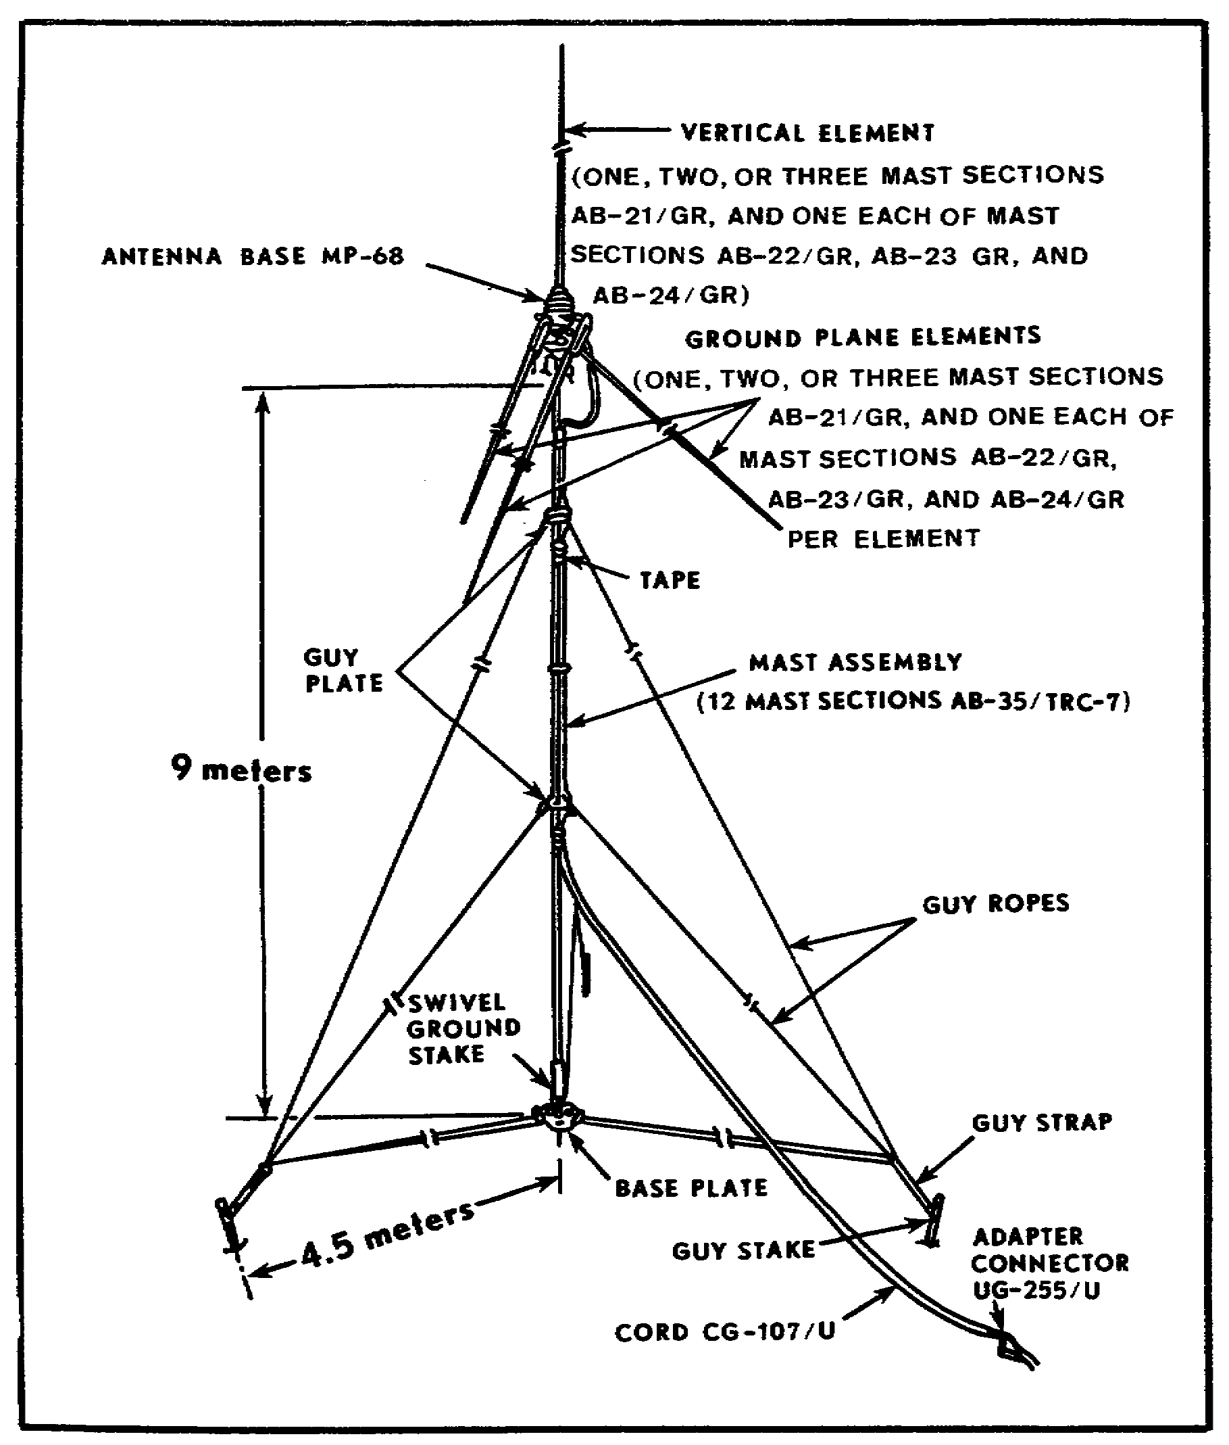
Figure 14. Antenna equipment RC-292.

22

13. ASSEMBLE ANTENNA EQUIPMENT RC-292. Before starting to assemble the antenna, the user should be sure the antenna is complete. TM 11-5820-348-15, Appendix II, contains a complete list of basic issue items and spare parts. (Figure 15 pictures these components and spares.) Once you are sure you have a complete system and have selected a good site, you are ready to assemble and erect the antenna system RC-292.



WHEN SELECTING AN ANTENNA SITE, BE SURE THE 20-METER COAXIAL CABLE TRANSMISSION LINE WILL REACH FROM THE ANTENNA TO THE RADIO SET. KEEP THE ANTENNA CLEAR OF POWER AND ELECTRIC LINES. LOCATE ALL GROUND-MOUNTED ANTENNAS A DISTANCE OF AT LEAST TWO TIMES THE HEIGHT OF THE ANTENNA AWAY FROM ELECTRICAL POWER LINES.

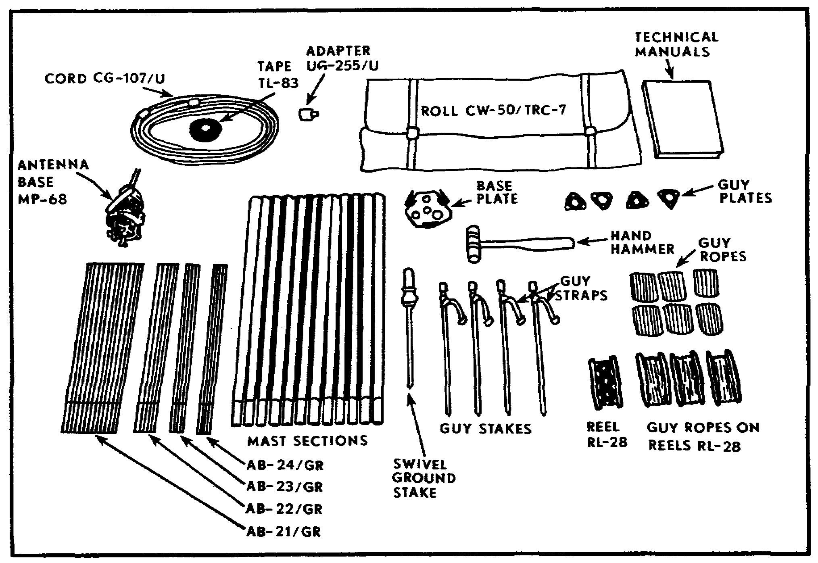
Figure 15. Antenna equipment RC-292, components and spares.

a. Position baseplate and guy stakes.

(1) Place the baseplate (Fig 16), with cleats up, where the antenna is to be erected.

23

(2) Drive the swivel ground stake through the center hole of the baseplate.

(3) Assemble six mast sections AB-35/TRC-7 (Fig 15). Place the bottom section of this assembly over the moveable (swivel) portion of the mast base assembly AB-154/U (Fig 16). This assembly provides a 4.5-meter (15 feet) measuring device for proper spacing of the ground stakes.

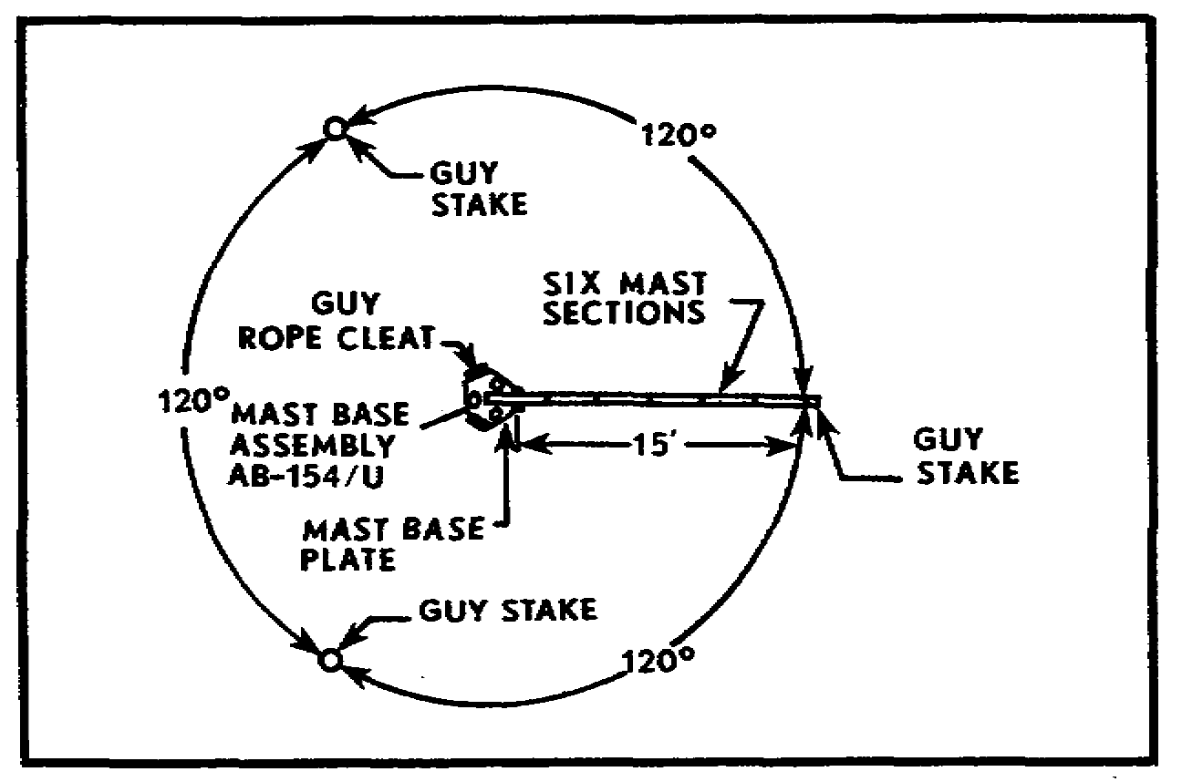
Figure 16. Positioning guy stakes.

(4) Using the assembled mast sections as a measuring device, align the mast sections over the center of one guy rope cleat on the baseplate. Drive a guy stake (Fig 15) at the far end of the mast sections (Fig 16). Repeat this procedure at each guy rope cleat. (This spaces the three guy stakes 120° apart and gives stability to the erected antenna.)

NOTE: Drive guy stakes at a 45° angle into the earth and facing away from the mast.

b. Assemble the mast.

(1) Insert one guy plate between the sixth and seventh sections of the mast assembly.

(2) Assemble five additional mast sections, and join them to the six sections already assembled.

(3) Place a second guy plate over the end of the eleventh section of the mast assembly, and add the final mast section.

(4) Lay the assembled antenna mast between two guy rope cleats on the baseplate with the mast against one of the cleats. (This results in a 90° angle between the mast and the guy stake that is in line with the next cleat.)

(5) Tie the flexible end of each of the three guy straps around each of the three guy stakes. Use a cow hitch (Fig 17) to ensure proper tension on the D-rings when the antenna is erected.

24
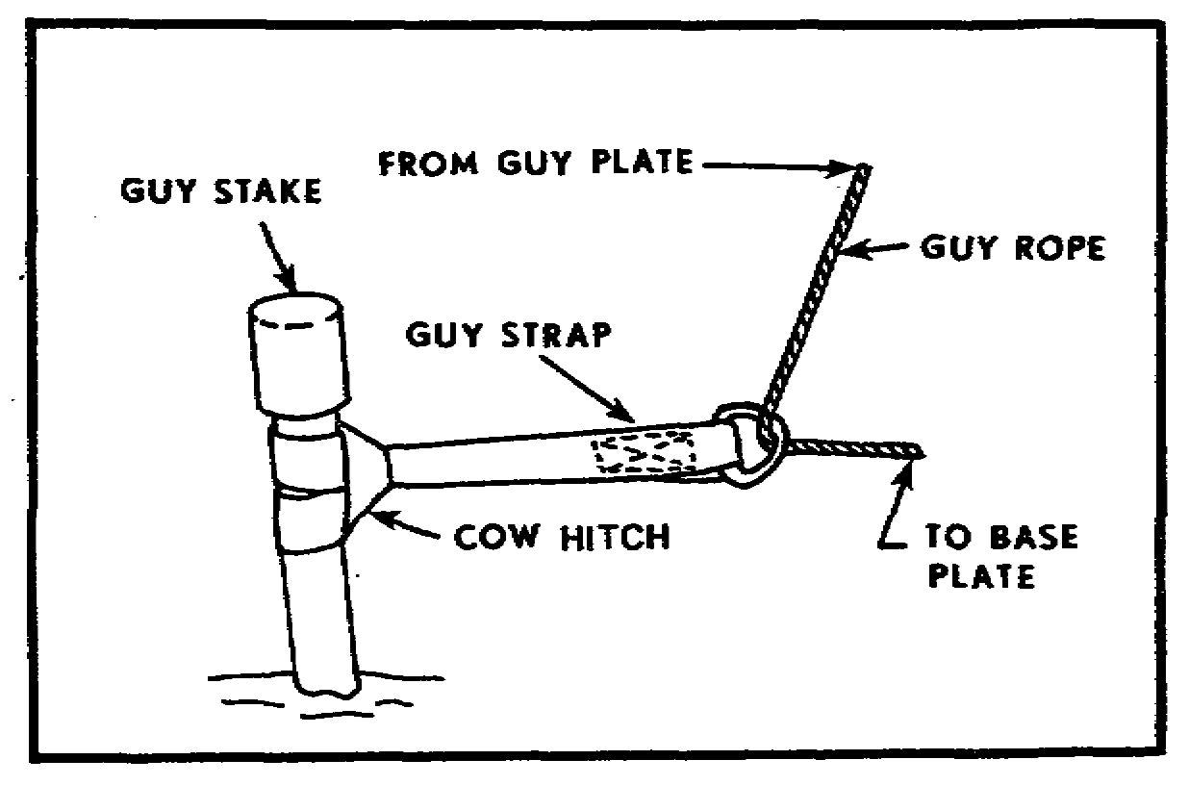
Figure 17. Attaching guy strap to guy stake.

(6) With the assembled antenna still on the ground, turn the upper and lower guy plates until one hole is up. (This aligns the guy plates with the baseplate and the guy stakes, making it easier to erect the antenna.)

(7) Attach guy ropes to the side holes of the lower and upper guy plates. Pass these ropes through the D-rings of the guy straps (Fig 17) and then through the holes in the baseplate.

(8) Form a slip knot in each guy rope, and pull the free end through the slip knot as shown in Figure 18. (When tied in this manner, each guy rope can be pulled as taut as desired.)

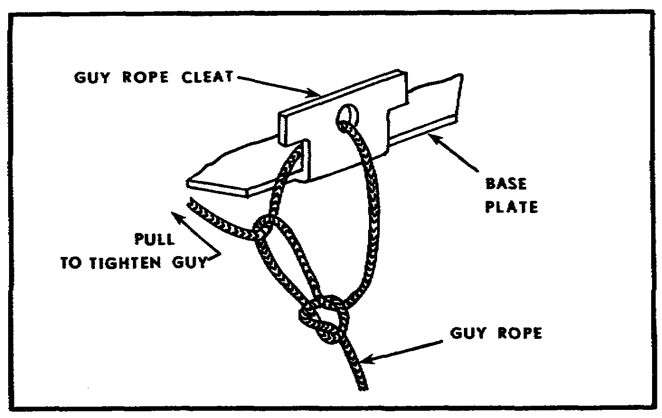
Figure 18. Slip knot for tying guy rope.

25

(9) Pull ropes tight, and fasten them to the baseplate cleats with a hitch (Fig 19).

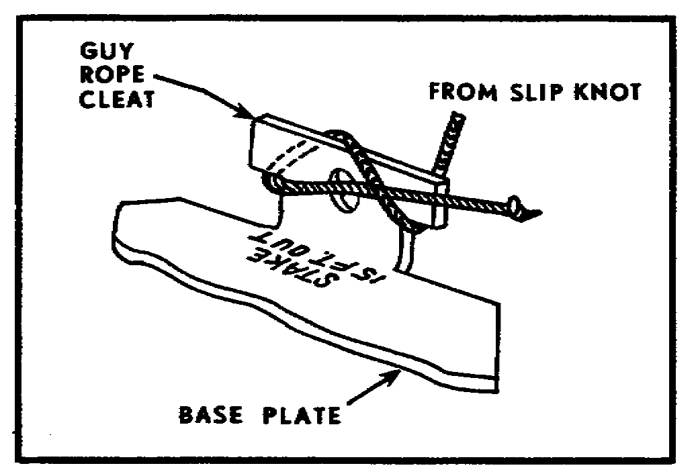
Figure 19. Hitch for securing guy ropes.

(10) Now, move the assembled mast against the opposite cleat of the baseplate, and repeat steps 7 through 9 with two more guy ropes.

(11) Snap the third set of guy ropes into the third hole in the upper and lower guy plates, and lay the ropes along the mast toward the third guy stake.

c. Antenna elements required.

(1) Determine operational frequency for the radio station.

(2) Using Table 1 (or chart in TM 11-5820-348-15), page 24), select the number of antenna elements required for the vertical antenna element and the three ground-plane elements.

Table 1. Antenna and ground-plane elements.

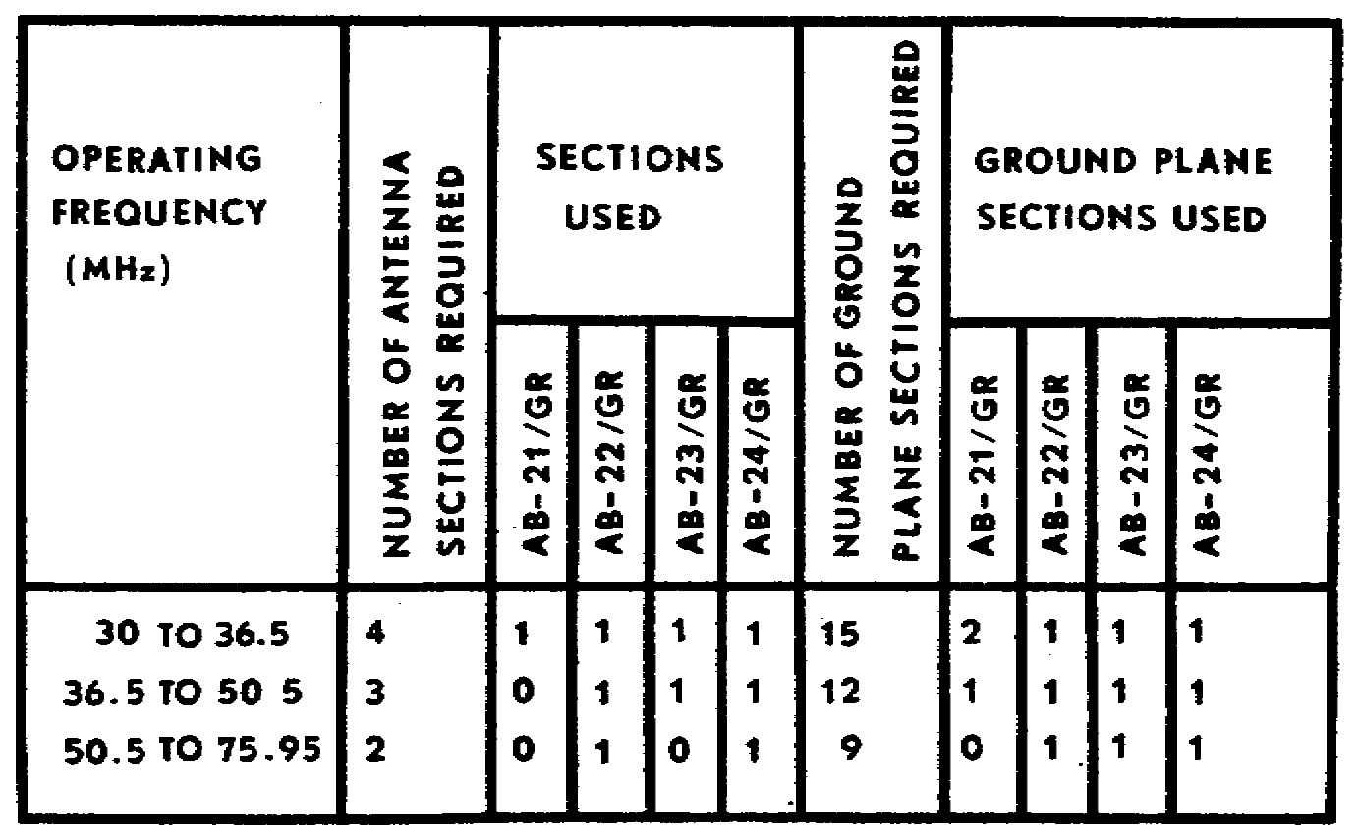

26

d. Complete antenna assembly.

(1) Place antenna base MP-68 over the top mast base section of the assembled mast. Tighten the vice to secure the base to the mast.

(2) Assemble the vertical antenna radiating element by screwing together the correct number of antenna sections, as determined from Table 1.

(3) Insert the assembled vertical radiating element into the socket at the top of antenna base MP-68.

(4) Assemble three ground-plane elements with the correct number of antenna sections, as determined from Table 1.

(5) Connect adapter UG-255/U to plug PL-259-A on the cable assembly CG-107/U (Fig 20).

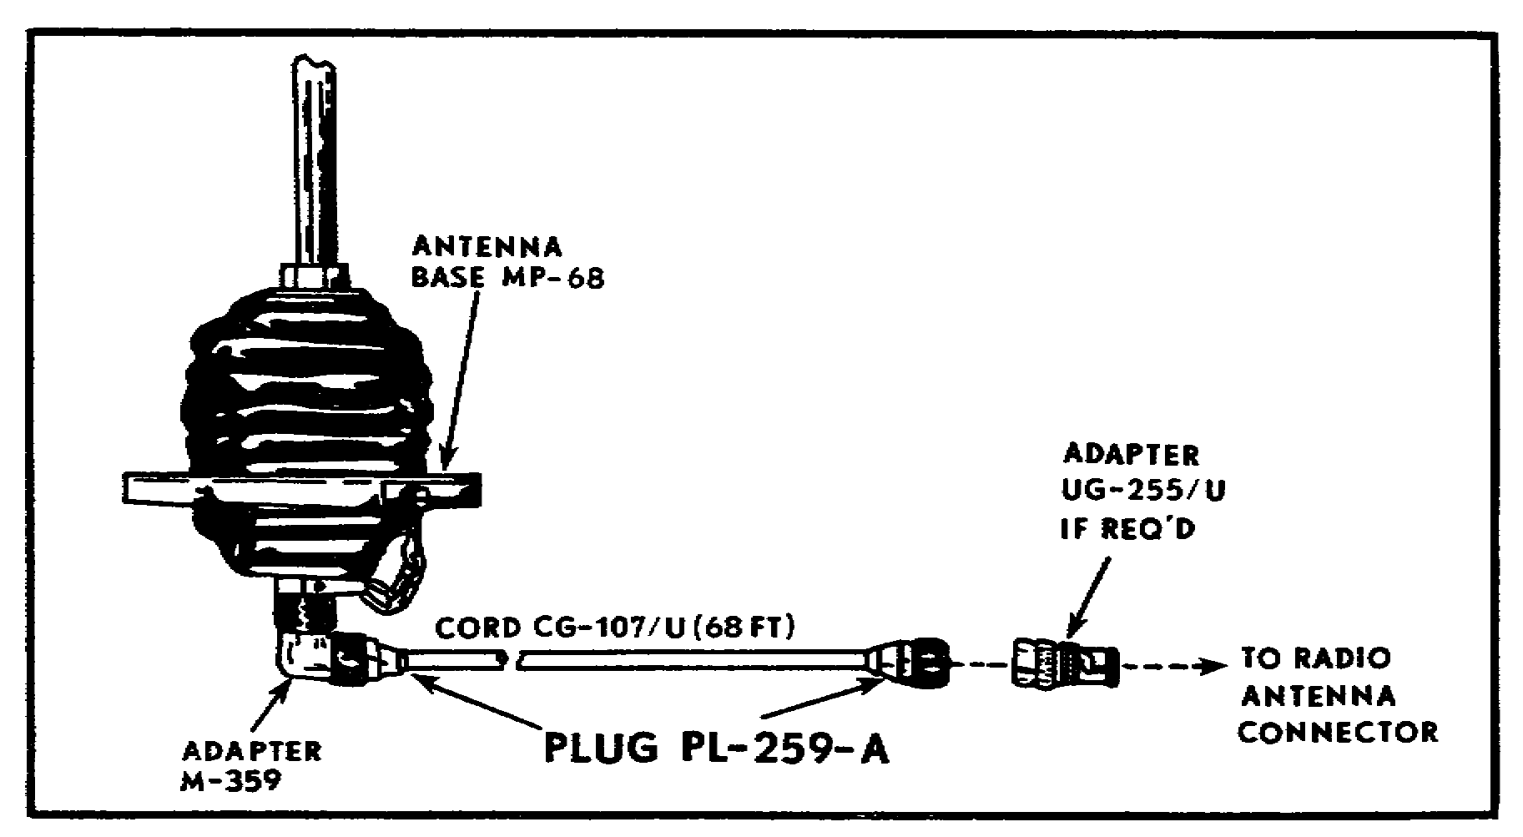
Figure 20. Connecting cord CG-107/U to MP-68.

(6) To connect cord CG-107/U to the antenna base, screw plug PL-259-A (on the cord) into adapter M-359 on the bottom of the antenna base (Fig 20).

(7) Relieve any strain on the cord plug and adapter by taping the cable assembly to the mast base with tape TL-83. Tape at 5-foot intervals down the mast.

(8) Insert the three assembled ground-plane elements into the sockets on antenna base MP-68.

27

14. ERECT THE ANTENNA MAST. Two soldiers, coordinating their movements, can erect the antenna as follows:

a. One soldier stands near the swivel stake and grasps the two free guy ropes (Fig 21).

b. The second soldier raises the top of the mast to shoulder level.

c. The first soldier bows the top end of the mast upward by pulling both guy ropes taut.

d. Pushing the antenna mast upward, the second soldier walks toward the baseplate. The first (coordinating his moves with the second) walks backward toward the third guy stake. While keeping tension on the guy ropes, the second soldier pulls the mast slowly and firmly erect.

e. When the mast is in a vertical position, the second soldier adjusts and tightens all guy ropes.

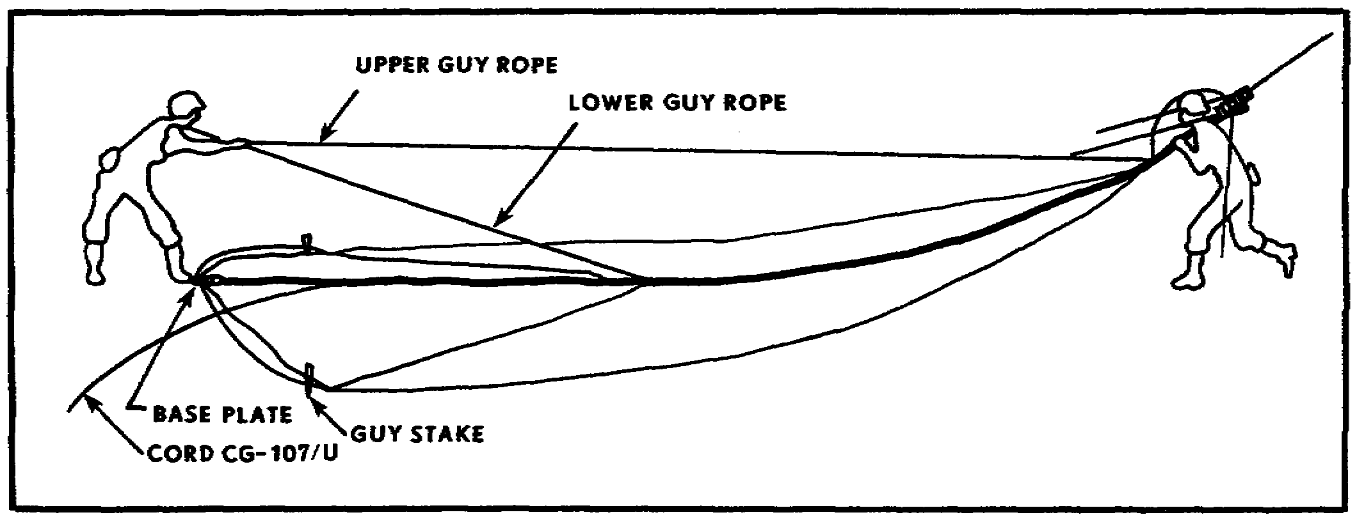
Figure 21. Erecting antenna equipment RC-292 with two men.

NOTE: If necessary, this antenna system can be assembled and erected by one person.

CAUTION

BE SURE THE RADIO SET IS OFF BEFORE MAKING ANY CONNECTIONS.

28

15. CONNECT ANTENNA TO RADIO. Once the antenna has been erected, connect it to the radio as follows:

CAUTION

DO NOT CONNECT ADAPTER UG-255/U TO THE ANTENNA MATCHING UNIT.

• Connect adapter plug UG-255/U to the 20-meter coaxial cable CG-107/U. Connect the adapter to the antenna connector at the radio set.

• For radios provided with antenna AS-1729 or AT-912, connect the adapter UG-255 directly to the antenna connector at the radio set.

16. LOWER AND DISASSEMBLE ANTENNA. Disconnect the antenna from the radio set. Loosen one set of guy ropes (upper and lower). One soldier lowers the antenna while a second is positioned under the antenna mast to assist in lowering it to the ground. Reverse the assembly procedure. Clean the components, and return them to the canvas carrying bag. Figure 22 pictures the antenna equipment packed in the bag.

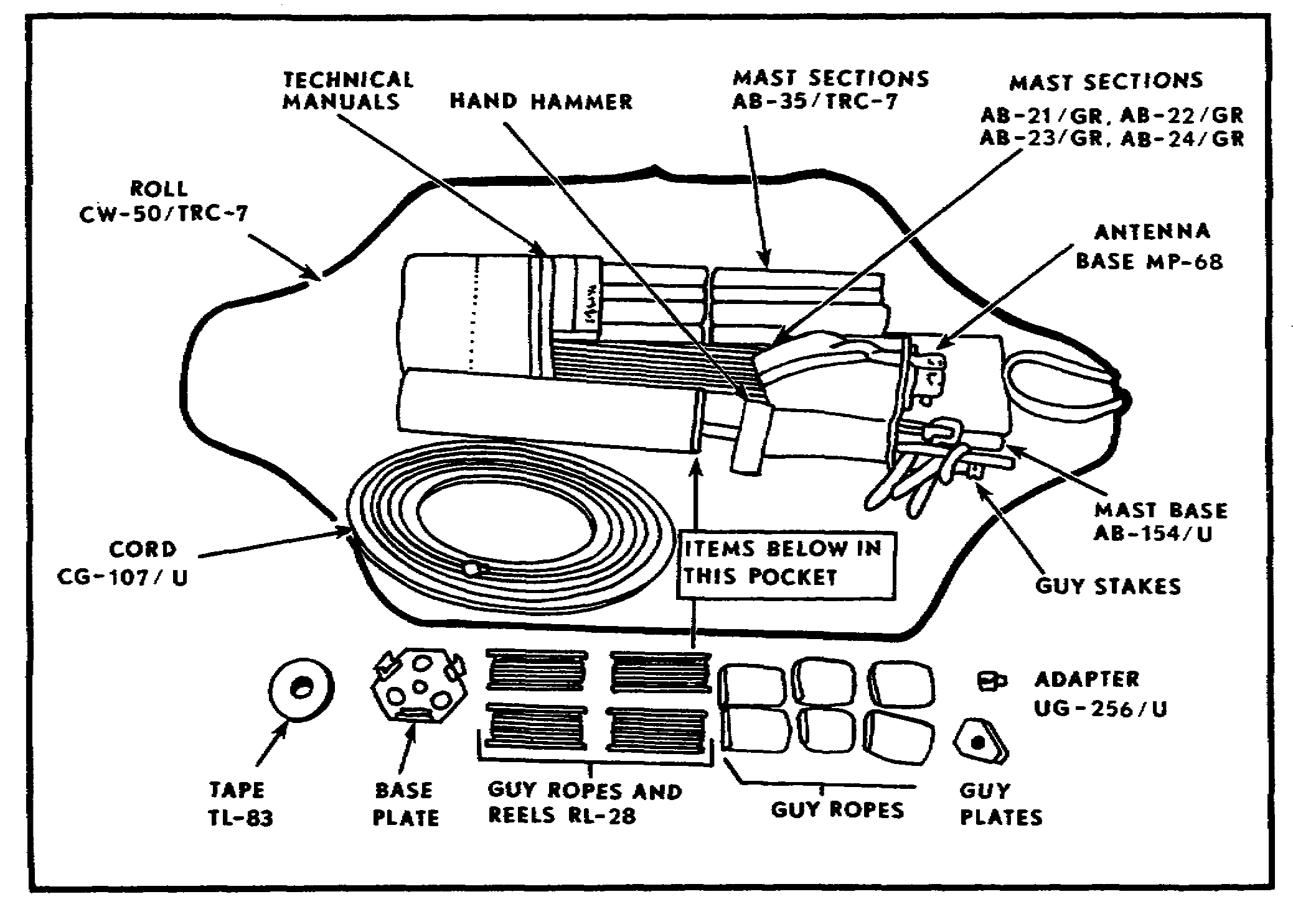
Figure 22. Antenna equipment RC-292 packed in bag.

29

17. OPERATOR CHECKS AND SERVICES. A record of operator/organizational services is kept on DA Form 2404.

a. Operator maintenance. The operator's maintenance of the RC-292 consists primarily of checking the equipment for completeness, checking for correct installation, cleaning the equipment, painting components that have painted surfaces, and examining the components for serviceability. Checks and services that must be accomplished daily are found in TM 11-5820-348-15, paragraph 3-5. Weekly services include the daily service plus the weekly services found in TM 11-5820-348-15, paragraph 3-6. (These paragraphs are reproduced as Tables 2 and 3.)

Table 2. Operator's daily PM checks and services.

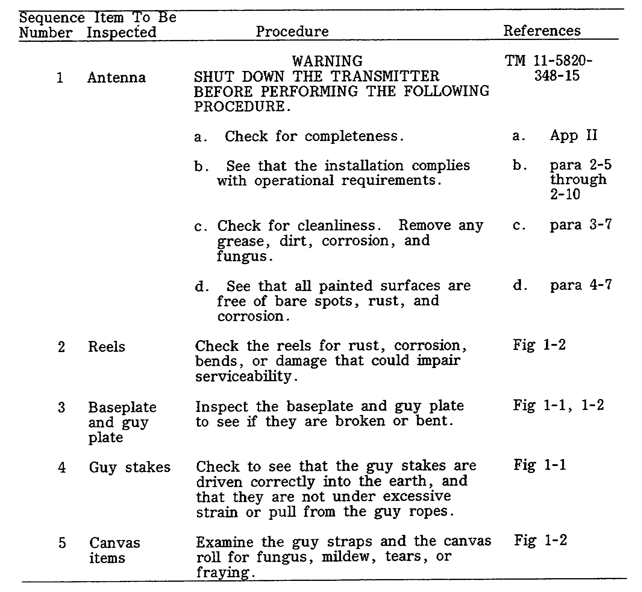

30

Table 3. Operator's weekly PM checks and services.

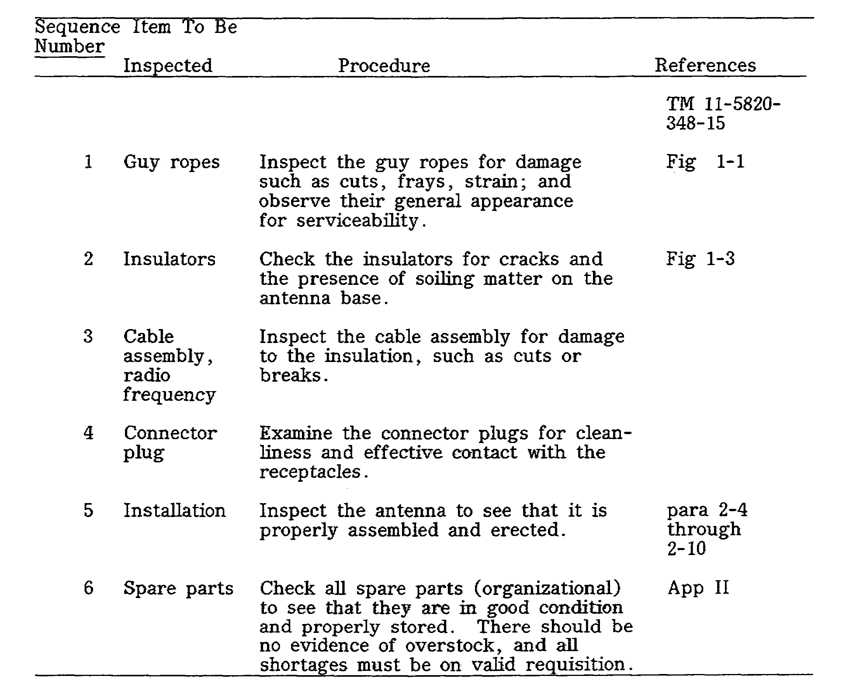

b. Organizational maintenance. TM 11-5820-348-15, Chapter 4, contains the quarterly organizational preventive maintenance (PM) checks and services. Equipment operators assist organizational maintenance personnel in performing quarterly services (TM 11-5820-348-15, para 4-4). Quarterly services usually are performed in conjunction with a scheduled weekly service.

31

Table 4. Organizational quarterly PM checks and services.

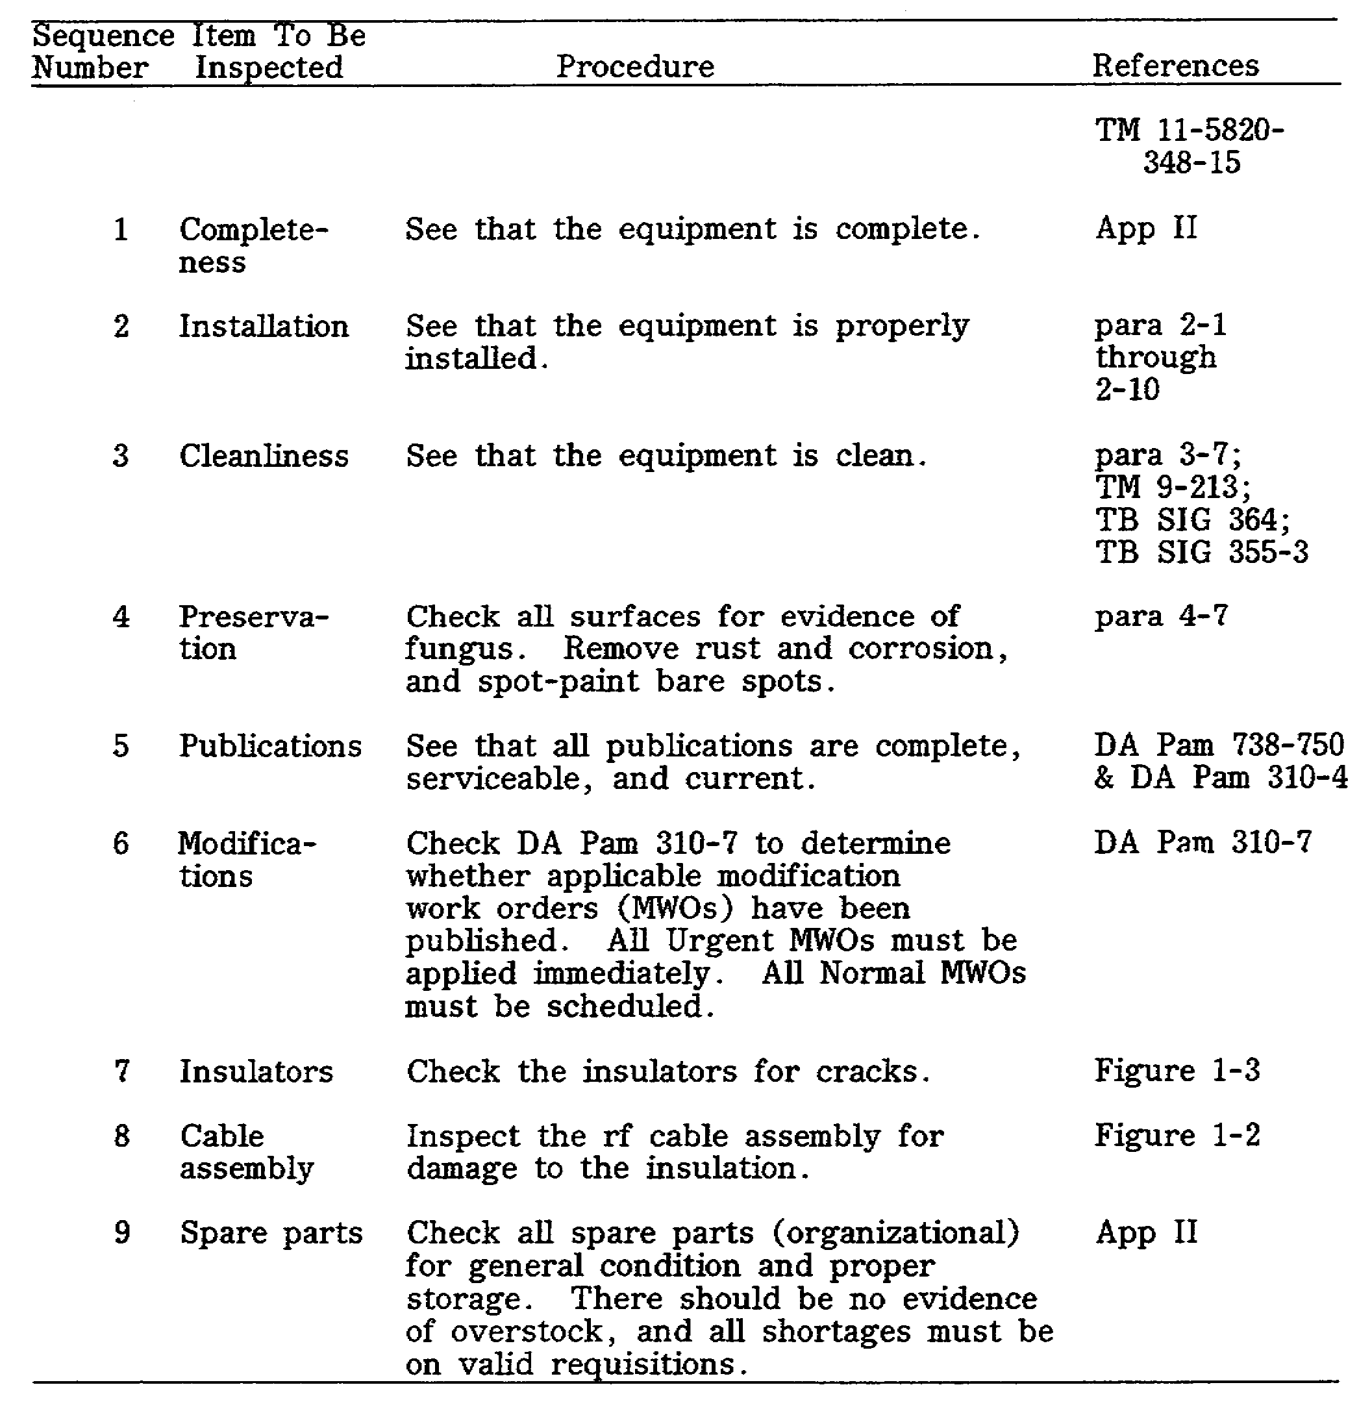

32

18. ANTENNA GROUP OE-254/GRC. The antenna RC-292 is being replaced by antenna group OE-254. Antenna group OE-254/GRC (Fig 23) is an omnidirectional, biconical antenna designed for broad hand operation without field adjustment in the frequency range from 30 to 88 MHz. The OE-254 can be used with all of the low- and medium-power field artillery radios. The sectionalized mast raises the antenna 10.3 meters (33'8") above the ground. With the antenna mounted, the overall height exceeds 12 meters. The antenna is connected to the radio by an 80 foot (24 meter) coaxial cable. The entire antenna group weighs about 44 pounds, is readily transportable, and can be erected by two trained personnel in 15 minutes.

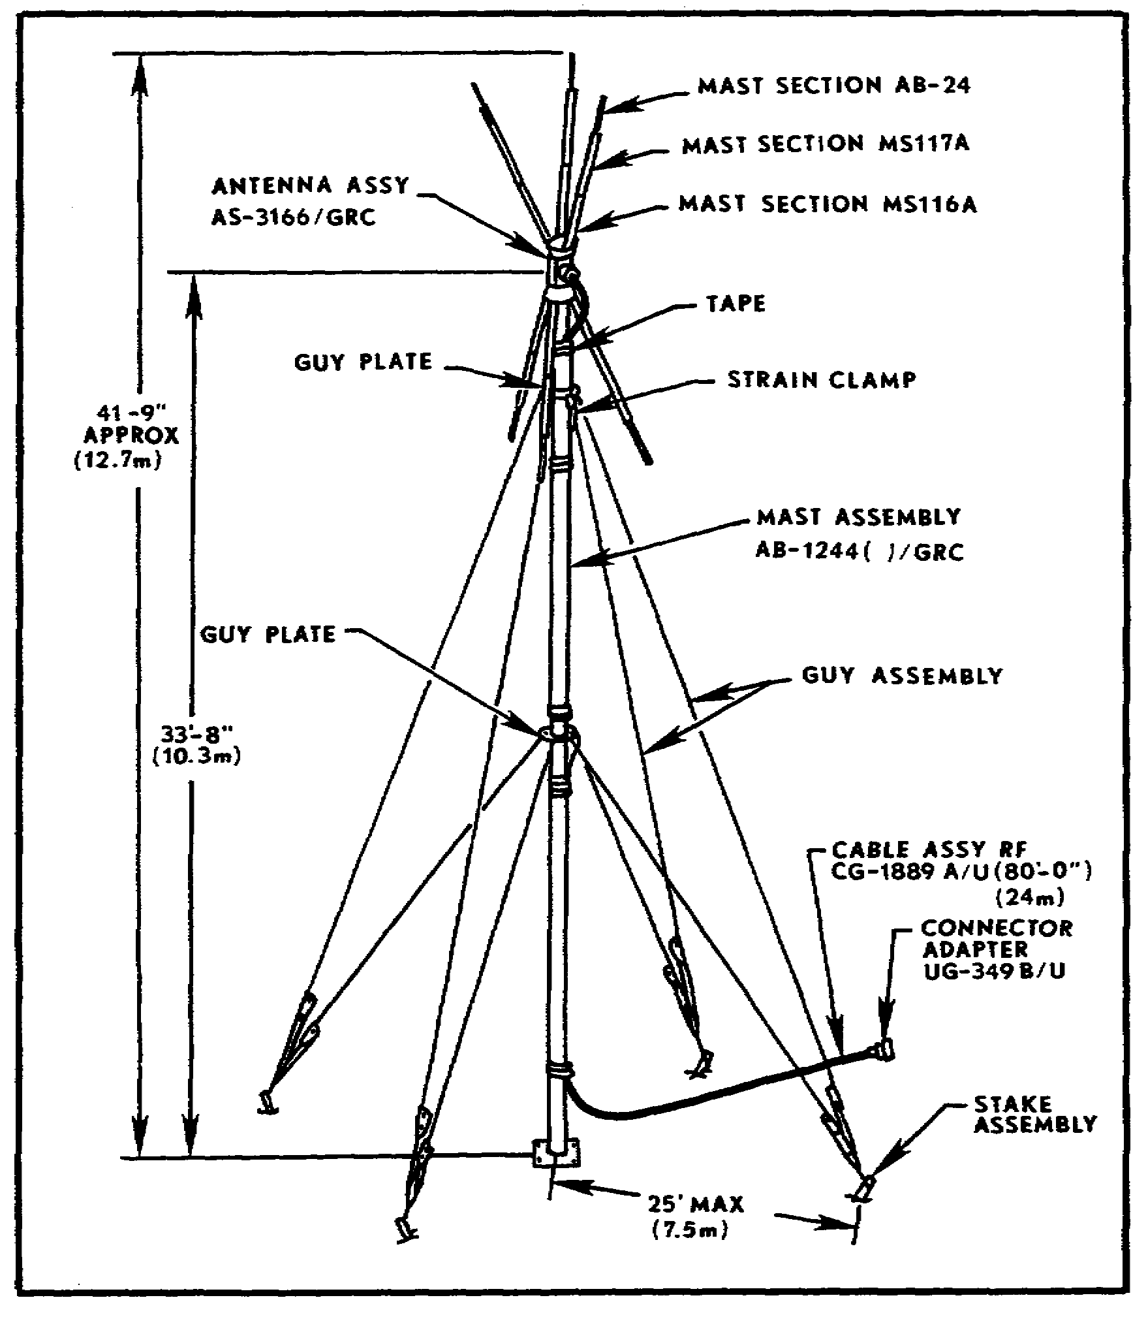
Figure 23. Antenna group OE-254/GRC.

33
19. ASSEMBLE ANTENNA EQUIPMENT. Before starting to assemble the antenna, the operator/user should be sure the antenna group is complete. TM 11-5985-357-13, Appendix B, contains a complete listing of the components. Figure 24 pictures the components and running spares.

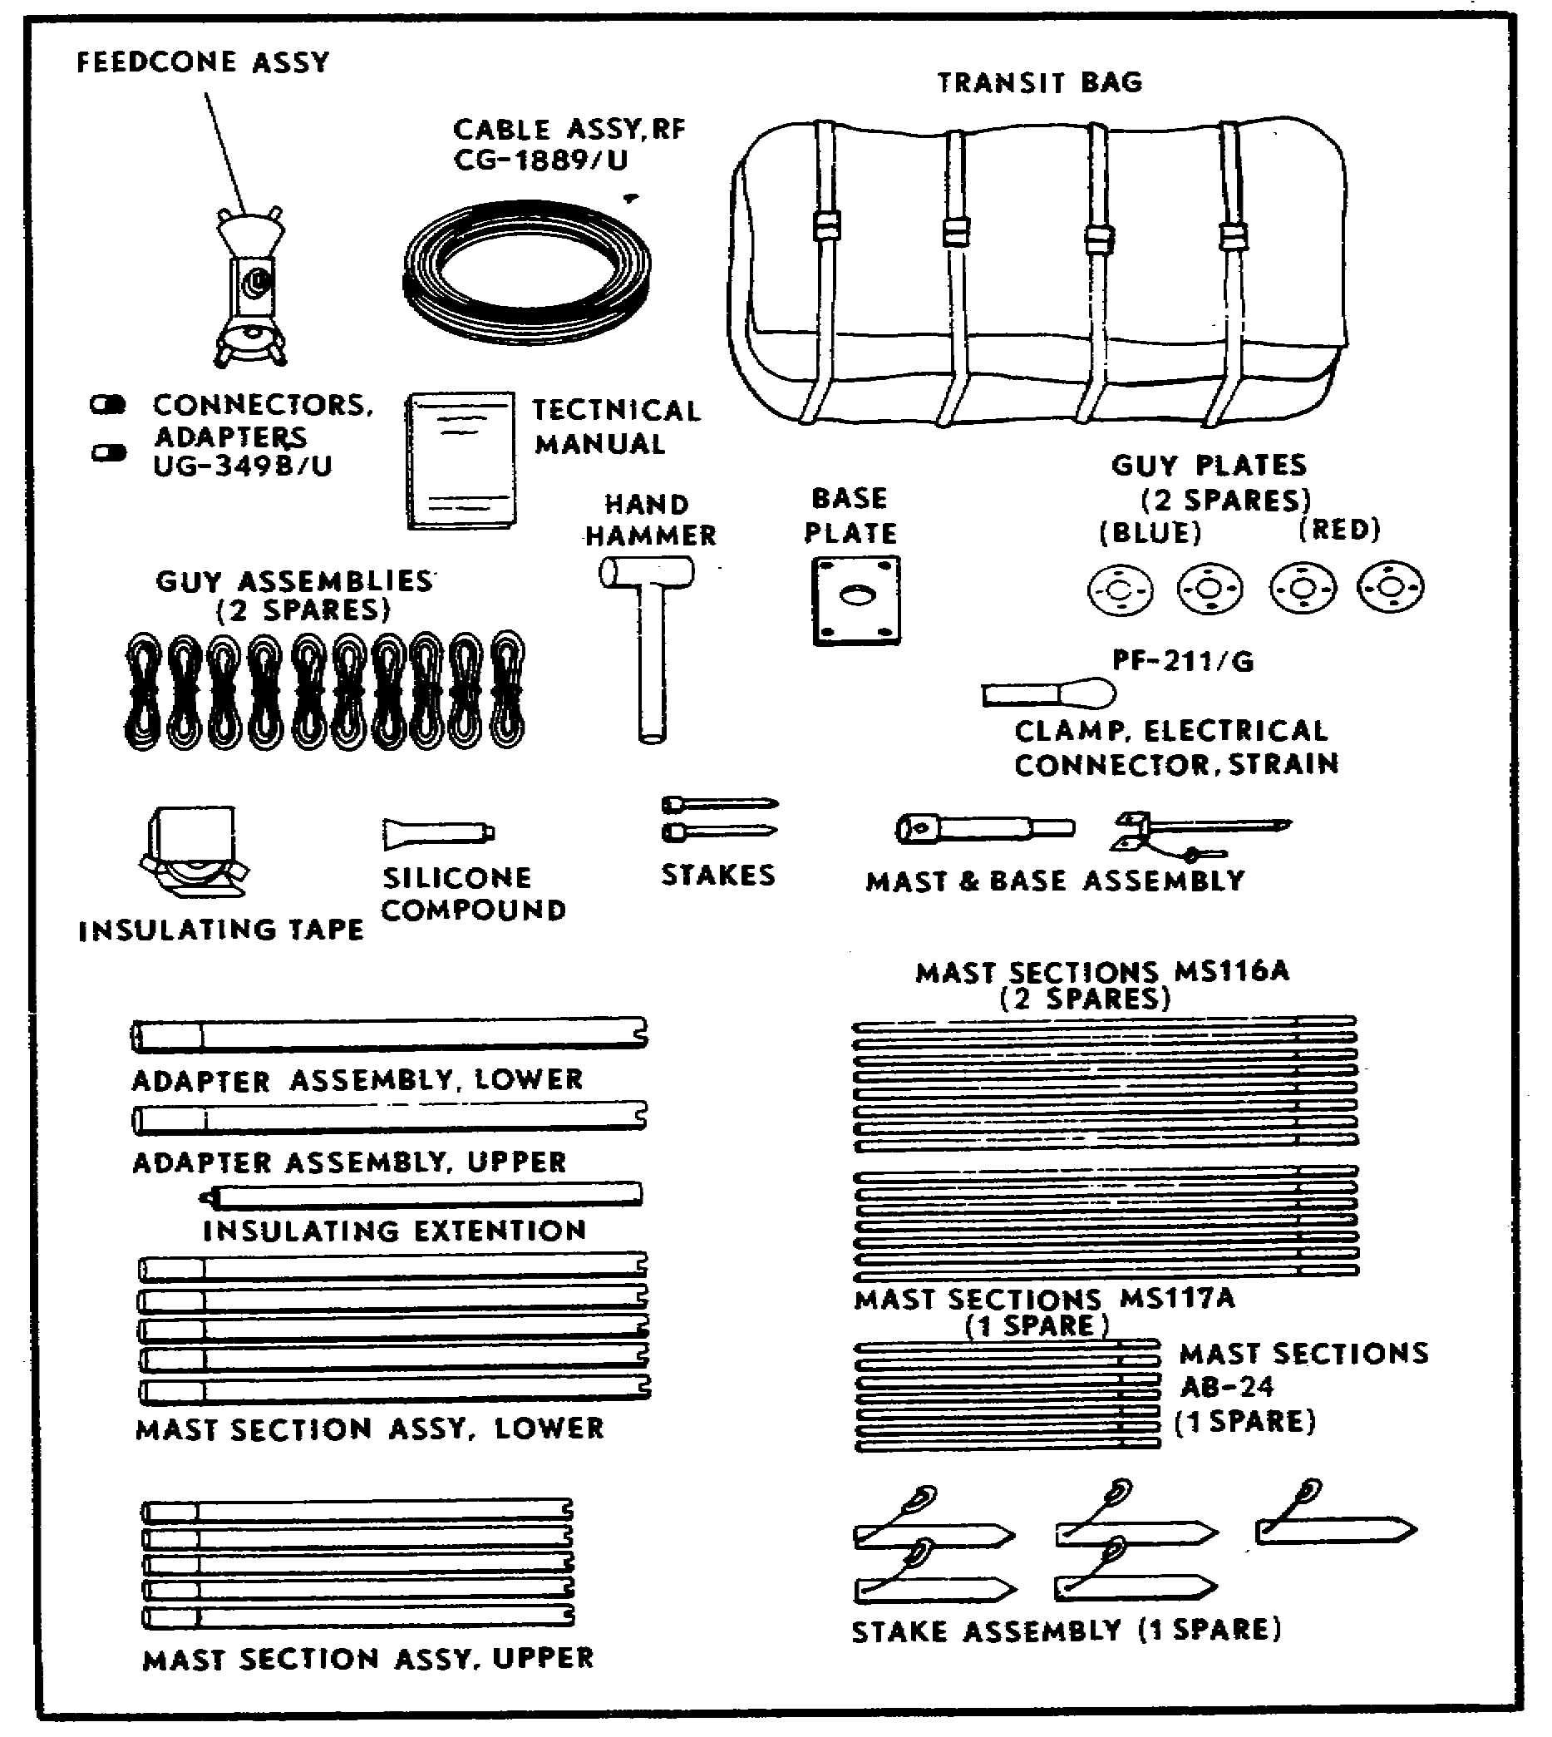
Figure 24. Antenna group OE-254, components and spares.

a. Position baseplate and guy stakes.

(1) Place the baseplate, with the ribs up, where the antenna is to be erected.

34

(2) Drive the mast and base assembly stake through the center hole of the baseplate. Assemble the mast base.

(3) Drive two pin stakes through opposite corner holes of the baseplate.

(4) Locate the position of the four guy stakes at a distance of 25 feet (7.5 meters) from the baseplate. Position the guy stakes 90° apart. Align the baseplate with two opposite stake assemblies.

(5) Assemble five lower mast sections, the lower adapter assembly, and three upper mast sections. These give you a 25-foot (7.5 meters) measuring device to use to position guy stakes.

(6) Drive the guy stakes at a 60° angle into the earth facing away from the mast. Notice that these stakes include an anchor hook and cable.

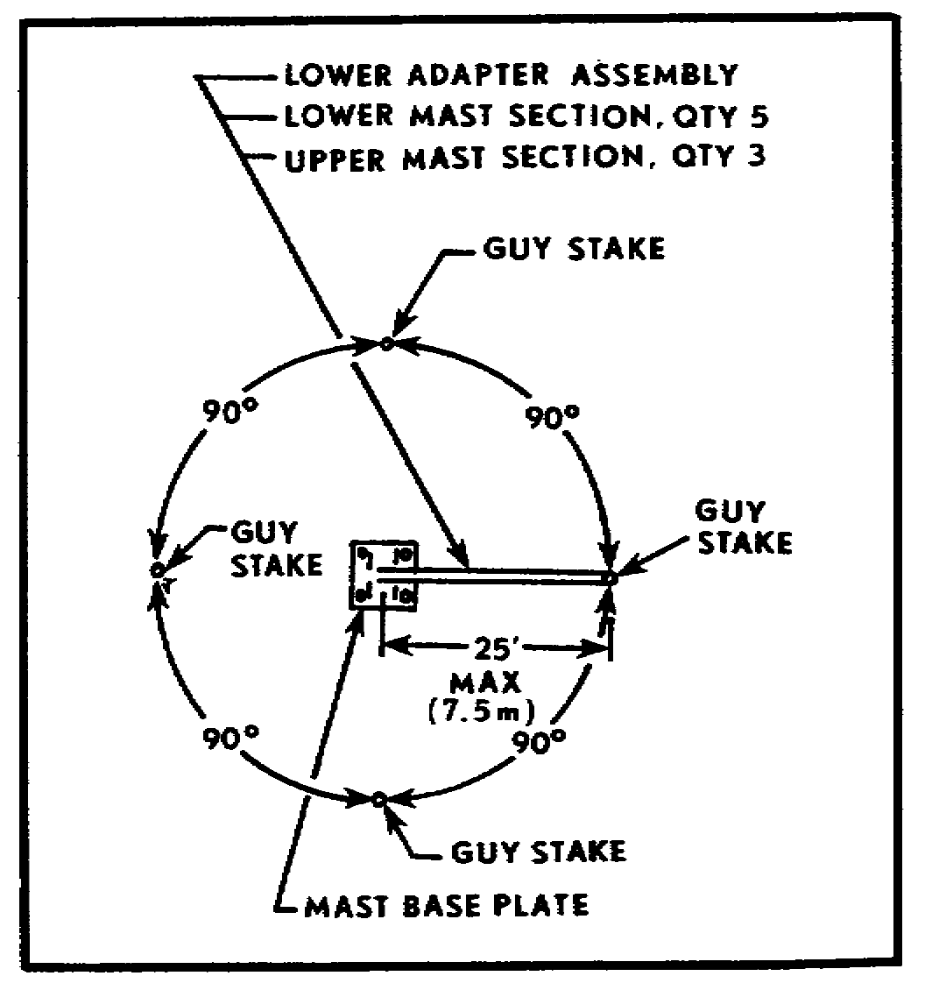
Figure 25. Positioning guy stakes.

b. Assemble the mast. On the ground, assemble mast toward one guy stake (back guy stake).

(1) Assemble five lower mast sections by inserting the keyed male ends into the keyed female ends. Place the bottom section over the moveable portion of the mast base assembly.

(2) Slide a blue guy plate onto the male end of the lower adapter assembly. Assemble to the five lower mast sections.

35

(3) Assemble the five upper mast sections and join them to the previously assembled lower mast section.

(4) Slide a red guy plate onto the male end of the upper adapter assembly. Attach to assembled mast.

(5) Turn the guy plates so that one hole of each is uppermost.

(6) Attach the blue guy hooks of the four lower guy ropes to the holes in the lower guy plate (blue).

(7) Extend the guy ropes to the anchor assemblies (on the guy stakes) and attach the free end guy loop of the guy snubber to the anchor hooks (Fig 26). When attached this way, each guy rope can be pulled taut by lengthening the guy loop.

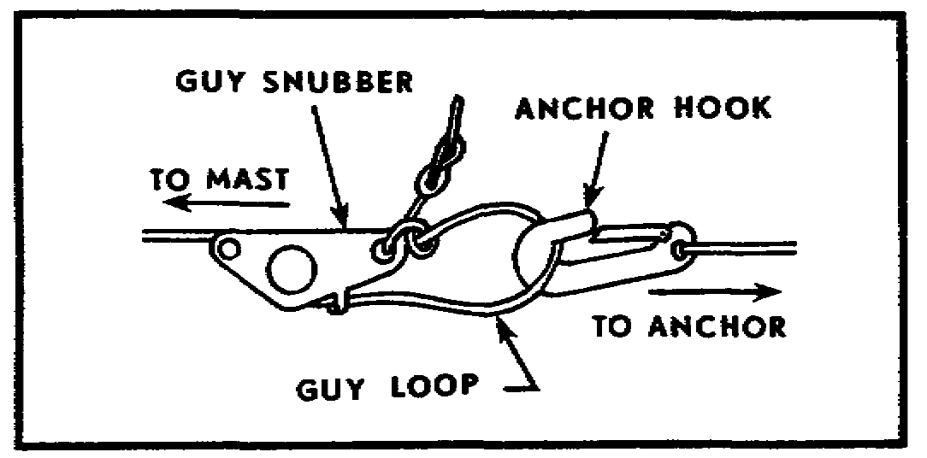
Figure 26. Guy attachment to guy anchor.

(8) Attach the upper guy ropes (red) to the upper guy plate (red) and to the anchor assemblies.

(9) Pull the four side guy ropes (two upper and two lower) taut, and secure them (Fig 27 (A)).

• Remove guy from snubber lock (Fig 27 (B)).

• Pull snubber along guy toward the mast (Fig 27 (C)).

• Secure guy by looping under the snubber lock (Fig 27 (A)).

36

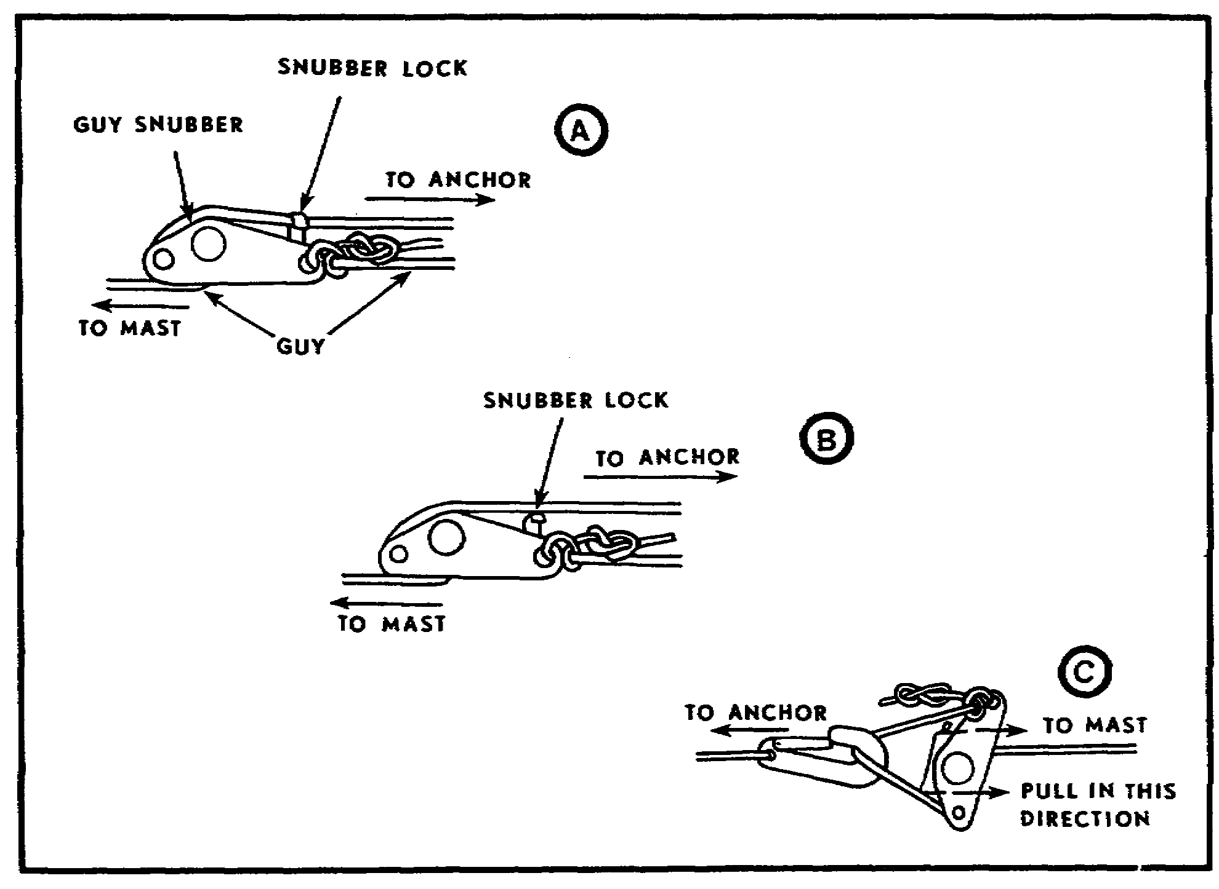
Figure 27. Pulling guy ropes taut.

(10) Lay the two bottom guy ropes (upper and lower) along one set of taut guy ropes, and adjust to the same length.

(11) Attach the remaining guy ropes to the back guy stake.

37

c. Assemble the antenna AS-3166/GRC. The antenna (Fig 28) mounts on top of the assembled mast.

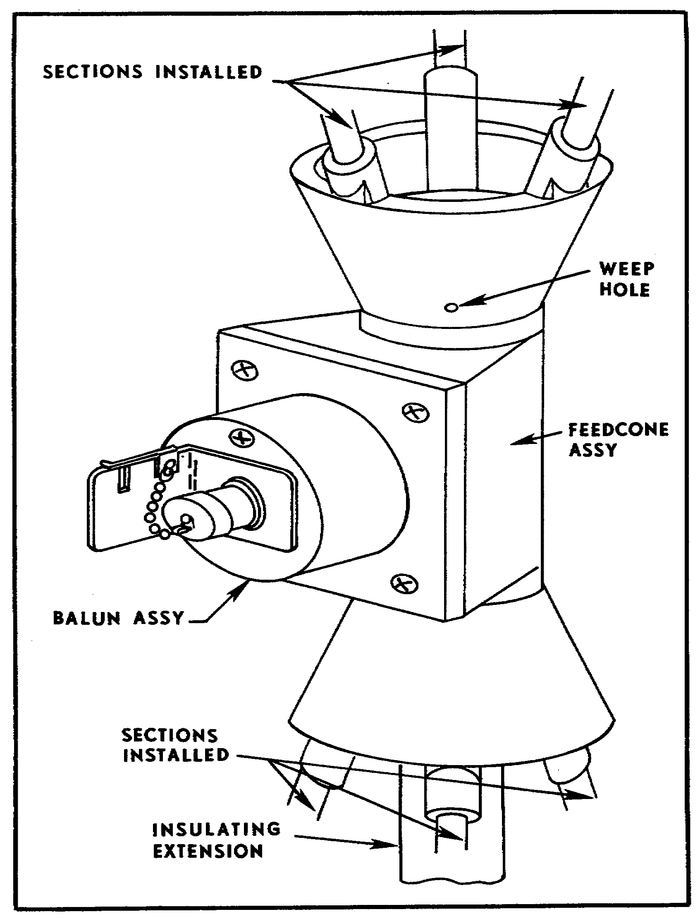
Figure 28. Antenna AS-3166/GRC.

38

(1) Coat the insulating extension screw (Fig 28) thread with silicone compound. Screw the extension into the feedcone assembly (Fig 28), and assemble to the mast.

(2) Coat the threads of mast sections AB-24, MS-117A, and MS-116A with silicone. Assemble six mast sections (1 each AB-24, MS-117A, and MS-116A in each section).

(3) Attach the six antenna elements to the feedcone assembly by screwing the male end of the MS-116A into the female sockets-on the feedcone assembly.

d. Connect feedcone assembly.

(1) Unscrew the connector cap of the feedcone assembly connector (Figs 28 and 29), and secure the cap in the slot (Fig 29).

(2) Connect cable assembly, CG-1889A/U to the feedcone assembly by screwing the cable connector into the connector on the feedcone assembly.

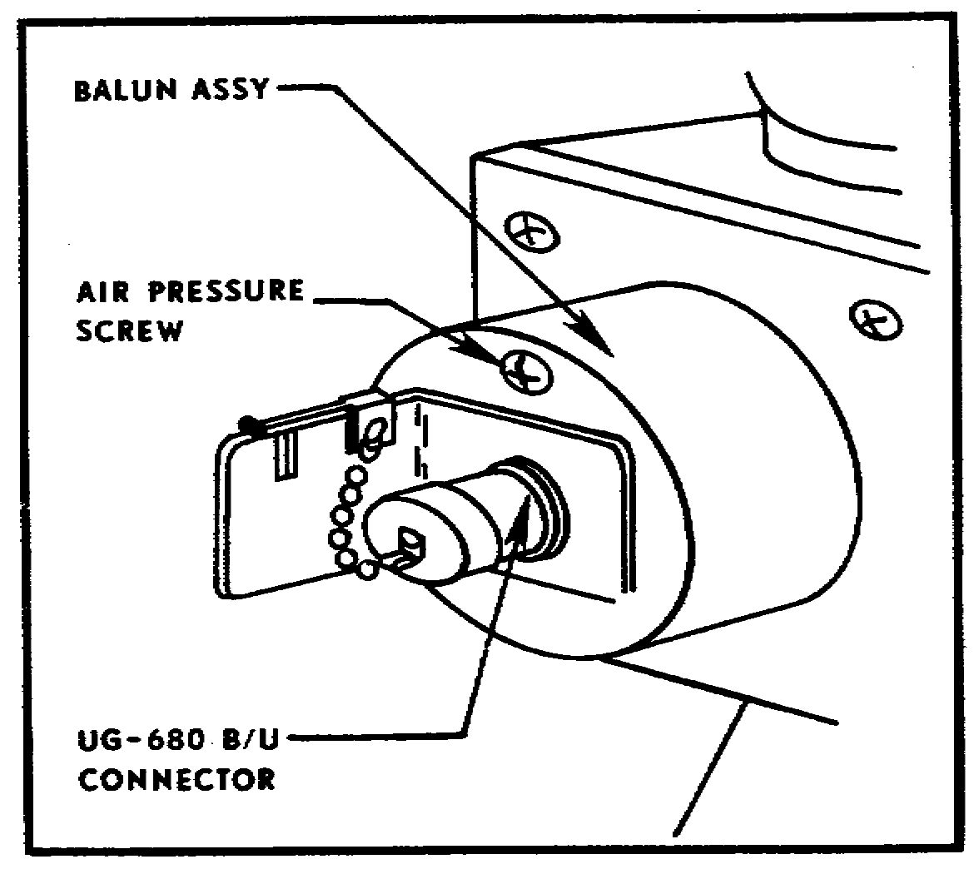
Figure 29. Feedcone assembly connector cap.

(3) Relieve strain on the fittings and the cable connector by attaching the strain relief clamp (Fig 30) through the fifth hole of the upper guy plate and by attaching it to the cable CG-1889A/U (Fig 30).

39

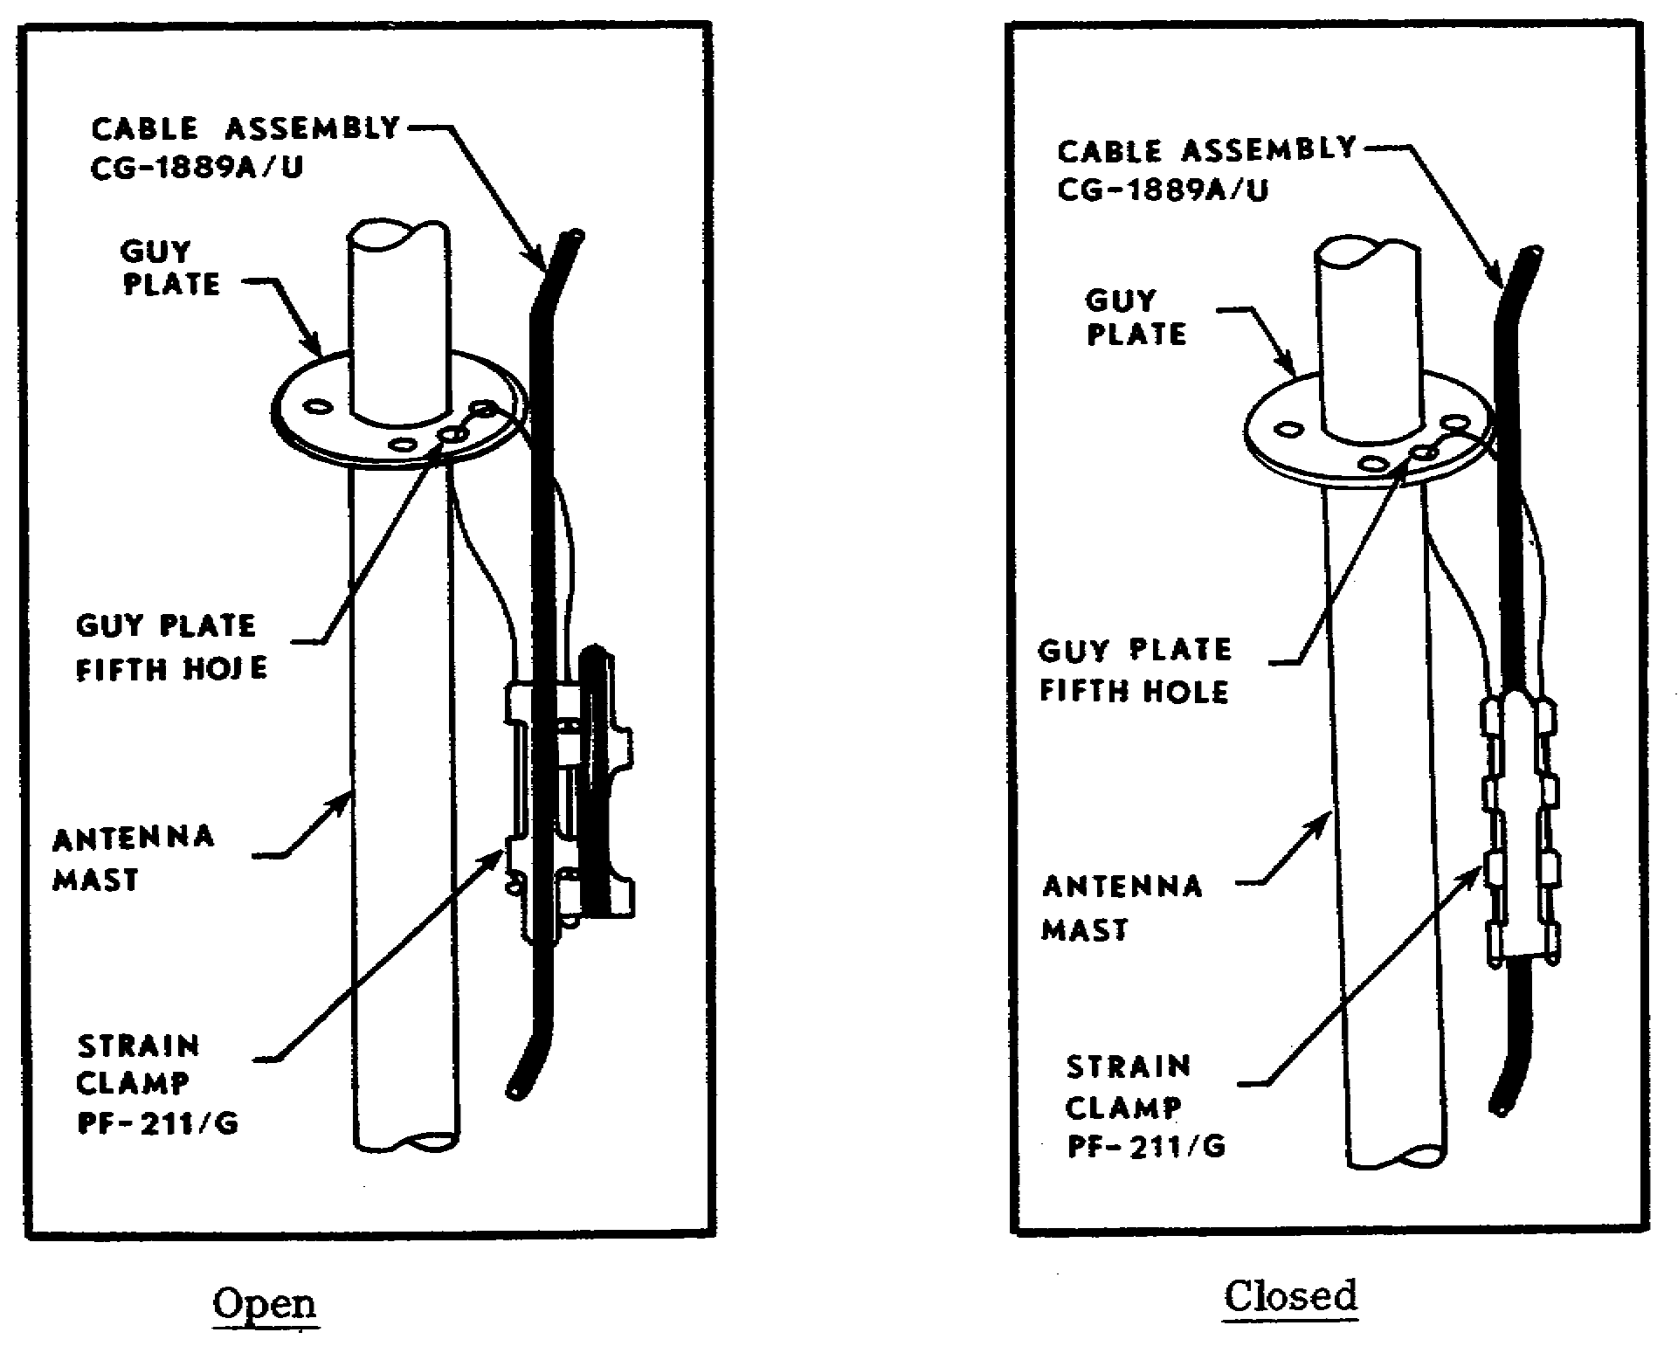
Open Closed
Figure 30. Strain clamp.

(4) Additional strain relief can be provided by taping the cable assembly to the mast just below the feedcone assembly and at 5-foot intervals down the mast.

40

20. ERECT THE ANTENNA. The antenna can be erected (or lowered) by two soldiers in the same manner as the RC-292 (Fig 31).

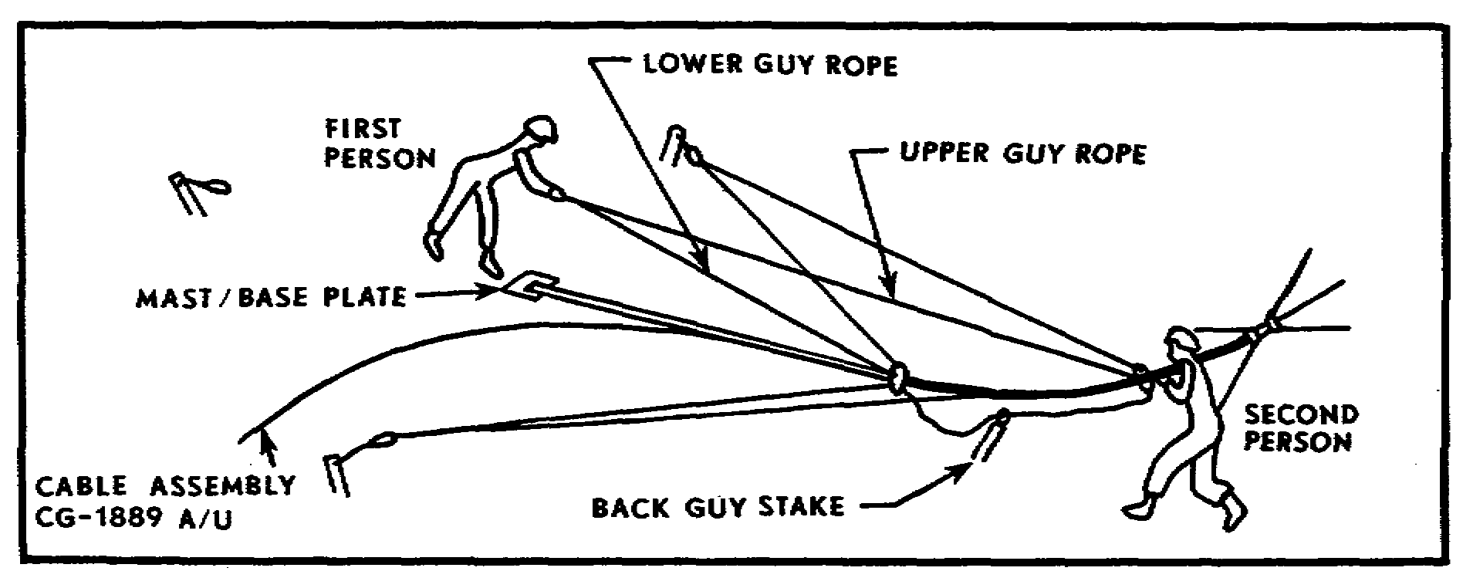
Figure 31. Erecting antenna group OE-254 with two soldiers.

21. CONNECT TO RADIO SET. Connect the cable assembly CG-1889A/U to the antenna connector at the radio set. (Use connector adapter UG349B/U as the interface between CG-1889A/U and radios equipped with a BNC-type connector.)

NOTE: Operator checks and services on antenna group OE-254/GRC are similar to those on antenna RC-292 (para 16). For further information on antenna group OE-254/GRC, see TM 11-5985-357-13, Chapters 3 and 4.

41

SELF-EVALUATION:

1. Energy radiated from an antenna is referred to as--

a. wavelengths.
b. wave pulses.
c. radio waves.
d. direct waves.

2. Long-range communication is made possible by use of the--

a. ground wave.
b. direct wave.
c. sky wave.
d. surface wave.

3. Electrical energy is carried from the transmitter to the transmitting antenna by means of a--

a. counterpoise.
b. transmission line.
c. modified ground plane.
d. coupling device.

4. One important characteristic of a vertical antenna is that it--

a. radiates in one direction only.
b. is horizontally polarized.
c. is omnidirectional.
d. has a 180-degree radiation pattern.

5. One important characteristic of a horizontally mounted, half-wave antenna is that it is--

a. omnidirectional.
b. monodirectional.
c. vertically polarized.
d. bidirectional.

6. A counterpoise is commonly referred to as--

a. earth ground.
b. artificial ground.
c. chassis ground.
d. vehicular ground.

7. Communication between most field artillery tactical radio sets is accomplished by using--

a. sky-wave propagation.
b. skip-zone propagation.
c. ground-wave propagation.
d. skip-wave propagation.

42

8. Antenna equipment RC-292 is a--

a. half-wave antenna.
b. horizontal antenna.
c. modified ground-plane antenna.
d. a highly directional antenna.

9. No antenna should be erected closer than _______ times its height from power lines.

a. five
b. four
c. three
d. two

10. A 20-meter coaxial cable is used as the transmission line for the--

a. antenna equipment RC-292.
b. antenna AT-984A/G.
c. antenna group AN/GRA-50.
d. antenna group OE-254/GRC.

11. The vehicle-mounted, whip antenna is a ____________-wave antenna.

a. quarter
b. half
c. three-quarter
d. full

12. A wavelength is the distance in meters traveled by a wave during a time interval of--

a. one second.
b. a few seconds.
c. one-half cycle.
d. one complete cycle.

13. The transmitting antenna of a radio set broadcasts radio frequency waves which are made up of two fields of force. The field which transmits the signal is the--

a. induction field.
b. radiation field.
c. electrical field.
d. magnetic field.

14. The purpose of grounding a quarter-wave antenna is to--

a. provide stability for the antenna mount.
b. decrease the power demand on the transmitter.
c. reduce excessive voltage at the antenna.
d. give it the electrical length of a half-wave antenna.

43
15. When properly installed, the long-wire antenna AT-984A/G is--

a. one-quarter wavelength long.
b. one-half wavelength long.
c. 150 feet long.
d. 75 feet long.

////////////////////////////////////////////////////////////////////////////

ANSWERS:

1. c.
2. c.
3. b.
4. c.
5. d.
6. b.
7. c.
8. c.
9. d.
10. a.
11. a.
12. d.
13. b.
14. d.
15. c.

////////////////////////////////////////////////////////////////////////////

22. SUMMARY. This lesson has considered the fundamentals of antenna theory (radiation, polarization, and wave propagation). By understanding these basic theories, you will be better able to site your antennas and gain optimum use of your radios. As units become more mobile and battlefield frontages expand, the field artilleryman will depend more and more upon radio communications to coordinate fire support activities and to bring steel onto the target.

Additionally, this lesson has discussed the installation, use, and operation of three antenna systems (AT-984A/G, OE-254, and RC-292) available to the field artillery to extend the range of the low- and medium-power FM radios authorized by current tables of organization and equipment.

The antenna AT-984A/G is a long-wire, end-fed, directional antenna available to forward observers and others who require directional, point-to-point radio communication.

Antenna equipment RC-292 is an elevated, wide-band, modified ground-plane antenna designed to increase the range of FM tactical radio sets by 50 to 200 percent. RC-292 is especially useful because it is omnidirectional (all direction transmitting and receiving). The OE-254 antenna group will eventually replace RC-292 in the Army inventory.

All these antennas are portable and easily installed by one or two persons in a short period of time.

44
Lesson 2

FIELD-EXPEDIENT ANTENNAS

OBJECTIVE

Upon completion of this lesson, you will be able to--

• Compute the physical length of antennas for various broadcast frequencies.

• Repair broken antennas.

• Fabricate, install, and use field-expedient antennas.

REFERENCES

This lesson is based on FM 24-18, FM 24-1, FM 6-10, and other materials approved for US Army field artillery instruction; however, development and progress render the text continually subject to change. Therefore, base your examination answers on material presented in this text rather than on individual or unit experiences.

23. INTRODUCTION. For short- and medium-range communication, most communicators have available medium-power, vehicle-mounted, FM radios equipped with whip antennas. Low-power FM radios with quarter-wave whip antennas are available to some communicators who require smaller, portable radio equipment (forward observers and surveyors). When longer range radio communication is required, antenna equipment (RC-292 and OE-254) and/or antenna AT-984A/G are authorized in the TOE and are generally readily available. This equipment satisfies most communication requirements. But, in the heat of combat, whip antennas can be broken, and RC-292s and OE-254s can be destroyed by enemy counterfire. While replacement items may not be immediately available, the need to communicate will continue. Jump command posts, split battery operations, and reconnaissance of new position areas are but a few of the tactical operations which necessitate reallocation of items of radio equipment and strain the ingenuity of commanders to maintain adequate communication. Knowledge of how to repair antennas or to fabricate field-expedient antennas is a necessary part of the knowledge needed by lieutenants who must communicate under even the most rigorous conditions imposed by combat.

24. FIELD EXPEDIENTS. Field expedients are active measures that have been developed by resourceful individuals in the field to overcome problems that develop under field (tactical) conditions. The primary interest is to get the job done with improvised methods and materials when standard equipment is inoperative or not readily available. Communications personnel should learn to recognize the need for, and the use of, field expedients in establishing and maintaining radio communications.

a. Causes of poor communication. The use of a field expedient to correct poor radio communication must be preceded by an analysis of the cause. If the cause is continual failure of equipment, an aggressive preventive maintenance program is appropriate. If the cause is poor procedure or lack of knowledge

45

on the part of operators, a training program is needed. Field expedients are not a substitute for maintenance and training. If the cause for poor communications is some physical hindrance, a field expedient may correct the problem. Some problems which may indicate the use of field expedients are:

• Great distance between sets.

• Unfavorable terrain (mountains, hills, and dense foliage areas).

• Poorly chosen sites for antennas.

• Insufficient battery power.

• Noise and interference.

b. Operating hints. Frequently, these causes can be overcome by adjusting radio sets, or applying sound operating techniques. Common sense measures frequently preclude the use of more involved field expedients.

• When signals are weak, use a headset instead of a loudspeaker (this should reduce local noise).

• When transmitting, allow a few seconds for the transmitter to warm up before transmitting. Speak slowly, directly into the microphone.

• Ensure that battery voltage is normal. (It may be necessary to keep the vehicle running to maintain battery voltage.)

• Move the antenna. Frequently a move of only a few feet improves communications.

• Reorient the vehicle toward the distant station.

NOTE: The AN/VRC-12-series of radios uses center-fed, half-wave antennas which are not appreciably affected by the mass of a vehicle.

25. IMPROVISING ANTENNAS. If these hints do not improve communication, or if whip antennas have been broken, it may be necessary to improvise an emergency antenna. When preparing an expedient antenna, keep in mind:

• Copper or aluminum wire is the best for fabricating or repairing antennas. In an emergency, use whatever is available.

• The exact length of most antennas is critical. Fabricated antennas must have the same physical length as the antennas replaced.

• Improvised guys used to support antennas may affect antenna operation. To ensure that guy wires do not interfere with communication, cut them into several short lengths, and connect the pieces with insulators.

46

• It may be necessary to adjust the antenna height and/or length to ensure satisfactory communication.

NOTE: All you need to construct an expedient antenna is field wire WD-1/TT, insulators, a pair of pliers, some tape, and the wavelength formula.

26. COMPUTING WAVELENGTH. As previously mentioned, the length of the antenna is critical. Before considering the actual construction of expedient horizontal or vertical antennas, it is best to review wavelength. The operation and construction of all antennas is based on the principles of the fundamental antenna. The fundamental antenna consists of a single wire whose physical length is equal to one-half the full wavelength of the signal being transmitted. The wavelength is the distance between waves of energy leaving the antenna, and is computed using the following formula:

Wavelength (in meters)(L) = velocity (V)(in meters)
frequency (F)(in hertz)

a. Full-wave antenna. The velocity in this formula is the speed of radio waves (a constant 300,000,000 meters per second). For ease of computation, this figure is converted to 300 megahertz. (A frequency of 300 MHz is 300,000,000.) Frequency is also converted to megahertz (the standard graduation of the radio set band switch). The wavelength (Fig 32) at a frequency of 24 MHz is computed as L = 300 or L = 300 = 12.5 meters.
F(MHz) 24
Therefore, a full-wave antenna broadcasting at a frequency of 24 MHz is 12.5 meters long.

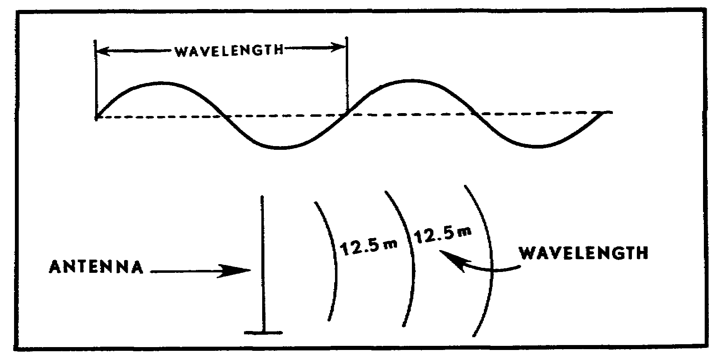
Figure 32. Wave length.

47

b. Half-wave antenna. The standard tactical radio antenna is half-wave length or a multiple thereof. If it were possible to construct a perfect half-wave antenna, its physical length (in meters) would be computed using the formula L = 300 - 2 or L = 150.
F(MHz) F(MHz)

c. Antenna energy losses. Because of energy losses on the radiating antenna, it is impossible to construct a perfect half-wave antenna. This loss is approximately five percent. To compensate for this loss, the 150 (para 26b) is multiplied by 95. This figure (142.5) is rounded to 142 for ease of computation. When using the formula
L = 142 or L = 142 = 3 meters, the length of an
F(MHz) 47.3 MHz
expedient, half-wave antenna to be used on a frequency of 47.3 MHz would be 3 meters.

REMEMBER: The use of this wavelength formula to compute the antenna length makes it easy to see that the lower the operating frequency, the longer the antenna; the higher the frequency, the shorter the antenna.

PRACTICE EXERCISES:

25. In the blank space below, write the formula for a full wavelength.

26. In the wavelength formula, velocity (V) is a constant _______________.

27. Energy losses from a radiating antenna are considered to be ________ percent.

48

28. What is the formula for computing the physical length of a half-wave antenna when a radiating antenna has energy losses? (Use space below for computations.)

29. What is the antenna length for a tactical radio set (half-wavelength) operating at a frequency of 24 MHz? (Use space below for computations.)

49

////////////////////////////////////////////////////////////////////////////

ANSWERS:

25. L = Velocity
Frequency

26. 300,000,000 meters per second or 300 MHz.

27. five

28. L = 142
F(MHz)

29. 142 = 5.9 meters
24

////////////////////////////////////////////////////////////////////////////

27. IMPROVISING WHIP ANTENNAS. Whip antennas are the most commonly used radio antennas on radios available to the field artillery (vehicle and backpack). Whip antennas are often broken. When a replacement is not immediately available, the operator can improvise a satisfactory antenna by using copper or aluminum wire. (If these are not available, field wire can be used.)

a. Repairing a whip antenna. An operator can repair a broken antenna by lashing the broken antenna sections together. When lashing the sections together, be sure paint and corrosion are removed from the parts being jointed (Fig 33).

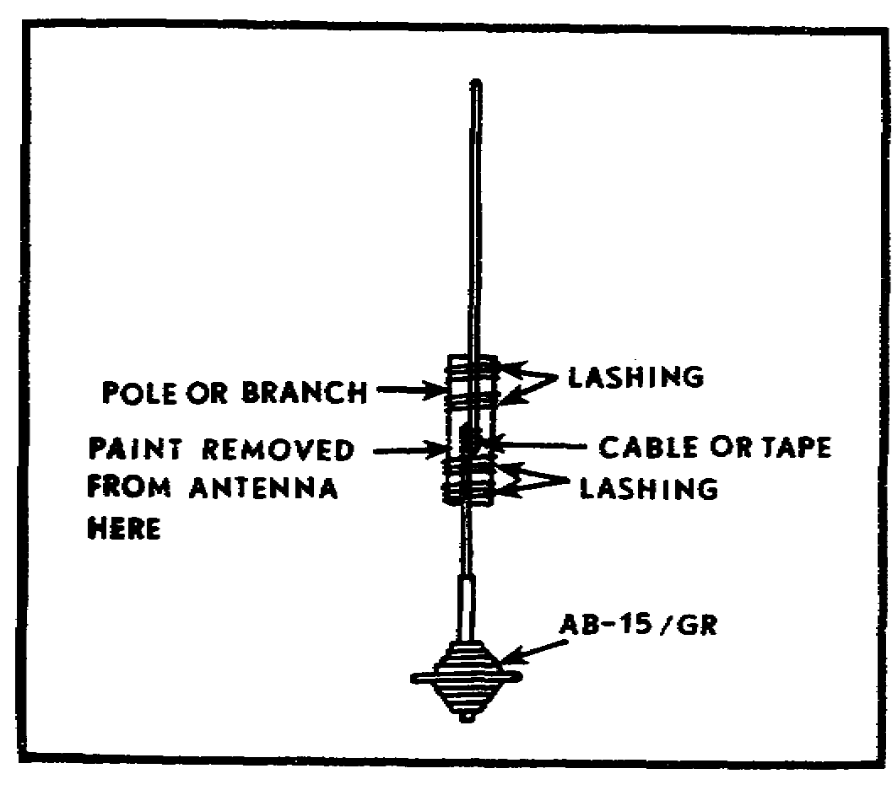
Figure 33. Emergency repair of whip antenna.
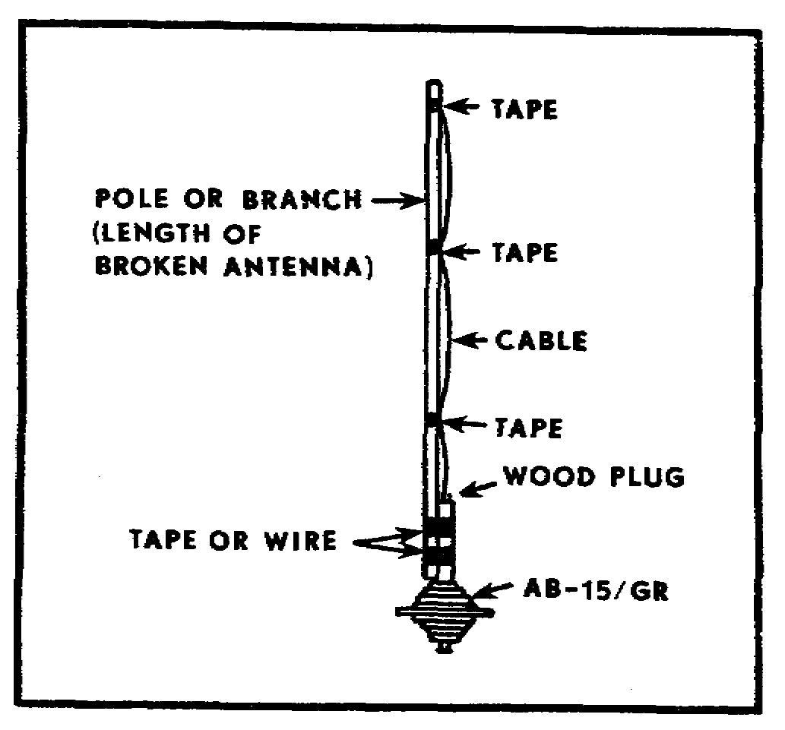
Figure 34. Improvised whip antenna.

50

b. Improvising a whip antenna. If the top portion of a whip antenna is unusable, use a tree limb or pole to support an improvised wire antenna (Fig 34). If the correct length cannot be determined by measuring, use the wavelength formula.

REMEMBER: Since whip antennas are quarter-wave antennas, the answer to the formula L = 142 must be divided by 2.
F(MHz)

If other wire is not readily available, use WD-1/TT field wire (twisted pair). To make the twisted pair act as a single conductor, remove approximately 1 1/2, inches of insulation from each end, and twist the bare leads together (Fig 35). Now, splice the wire to the base antenna stub, and tie (tape) the wire to the pole. Lash the pole to the antenna base (Fig 34).

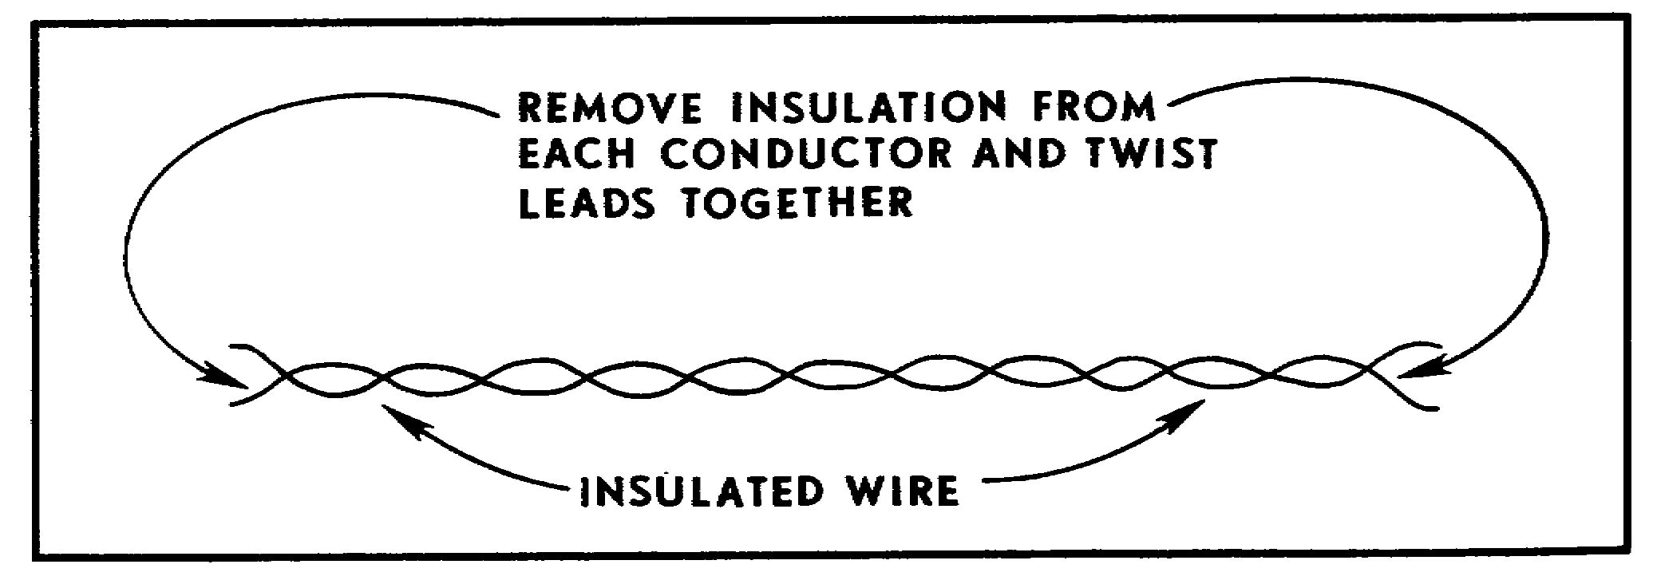
Figure 35. Using WD-1/TT as a single conductor.

28. IMPROVISING VERTICAL ANTENNAS. If mobility is not an immediate requirement, you may wish to improvise a vertical antenna. The problem of line-of-sight may be overcome by placing this antenna on top of a hill or fastening it to a tree or pole to increase its height above surrounding structures. Figures 36 and 37 show ways to support improvised vertical antennas. These antennas are relatively easy to prepare and emplace.

51

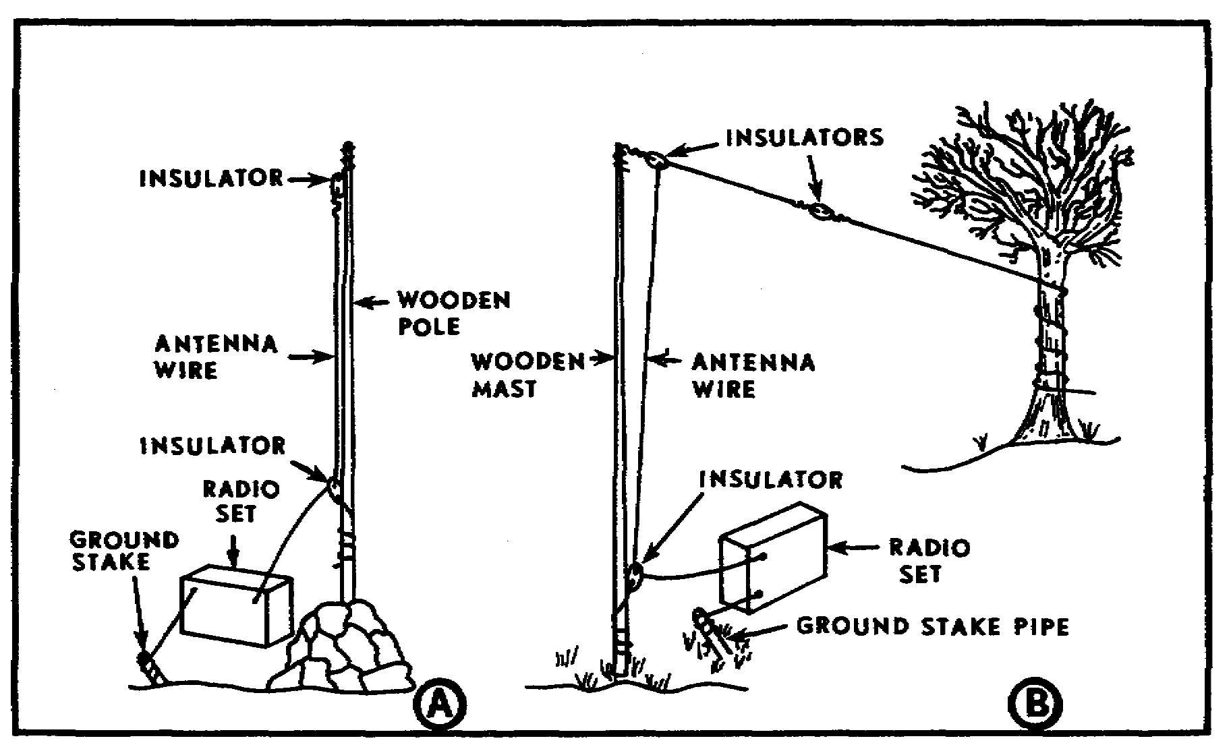
Figure 36. Expedient vertical wire antennas.

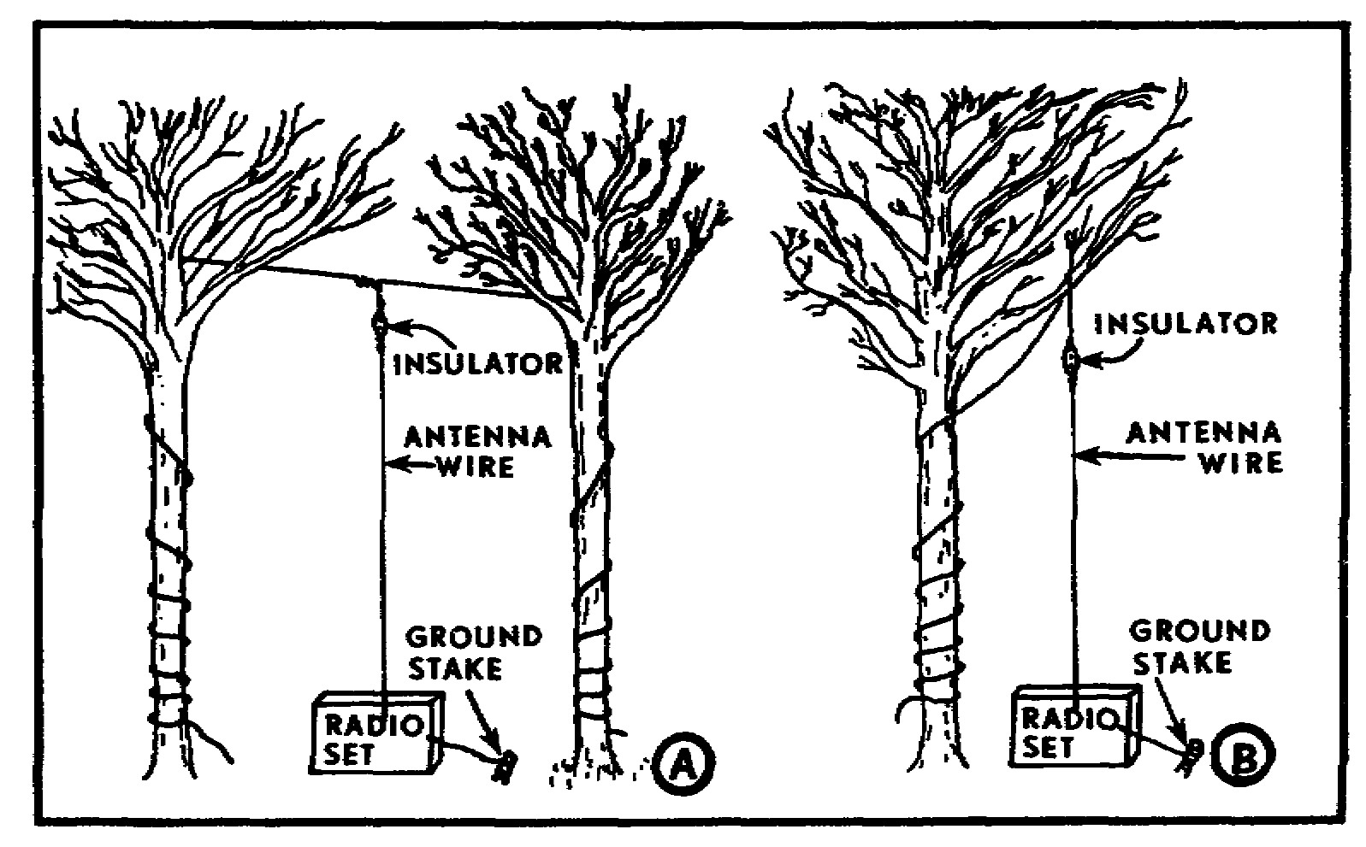
Figure 37. Additional means of supporting vertical antennas.

Step 1. Use the formula for a quarter-wave antenna to compute proper length.

52

Step 2. Cut wire to proper length, remove insulation from ends, and make a single conductor, if using WD-1/TT (para 27b).

Step 3. Attach an insulator (para 28) to one end of the prepared antenna wire, and attach the other end to the antenna connector on the radio.

Step 4. Tie a rope to the insulator end, and throw the rope over a convenient tree limb.

Step 5. Pull the antenna to a vertical position, and tie off the rope.

Step 6. Ground the radio set. Loosen any screw on the front panel, and clean off the paint for a good ground. Ground the set by inserting the ground wire behind the screw and tightening the screw. Attach the opposite end of the ground wire to a ground stake (Figs 36 and 37).

29. INSULATORS. Normally the antenna is electrically separated from its support lines by means of glass or porcelain insulators. If an insulator breaks and a spare insulator is not available, the antenna can be effectively insulated by inserting a piece of dry wood between the antenna wire and its support. (Figure 38 shows two methods of making emergency wooden insulators. If dry, rope supports may be attached directly to the antenna wire. If the rope contains any metal wire to provide strength, an insulator must be used.)

NOTE: Wood or dry rope should be used as insulators only in emergencies when better insulators cannot be obtained.

53

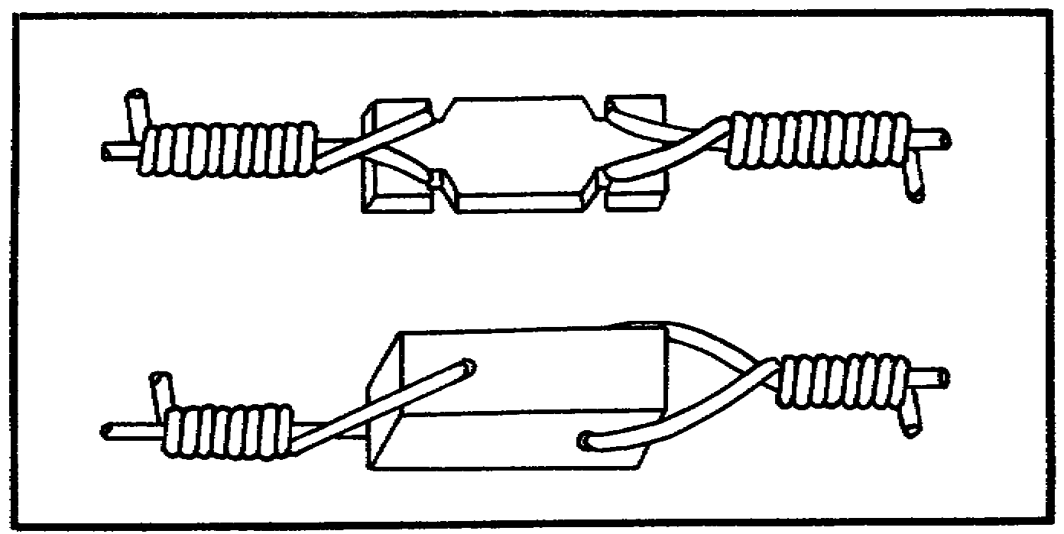
Figure 38. Improvised insulators.

PRACTICE EXERCISES:

30. The best types of wire to use in antenna repair or replacement are ______________ and ______________.

31. When preparing an expedient antenna to replace a vehicle whip antenna, it is necessary to ______________ the answer to the formula L = 142/F(MHz) by ______________ to compute the correct physical length.

32. WD-1/TT field wire may be used to replace or fabricate antennas. The two separate wires will act as a single conductor if they are __________ _______________________ at the ends.

33. You, a radio operator, have lost the upper portion of your vehicle whip antenna. You decide you can replace the lost portion with an improvised wire antenna. The remaining lower section of the antenna is 0.7 meters long. You are operating at a frequency of 75.50 MHz. What is the length of wire needed to fabricate the top portion of your antenna? (Use space below for computations.)

54

34. Glass insulators are not available; therefore, _____________ or ______________ can be used as emergency insulators when fabricating expedient antennas.

////////////////////////////////////////////////////////////////////////////

ANSWERS:

30. copper, aluminum.
31. divide, 2
32. twisted together.
33. L = 142 = 1.88 1.88 = .94 .94 - .70 = .24 meters
75.5 2
34. wood, dry rope.

////////////////////////////////////////////////////////////////////////////

30. IMPROVISING GROUND-PLANE ANTENNAS. When your RC-292 or OE-254 is inoperative or not readily available, a satisfactory expedient can be fabricated from field wire and pieces of wood (Fig 39). This expedient antenna is omnidirectional and can be used with al FM radios.

Step 1. Compute quarter-wave antenna lengths, and prepare four lengths of wire.

Step 2. Cut three spacers (must be of equal length to achieve 120° separation between ground-plane elements).

Step 3. Prepare antenna transmission line and ground wires. (Transmission line should not exceed 13 meters because of possible energy losses.)

Step 4. Assemble antenna (Fig 39).

Step 5. Tie rope to insulator end of antenna, and suspend from a tree limb at least 8 feet off the ground.

Step 6. Connect the antenna to the antenna terminal.

Step 7. Ground the radio set.

55

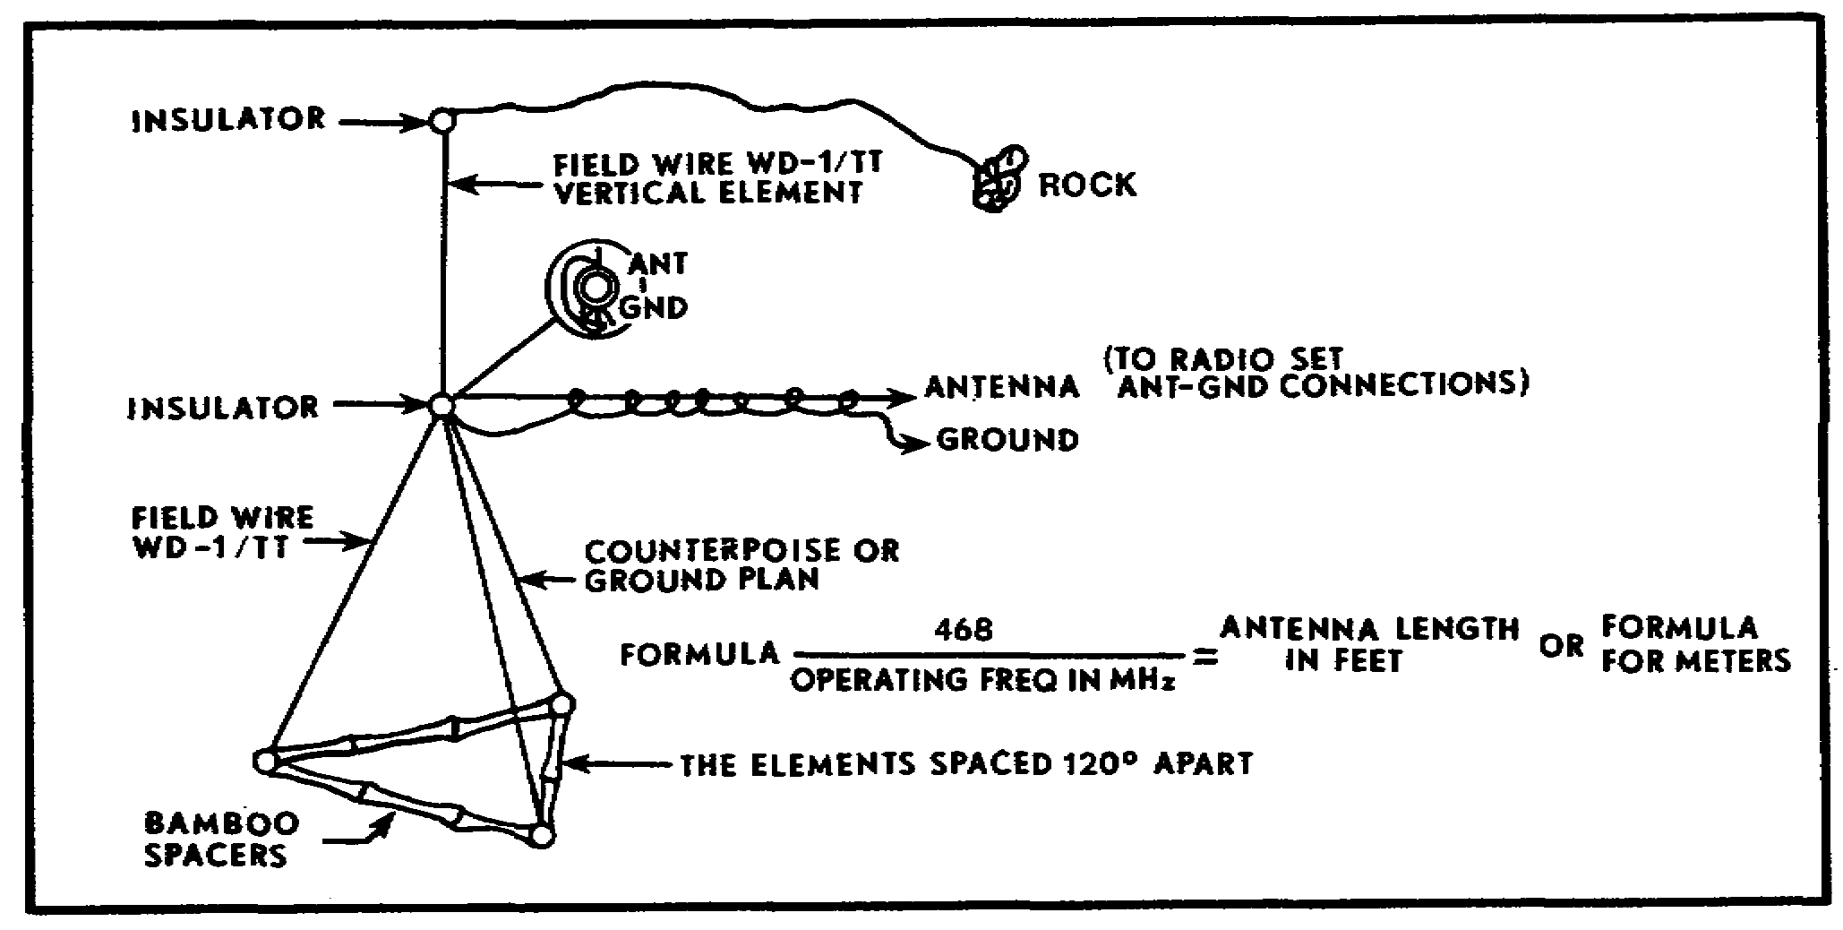
Figure 39. Field-expedient ground-plane antenna.

If you expect strong winds, add a rope from the ground plane to a stake in the ground. A swaying antenna causes the signal to fade in and out.

31. IMPROVISING HORIZONTAL (DOUBLET) ANTENNAS. The doublet antenna is a bidirectional, horizontally mounted, half-wave antenna. It consists of two quarter-wavelength sections on each side of an insulator (Fig 40). For best operation, it should be suspended as close to one-half wavelength above the ground as possible. (This depends on the height of the supports.)

a. Construct the antenna.

Step 1. Determine direction of transmission, and prepare supports (trees, poles, etc.).

Step 2. Compute half-wave antenna length, and prepare wire.

Step 3. Cut the wire in half, and put an insulator on each end (three insulators--see Figure 40).

Step 4. Prepare transmission line. Separate the two wires of WD-1/TT, and attach one wire to each side of the center insulator. (Be sure the transmission line is long enough to reach to the ground and then to the radio set.)

Step 5. Tie rope or wire to the two end insulators, erect the supports, and hang the antenna. Keep it as level as possible.

56

Step 6. If needed, use counterweight (water can is used in Figure 40) to prevent high winds from breaking the antenna. Counterweight also helps keep the antenna taut and level.

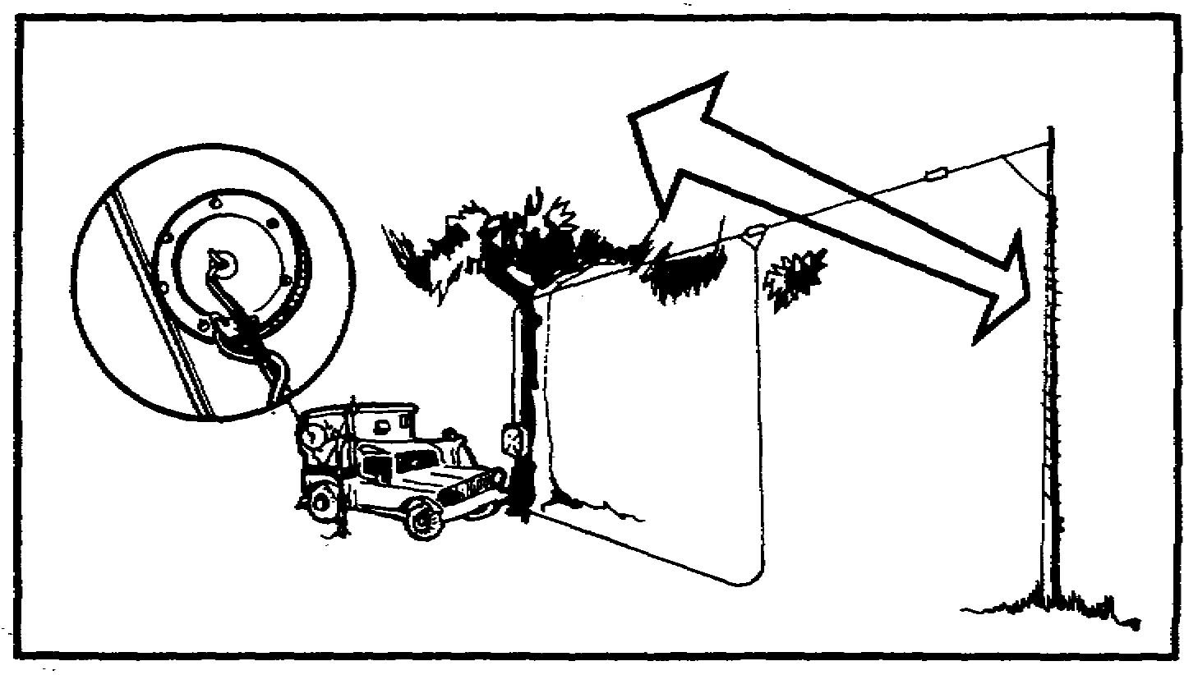
Figure 40. Expedient doublet (bidirectional) antenna.

b. Connect to radio. Bring one end of the transmission line to the antenna connector, and insert it into the "hot" center of the antenna connector. The ground should be as close as possible to the antenna connector (Fig 40).

32. EXPEDIENT LONG-WIRE ANTENNAS. The most practical antenna for combating jamming is the long-wire antenna, because it is highly directional. By pointing the antenna toward the receiving station antenna, transmissions are almost impossible to detect or jam. The antenna AT-984A/G is an issue item. Expedient long-wire antennas are easily fabricated by use of WD-1/TT field wire.

a. Expedient long-wire antenna. This antenna operates in the same manner as antenna AT-984A/G. The long-wire antenna can be easily fabricated from 100 to 150 feet of WD-1/TT field wire. For best performance, the antenna should be two or more wavelengths long. (Use the formula to compute length.)

Step 1. Pick a support at least 15 feet off the ground.

Step 2. Move the radio (vehicle) close enough to the support to connect one end of the expedient antenna to the antenna connector on the receiver-transmitter.

Step 3. Use rope or wire to anchor the antenna to the support.

Step 4. Connect the antenna to the hot center of the antenna connector (Fig 40), and ground the radio.

Step 5. To make this antenna unidirectional (one direction), add a 500- or 600-ohm resistor at the end of the antenna closest to the support (Fig 41).

57
b. Supporting the long-wire antenna. When using the AN/PRC-77 radio, tie the antenna (WD-1/TT) to the handle on the receiver-transmitter before connecting to the antenna connector. With a vehicle-mounted radio, a broken antenna stub can be used as a tie for the antenna (Figure 41). (Be sure to remove paint from the area where the antenna is connected.)

NOTE: When using this configuration with a vehicle-mounted radio (Fig 41), remove the control cable and antenna cable from the vehicle antenna matching unit. Connect the expedient antenna directly to the receiver-transmitter antenna connector (Figs 40 and 41).

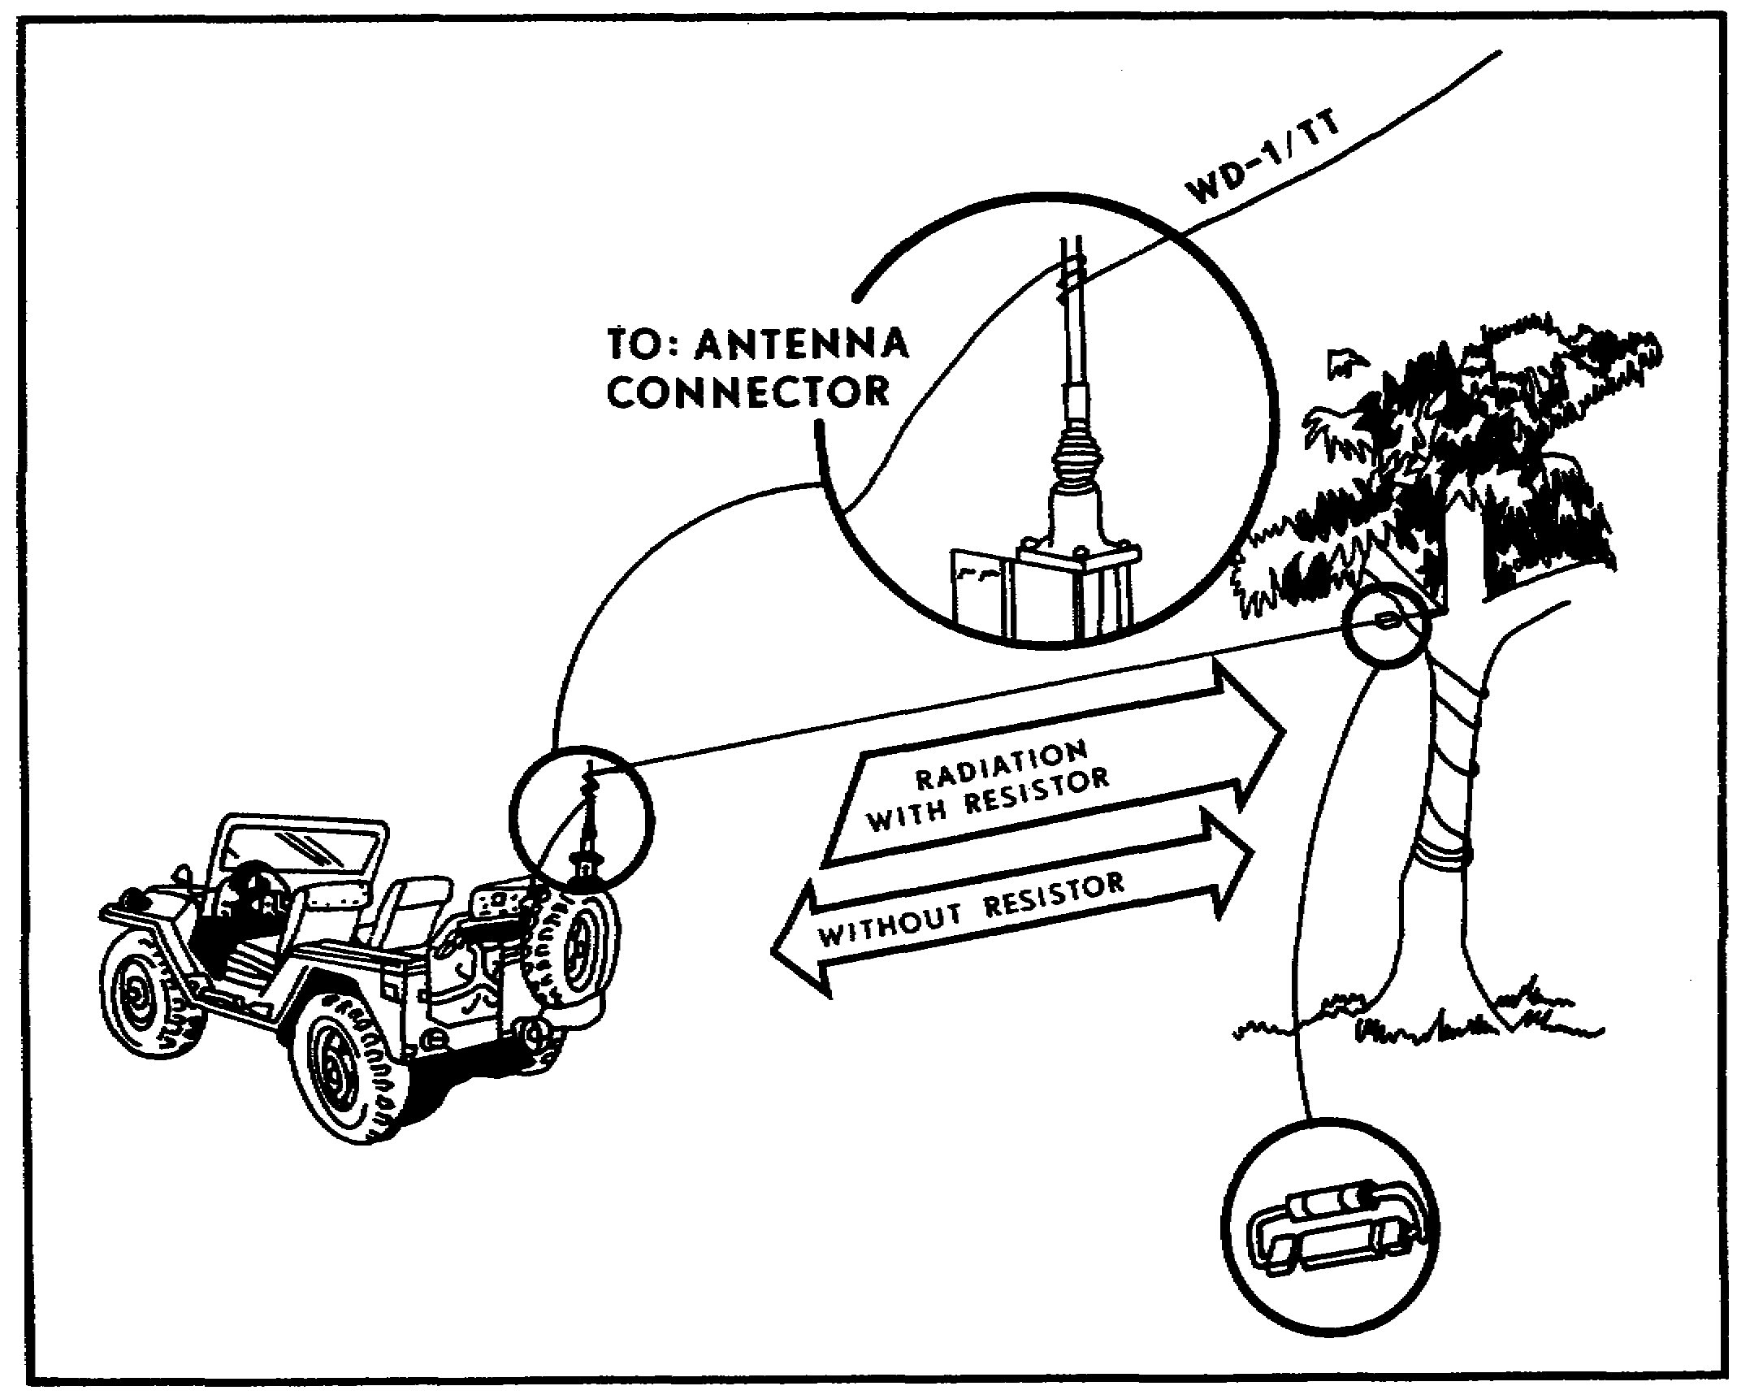
Figure 41. Expedient long-wire antenna.

58

c. Half-rhombic antenna. The half-rhombic antenna (Fig 42) is another easily constructed directional antenna. To ensure satisfactory performance, the length of each leg of the half-rhombic antenna should be a minimum of one wavelength at the lowest frequency used. A typical military half-rhombic antenna consists of 100 feet of field wire erected over a single 30-foot support with an 80-foot counterpoise (laid about one foot above the ground). The 100 feet of wire should be erected on the support pole so that each leg is about 50 feet long. One leg of the antenna terminates at a 500-to 600-ohm resistor. One end of the counterpoise also terminates at the resistor (Fig 42). A lead-in wire is attached between the other leg of the antenna and the radio set. The remaining end of the counterpoise is then grounded. The supporting pole should be wooden and should be guyed with rope. In operation, current flows only from the transmitter toward the resistor. This resistor absorbs energy that is not radiated and in so doing prevents any reflection along the antenna. Thus, the antenna is unidirectional--the direction of transmission is from the radio toward the resistor end of the antenna.

NOTE: Resistor can be obtained through prescribed load list (PLL) channels by using NSN 5905-00-407-6167.

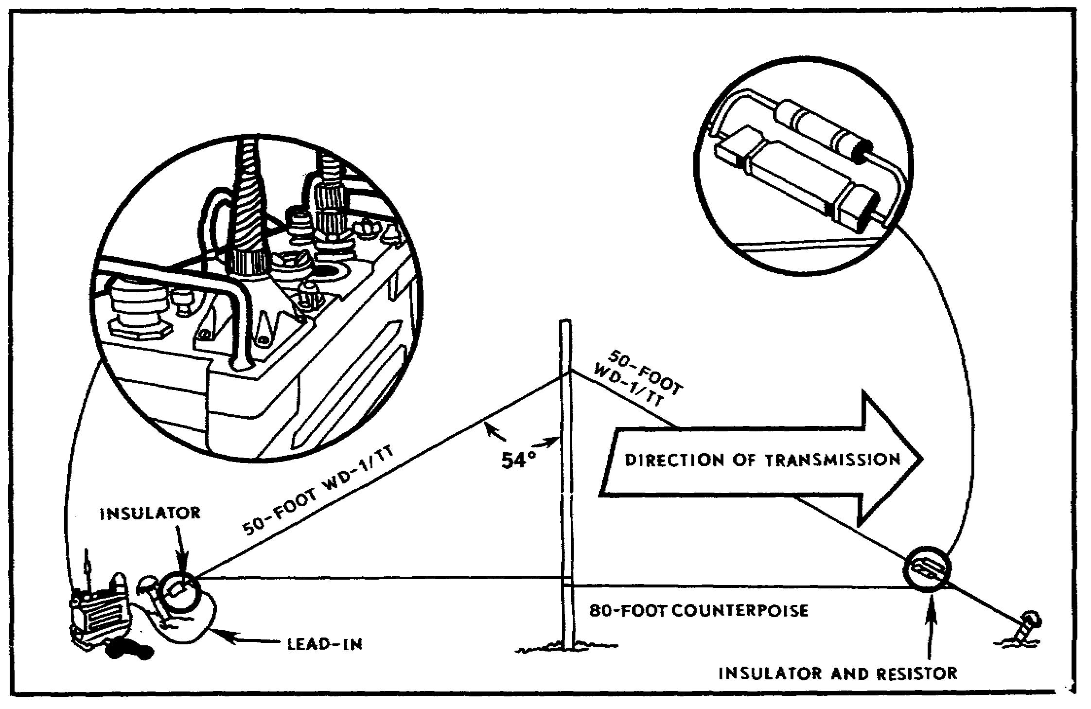
Figure 42. Half-rhombic (unidirectional) antenna.

59

33. ELEVATED ANTENNAS. The standard vehicle antenna, complete with bracket and mast base, can be raised on poles to add height above obstructions to improve line-of-sight transmissions. The antenna can be connected to the radio set by using field wire as the transmission line. The guy wires, with insulators installed (Fig 43), act as the ground plane or counterpoise.

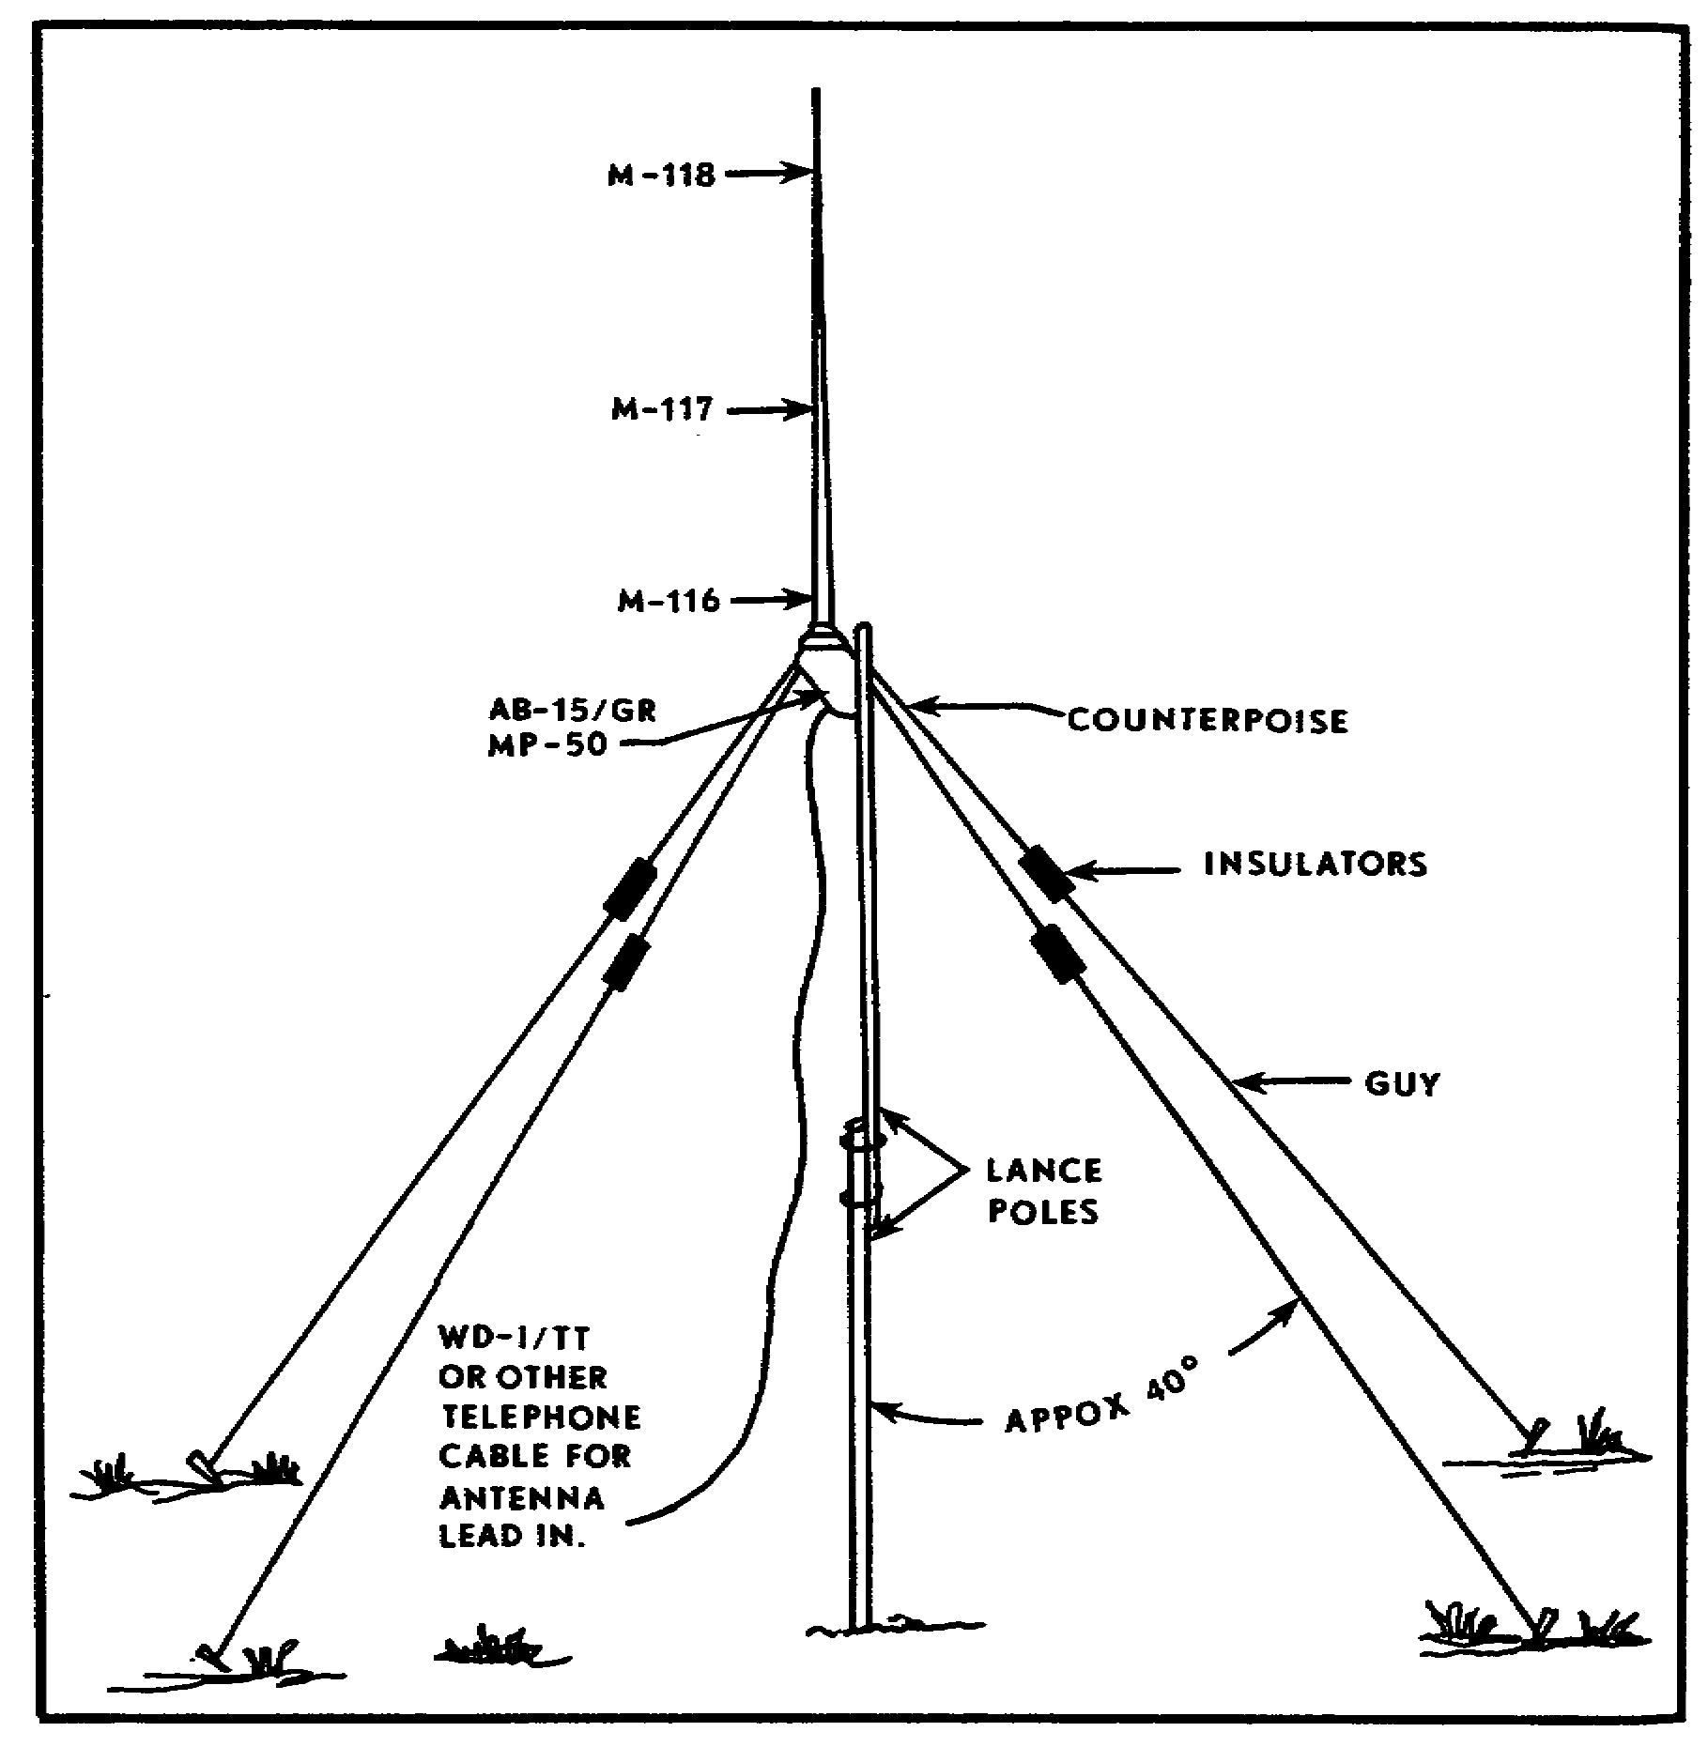
Figure 43. Elevated antenna.

60

SELF-EVALUATION:

16. Taking into consideration all antenna losses, which of the formulas below would you use to compute the length of a half-wave antenna?

a. 300 b. 150 c. 142 d. 71
F(MHz) F(MHz) F(MHz) F(MHz)

17. The distance between A and B (Fig 44) is called a--

a. meter.
b. wave pulse.
c. frequency.
d. wavelength.

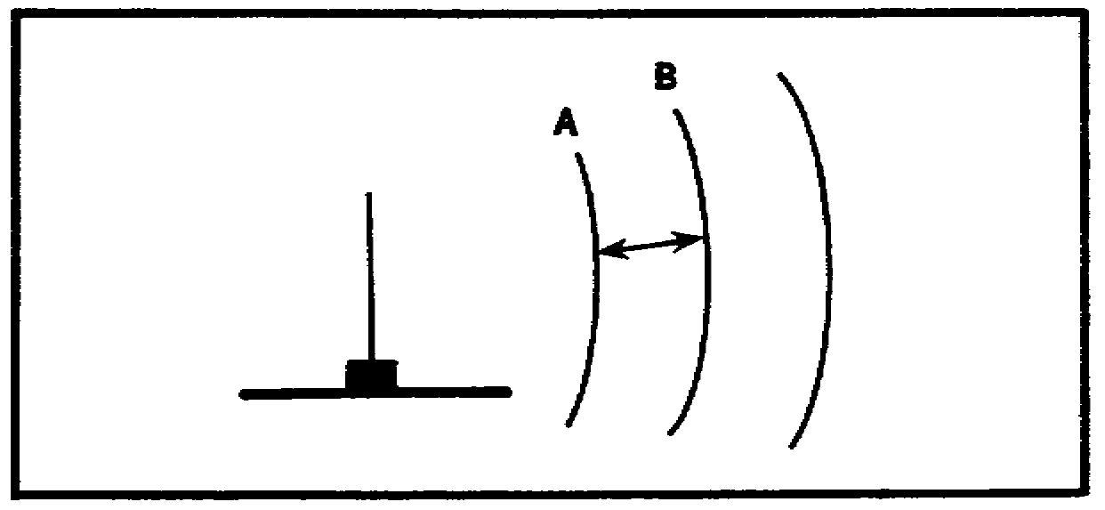
Figure 44. Illustration for Exercise 17.

18. The most useful types of wire to use in antenna repair are aluminum and--

a. steel.
b. copper.
c. zinc.
d. magnesium.

19. As radio operator, you are having difficulty receiving a voice transmission because of a weak signal and external noises. To eliminate this problem you would--

a. switch to another frequency.
b. fabricate a long-wire, expedient antenna.
c. cease operation.
d. use a headset instead of the radio loudspeaker.

61

20. Figure 45 represents a--

a. one-quarter wave antenna.
b. counterpoise.
c. doublet antenna.
d. wavelength.

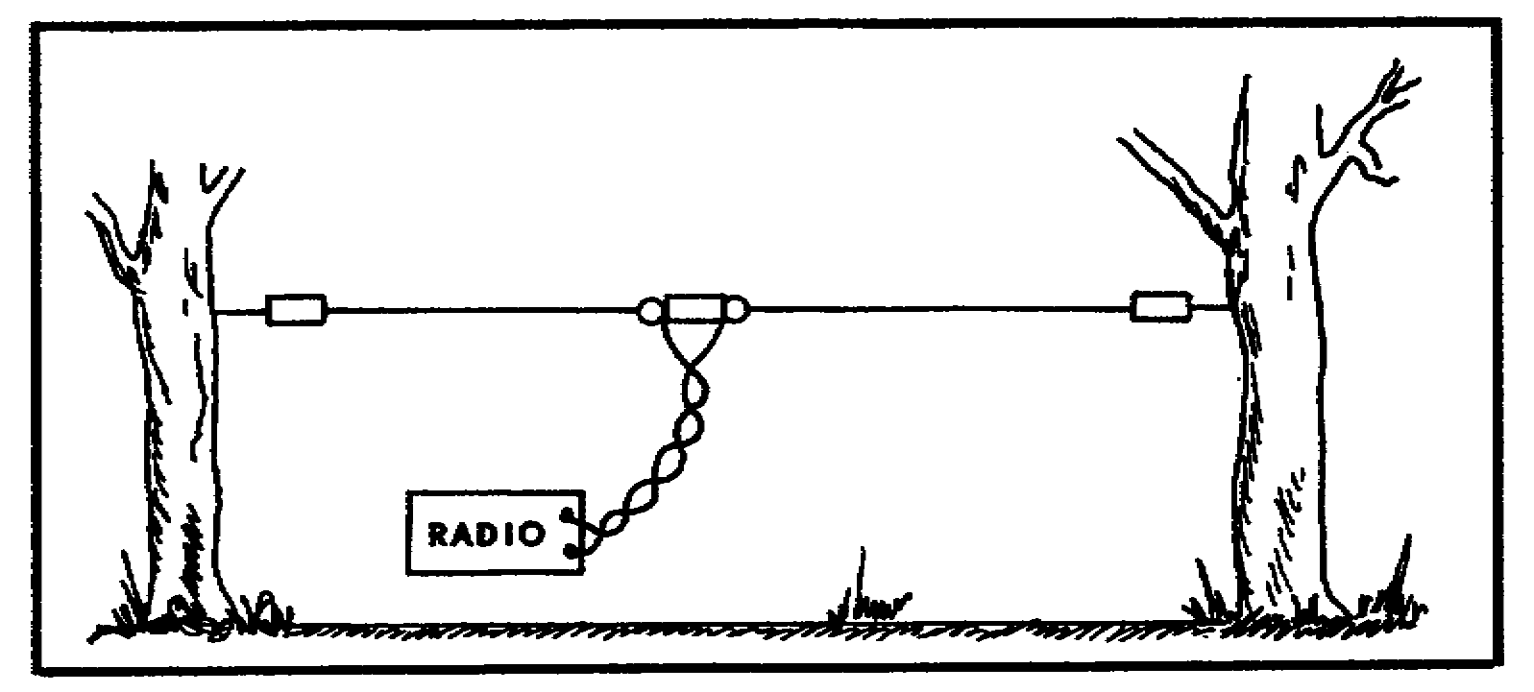
Figure 45. Illustration for Exercise 20.

21. A forward observer is slightly out of range of the fire direction section. The FO decides to fabricate a field-expedient, long-wire, directional antenna. The length of this antenna should be no less than--

a. one wavelength.
b. two wavelengths.
c. three wavelengths.
d. four wavelengths.

22. When computing the length (wavelength) of a replacement antenna for a vehicle-mounted radio, you must remember that the vehicular (whip) antenna is a--

a. quarter-wave antenna.
b. half-wave antenna.
c. full-wave antenna.
d. horizontally polarized antenna.

23. When necessary to improvise insulators, the best material available in the field is--

a. WD-1 field wire.
b. an empty soft drink can.
c. dry wood.
d. a broken antenna section.

62

24. In improvising a ground-plane antenna, it is important to separate the three ground-plane elements by--

a. 45 degrees.
b. 90 degrees.
c. 120 degrees.
d. 180 degrees.

25. For best operation of the half-rhombic expedient antenna, each leg should be a minimum of one wavelength long at the lowest operating frequency. This is done by making each leg--

a. 25 feet long.
b. 50 feet long.
c. 80 feet long.
d. 100 feet long.

////////////////////////////////////////////////////////////////////////////

ANSWERS:

16. c.
17. d.
18. b.
19. d.
20. c.
21. b.
22. a.
23. c.
24. c.
25. b.

////////////////////////////////////////////////////////////////////////////

34. SUMMARY. This lesson has concentrated on field-expedient antennas and the methods used to improvise antennas. You have not learned enough to consider yourself an expert in the subject of antennas. However, you have learned enough to enable you to maintain or restore communication.

Before using field expedients, analyze your communication problem. Remember, expedients will not overcome maintenance or operator problems. Expedient antennas are easily fabricated from materials normally found on the battlefield. Field wire (WD-1/TT) can be used to manufacture most antennas.

Antenna lengths are critical. Remember the wavelength formula. Always compute the proper antenna length that will keep you communicating.

63

